DECLARATION OF COVENANTS, CONDITIONS AND RESTRICTIONS FOR
ASPENGLEN AT SUN MEADOW

SUMMIT COUNTY, UTAH

/2_,2000

TABLE OF CONTENTS

ARTICLE I ................................................................... 3

DEFINITIONS ............................................................ 3

ARTICLE II .................................................................. 5

HOMEOWNERS ASSOCIATION ............................................. 5
2.1 Enforcement Powers .............................................. 6
2.2 Use and Maintenance of Common Areas .............................. 6
2.3 Assessments .................................................... 6
2.3.1 Assessments on Lots Owned byDec1arant .......... 6
2.4 Assessments Constitute Lien, Mortgagee Protection ..................... 7
2.5 Statement of Account ............................................. 7
2.6 fudemnity of Association Trustees and Officers ......................... 7
2.7 Election ........................................................ 7
2.8 Notice ofE1ection, Notice of Meeting ................................ 8
2.9 Special Meeting ................................................. 8
2.10 NumberofTrustees. TermofOffice ................................ 8

ARTICLE ill ................................................................. 8

ARCHITECTURAL COMMITTEE ............................................ 8
3.1 Architectural Committee Created .................................... 9
3.2 Approval by Committee Required ................................... 9 (a) Plans Submitted ........................................... 9 (b) Review Fee .............................................. 9 (c) Review ................................................. 10 (d) Written Record .......................................... 10 (e) Failure to Act ............................................ 10
3.3 Development of Architectural Standards ............................. 10
3.4 Variances ...................................................... 10
3.5 Costs of Professional Review ...................................... 11
3.6 General Design Review .......................................... 11
3.7 Declarant. Trustees and Committee not Liable ......................... 11
3.8 Limitations on Review ........................................... 12
3.9 County Approval ................................................ 12
3.10 Construction Rules ............................................. 12

ARTICLE N ..... : .......................................................... 12

RESTRICTIONS ON ALL LOTS ............................................ 12
4.1 Zoning Regulations .............................................. 12
4.2 No Mining Uses ................................................ 12
4.3 No Business or Commercial Uses ................................... 12
4.4 Restrictions on Signs ............................................ 13
4.5 Antennas ...................................................... 13
4.6 Solar Panels .................................................... 13
4.7 No Used or Temporary Structures .................................. 13
4.8 Number of Dwellings ............................................ 13
4.9 Completion Required Before Occupancy ............................. 13
4.10 No Other Construction .......................................... 13
4.11 Animals ...................................................... 14
4.12 Underground Utilities ........................................... 14
4.13 Service Yards ................................................. 14
4.14 Maintenance of Property ......................................... 14
4.15 No Noxious or Offensive Activitv ................................. 14
4.16 No Hazardous Activity .......................................... 14
4.17 No Unsightliness ............................................... 14
4.18 No Annoying Lights ............................................ 14
4.19 No Annoying Sounds ........................................... 15
4.20 No Fuel Storage .......... _ ...................... _ ..... _ ....... 15
4.21 Drainage . _ ...... ...... _ ................. _ ............... _ .. 15
4.22 Vehicles Restricted to Roadways .... _ ............. _ ............... 15
4.23 Kennels ...... _ ........... _ .................................... 15
4.24 No Transient Lodging Uses . _ ..... _ ........... _ .................. 15

4.25 Parking ...... _ ..........
................................... 15

4.26 Fences ............... _ .. _ ......................... _ ........ 15
4.27 No Re-Subdivision .. _ ..... _ .................................... 15

4.28 Landscaping ...
....... _ ................................ _ .... 16

4.29 Landscaping Standards .. _ . _ ...................
....... _ ....... _ 16

4.30 Landscape Preservation .... _ .......... _ .......................... 16

ARTICLE V ................... _ ............................................. 17

OWN ERS' MAINTENANCE OBLIGATIONS ......... _ ...... _ ................. 17
5.1 DutytoMaintain .............................. _ ................. 17
5.2 Maintenance by Association ....................................... 17
5.3 Repair by Association _ ................................ _ .......... 18
5.4 Alterations ofExterior Appearance ................. _ ............... 18
5.5 Repair Following Damage . _ ........ , ............................ _ 18

Saltl..ake-115875.1 oozo4n-oooo1

ARTICLE VI ................................................................ 19

GENERAL PROVISIONS .................................................. 19
6.1 Violation Deemed a Nuisance ..................................... 19
6.2 Remedies ...................................................... 19
6.3 Severability .................................................... 19
6.4 Limited Liability ................................................ 19
6.5 A mendment .................................................... 20
6.6 Constructive Notice ............................................. 20
6.7 Notices ....................................................... 20
6.8 Liberal Interpretation ............................................ 20

Salt:I..ake-115875.1 0020472-0CQOl

DECLARATION OF COVENANTS, CONDITIONS AND RESTRICTIONS FOR
APSENGLEN HOMEOWNERS ASSOCIATION SUMMIT COUNTY, UTAH

THIS DECLARATION OF COVENANTS, CONDITIONS AND RESTRICTIONS FOR ASPENGLEN AT SUN MEADOW HOMEOWNERS ASSOCIATION ("Aspenglen at Sun Meadow") is made this_ day of , 2000 by Fieldstone Partners, L.L.C., a Utah limited liability company, referred to below as "Declarant."

RECITALS:

A. Declarant is the owner of the following described real property (the "Initial Property'')
located in Summit County, Utah and known as the Silver Summit Subdivision -Phase 3.
Silver Summit Subdivision- Phase 3, in accordance with the official plat thereof recorded in the office of the Summit County
Recorder as Entry No. Sl31OS on $;:¢ d:]_, 2000.

B. The Initial property is part of a larger tract of real property more particularly described in Exhibit B (the "Entire Property''). The Entire Property consists ofthe Initial Property and the Silver Summit Subdivision- Phase 4, which Phase is referred to herein as ''Neighborhood 4" and the "Additional Property."

C. Declarant intends to develop a residential subdivision on the Initial Property.
Declarant will develop and convey all of the Lots within the Subdivision subject to a general plan of development, outlined in the Silver Summit Design Guidelines ("Design Guidelines") attached hereto as Exhibit C, and subject to certain protective covenants, conditions and restrictions all as set forth in this Declaration, and which are deemed to be covenants running with the land
mutually burdening and benefiting each of the Lots within the Subdivision.

D. Declarant intends to develop the subdivision on the Entire Property in phases, with the initial phase consisting of the Initial Property. The Declarant reserves the right to subject the Additional Property to the terms and conditions of this Declaration at a later time. As used herein, the term "Property'' shall refer to the Initial Property and such portion of the Additional Property as may be subject to the terms and conditions of this Declaration from time to time.
The subdivision project on the Property will be known as "Aspenglen at Sun Meadow".

E. Declarant desires to provide for the maintenance of certain Common Areas, consisting of open space and recreational trails, which Declarant intends will be owed by and assessed for tax purposes in the name of the Aspenglen at Sun Meadow Homeowners Association, an association of all owners within the Property.

5JiJ5 ./'..s829 Br.:01335 PeOi.342

DECLARATION:

DECLARANT HEREBY DECLARES that all of the Lots within the Subdivision shall be held, sold, conveyed, encumbered, leased, used, occupied and improved subject to the protective covenants, conditions, restrictions and equitable servitudes set forth in this Declaration, all of which are created for the mutual benefit of the Owners. It is the intention of the Declarant in imposing these covenants, conditions and restrictions to protect and enhance the property values and aesthetic values of the Lots by eliminating inconsistent uses or improvements, all for the mutual protection and benefit of the Owners. The covenants, conditions and restrictions are intended to, and shall in all cases run with the title of the land, and be binding upon the successors, assigns, heirs, lien holders, and any other person(s) holding any
interest in the Lots, and shall inure to the benefit of all other Lots in the Subdivision to be located on the Property. The covenants, conditions and restrictions shall be binding upon the Declarant
as well as its successors in interest, and may be enforced by the Declarant or by any Owner.

Portions of the Additional Property may also be made subject to the terms of this Declaration through recordation of a Supplementary Declaration. The Supplementary Declaration may contain protective covenants, conditions and restrictions substantially similar to
the covenants set forth in this Declaration, with such modifications or supplemental provisions as
may be deemed appropriate by Declarant on a phase-by-phase basis to address differences in market conditions, financially or technically unworkable design standards, changes mandated by law, or differences in the circumstances affecting Lots to be constructed after the initial phase.

Notwithstanding the foregoing, no provisions of this Declaration shall prevent the Declarant from doing any of the following, which shall be deemed to be among Declarant's reserved rights in addition to such rights as may be described elsewhere in this Declaration: (1) installation and completion of the Subdivision Improvements; (2) use of any Lot owned by the Declarant as a model home, or for the placement of a temporary construction or sales office; (3) installation and maintenance of signs incidental to sales or construction which are in compliance with applicable County ordinances; (4) assignment of Declarant's rights under this Declaration in whole or in part to one or more builders intending to construct homes within the Subdivision; (6) construction of any improvements, including homes, by Declarant as approved by the County; (7) access over any Lot for the installation of improvements; and (8) erection of permanent or temporary signs for use during the selling and marketing of the project.

COVENANTS, CONDITIONS AND RESTRICTIONS:

ARTICLE I DEFINITIONS
1 Unless the context clearly requires the application of a more general meaning, the following terms, when used in this Declaration, shall have the following meanings:

1.1 "Additional Improvements" shall mean Improvements other than those constructed by Declarant.

1.2 "Additional Property" shall mean the balance of the Entire Property not included within recorded Plats.

1.3 "Architectural Committee" shall mean the committee created under Article III of this
Declaration.

1.4 "Architectural Guidelines" shall have the meaning provided in the preamble of
Article III.

1.5 "Association" shall mean Aspenglen at Sun Meadow Homeowners Association, whether incorporated or not, and as the context requires, the officers and directors of that Association.

1.6 "Bylaws" shall mean the bylaws of the Association as adopted and amended from time to time by the Association's Board of Trustees.

1.7 "Common Areas" shall mean the areas designated on the Plat as Common Area which areas shall be owned by the Association and held for the common use and benefit of the Owners and the public.

1.8 "County'' shall mean the Summit County, Utah, and its appropriate departments, officials, and boards.

1.9 "Declarant" shall mean and refer to Fieldstone Partners, L.L.C., a Utah limited liability company.
0057 829 &OG 01 +

1.10 "Declaration" shall mean this Declaration of Covenants, Conditions and Restrictions, together with any subsequent amendments or additions. The subdivision Plats for Silver Summit Neighborhoods 3 & 4, and the easements and other matters shown on those Plats are also incorporated into this Declaration by reference.

L11 "Design Guidelines" shall mean the comprehensive document delineating the design guidelines and development regulations for Silver Summit Neighborhoods 3 and 4, as established and modified from time to time by the Association. The Design Guidelines may be amended without an amendment to this Declaration. An iuitial version of Design Guidelines, initially to
be applicable to Silver Summit Neighborhoods 1 through 5, is attached hereto as Exhibit C for
informational purposes only.

1.12 "Dwelling" shall mean the single family residence built or to be built on any Lot, including the attached garage.

L13 "Entire Property" shall mean the meauing set forth in the recitals and consists of
Silver Summit Neighborhoods 3 and 4.

1.14 "Family" shall mean one household of persons related to each other by blood, adoption or marriage, or one group of not more than five people not so related living together as a unit who maintain a common household.

1.15 "Improvement" shall mean all structures and appurtenances of every type and kind, including but not limited to buildings, Dwellings, garages, storage buildings, walkways, retaining walls, sprinklers, pipes, driveways, fences, landscaping, pools, decks, stairs, poles, lighting,
signs, satellite dishes or other antennas, and any mechanical equipment located on the exterior of any building.

1.16 "Lot" shall mean any numbered building Lot shown on any official plat of all or a portion of the Subdivision.

1.17 "Open Space" shall mean tracts of dedicated open space designated in the Chapter entitled "Community Character" of the Design Guidelines and shown on the Silver Summit Subdivision Phase 3 Plat and any other plats of the Entire Property Shown as Common Area.

1.18 "Owner" shall mean the person or persons having title to any Lot. Owner shall mean the person holding fee simple title, including the Declarant, and buyers under any contract for deed, but shall exclude any person or entity holding title for purposes of securing performance of an obligation.

1.19 "Person" shall mean a natural person or any legal entity with a right to hold title to real property in its own name in the State of Utah. 0057...:>8 29 i:\ :.{)1335

1.20 "Plat" shall mean the official ownership plat of Silver Summit Subdivision Phase 3, as approved by the County and recorded in the office of the Summit County Recorder, as it may be amended from time to time and the Plat of any other portion of Silver Summit Neighborhoods
3 and 4 as recorded in the office of the Summit County Recorder.

1.21 "Property" shall have the meaning in Recital D.

1.22 "Silver Summit" shall mean the entire Silver Summit consisting of "Neighborhoods
1 through 5" and an additional parcel of open space designated "Parcel6" in the Design Guidelines Master Plan map. Although the Property is a part of a larger project, separate declarations of covenants, conditions and restrictions will be adopted for different portions of the project.

1.23 "Subdivision" shall mean the residential subdivision indicated on Silver Summit Subdivision Phase 3 Plat and such portions of the Silver Summit Neighborhoods 3 and 4 as may be covered by a recorded plat, including all Lots, Common Areas, and other property within the subdivision as shown on the Plat covering the Property.

1.24 "Subdivision Improvements" shall mean all subdivision improvements to be installed outside of the boundaries of Lots or within easements as identified on the Plat that are necessary to provide public road access and utility service to the Lots, and including other construction work required to comply with any conditions of the County or other governmental agencies to the approval of the Subdivision or any Plat thereof.

1.25 "Trails" shall mean a system of trails connecting the various Silver Summit Neighborhoods and also connecting to regional trails beyond Silver Summit's boundaries and further described in the section entitled "Trails" of the chapter entitled "Landscape Concept" in the Design Guidelines.

1.25.1 "Regional Trails" shall mean trails which cross Silver Summit and are further described in the Design Guidelines as outlined in section 1.10 above.

1.25.2 "Secondary Trails" shall mean trails which connect the various Silver Summit Neighborhoods to the Regional Trail system and is further described in the Design Guidelines as outlined in section 1.10 above.

1.26 "Trustees" shall mean the duly elected and acting Board of Trustees of the
Aspenglen at Sun Meadow Homeowners Association, whether incorporated or not.

ARTICLE II HOMEOWNERS ASSOCIATION
2 To effectively enforce these Covenants, the Declarant has created, or will create, a Utah non-profit corporation called Aspenglen at Sun Meadow Homeowners Association. The Association shall be comprised of the Owners within the Subdivision, and is established

SaltLake-115875.1 0020472-00001 5

i:)JJ5 /3829 BKiJ1335 Ps0i34-6

to perform the:following functions and exercise the following rights and powers for the benefit of the Owners and the enforcement of these covenants. Membership in the Association is deemed an appurtenance to the Lot, and is transferrable only in conjunction with the transfer of the title to the Lot. The Association shall have and exercise, as necessary, the following powers:

2.1 Enforcement Powers. The Association shall have the power to enforce these covenants by actions in law or equity brought in its own name, the power to retain professional services needed for the enforcement of these covenants and to incur expenses for that purpose. The officers of the Association shall have the authority to compromise claims and litigation on behalf of the Association resulting from the enforcement of these Covenants. The Trustees of the Association shall have the exclusive right to initiate enforcement actions in the name of the Association, however this shall not limit the individual rights of Lot Owners to personally
enforce these Covenants in their own .name. The Association may appear and represent the
interests of the Subdivision at all public meetings conceruing zoning, variances, or other matters of general application and interest to the Owners. Owners may appear individually.

2.2 Use and Maintenance of Common Areas. Ownership of the Common Areas shall
rest in the Association. The Association will be responsible for the maintenance of the Common Areas and Secondary Trails for the Entire Property as they are developed. The Common Areas shall be used and improved for the benefit of all Owners of any Lot in Silver Summit as well as the public and as determined by the Association, provided that the Association use, maintain and improve the Common Areas in accordance with the Design Guidelines. The Association shall have the authority to assess its members for the cost of maintaining the Common Areas, including but not limited to restoring any damage to vegetation, fencing, removing of any debris or trash that ruight be deposited there, repaving and restoring streets and sidewalks, and paying property taxes assessed against the Common Areas.

2.3 Assessments. Except as provided in 2.4.1, the Association has the power to levy assessments against each Lot as necessary to carry out these functions. All assessments will be equal on all Lots, whether vacant or improved. Assessments will be made annually but shall be paid in equal monthly installments and shall be made to meet the anticipated and recurring costs, expenses and other expenditures of the Association including, but not limited to, the costs of Maintenance Easement and Common Areas maintenance, any water for irrigation of any areas within the control of the Association, reimbursement of expenses incurred by the Trustees and Architectural Committee in performance of their obligations, the costs of complying with and enforcing rights under these covenants, acquisition of liability insurance, working capital, and contingency reserves. Notice of the assessment and the proposed amount of the annual assessment will be given in advance along with the notice of the annual meeting of the Association, provided that the amount of the proposed assessment may be increased or decreased at the meeting in which it is approved by the Owners. The Association may also levy special assessments to cover unanticipated expenses or shortfalls.. No special assessment will be levied

Saltl..ake-115875.1 0020472-00001 6

00573829 ee:D1335 P,:;Di-347

without approval of a·majority of the votes held by a quorum of the Owners (as defined in 2.8) in attendance in person or by proxy at a meeting called for that purpose.

2.3.1 Assessments on Lots Owned by Declarant. No assessments shall be levied against Lots owned by Declarant that do not have a completed Dwelling. Assessments levied against Lots owned by Declarant that have a completed Dwelling shall not include any portion of costs incurred for management and administration of the Association or for reserves for capital repairs, replacements, or improvements.

2.4 Assessments Constitute Lien. Mortgagee Protection. Any validly imposed assessment by the Association shall constitute a lien against the Lots in the Subdivision. The Association shall have the right to foreclose on that lien under the procedures available for the foreclosure of mortgages in the state of Utah when any assessment remains unpaid for a period of more than 90 days from the date the assessment was levied. Alternatively, if the lien is not foreclosed upon, it may be renewed from year to year by recording a new notice of the lien, together with accumulated interest. The lien of the Association against any Lot shall have
priority from the date that the first Notice of Lien on a specific Lot is recorded in the office of the
Summit County Recorder, and is subordinate to any previously recorded liens or encumbrances filed against that Lot, specifically including any purchase money mortgage or trust deed. Notwithstanding the lien rights of the Association, the obligation to pay any assessments is a personal obligation of the Owner of each Lot, and the Association may proceed to collect against the Owner, or the prior Owner of any Lot (in the event of a sale) without any obligation to first take recourse against the Lot and Improvements to which the lien has been attached. The legal and administrative costs of any foreclosure or non-judicial sale proceeding, interest on all amounts due and owing, and all late fees shall be added to the assessment amount past due and shall constitute part ofthe assessment. Interest shall be charged on all assessments at a rate of
1.5% per month beginning 15 days after such amount is due. In addition, a late fee of 5% shall
be charged for each assessment installment paid 15 days or more after the installment is due. No Mortgagee or Beneficiary under a Trust Deed who takes title by foreclosure or non-judicial sale, or accepts a deed in lieu of foreclosure or non-judicial sale, shall be held liable for the unpaid assessments of the Owner whose Lot was acquired by the Mortgagee or Beneficiary under a Trust Deed. However, all other successor Owners shall be deemed to assume the obligation to pay unpaid assessments on the Lot.

2.5 Statement of Account. Any Owner may request the Association to provide a statement of his account to any lender or prospective buyer of that Lot showing the assessments
to be paid in full, or the amount of any past due assessments. The buyer or lender for whom such a statement was prepared will be entitled to rely on its accuracy, and will not be held liable for any amounts not shown on the statement.

2.6 Indemnitv of Association Trustees and Officers. The Association will indemnifY the officers, agents and trustees of the Association against any and all claims arising against them

Sald.ake-115875.1 0020472-00001 7 if)i057..5829 Br-:01335 PsOi-348

personally which are a result of the good faith exercise of the powers, duties and responsibilities of their office under this Declaration.

2.7 Election. The Association shall have two classes of membership. Declarant shall be the only Class A member and shall be entitled to cast 3 votes for each Lot it owns in the election of Trustees and for any other matter that is presented to the Association. All other Owners shall be Class B members and shall be entitled to cast one vote for each Lot he or she owns in the election of Trustees and for any other matter that is presented to the Association. In the case of a Lot with multiple Owners, the Owners will agree among themselves how the vote applicable to that Lot will be cast, and if no agreement can be reached, no vote will be received from that Lot. Any of the multiple Owners appearing at the meeting in person or by proxy is deemed to be acting with proper authority for all of the other Owners of that Lot unless the other Owners are
also present or have filed written objections to that Owner's representation of the other Owners of
the Lot in question.

2.8 Notice of Election. Notice of Meeting. Unless otherwise provided in the By-Laws of the Association, notice of any meeting for the election of members to the Board of Trustees or for any other purpose shall be sent to the Owners at their last known address (which may be determined from the most recent property tax assessment if no other address is known). Notice will be mailed not less than 30 days, nor more than 60 days in advance of the meeting. Any
notice will state the purpose of the meeting, and the time, date and place of meeting. At any such
meeting, a quorum will exist if Owners holding 51% of the total voting power within the Association are present, and notice was properly given. Those present at the meeting may vote to continue the meeting to any date within 30 days. Notice of the continued meeting will be given by mail, and at the subsequent continued meeting, a quorum will consist of those members present. The Chairman of the Board of Trustees will give notice of any meetings, and will chair meetings of the Owners.

2.9 Special Meeting. When circumstances warrant, a special meeting of the Owners may be called as provided in the Bylaws. No business may be conducted at a special meeting without a full quorum of the Owners (as defined in 2.8) being present in person or by written proxy.

2.10 Number of Trustees, Term of Office. Unless otherwise provided in the Bylaws of the Association, there shall be three (3) members ofthe Board of Trustees, who will serve for terms of three years, or until their successors have been elected. At such time as the first Board of Trustees is named, whether by appointment by the Declarant or by election from among the Owners, the Trustees will draw lots to divide themselves into terms of one, two and three years. Members of the Board of Trustees may serve consecutive terms.

Saltl.ake-115875.1 0020472-00001 8
()()573829 Br-:01-335 Psl}i349

ARTICLE III ARCHITECTURAL COMMITTEE
3 It is the intention and purpose of these covenants, conditions and restrictions to allow the Architectural Committee (1) to impose architectural standards on the Additional Improvements to any Lot of a type and nature that result in buildings which comport with the "Architectural Guidelines" chapter of the Design Guidelines ("Architectural Guidelines") and which are architecturally compatible in terms of Lot coverage, proportion, materials, colors, and general appearance, and (2) to impose construction rules on construction other than that performed by Declarant. Any additional architectural standards adopted by the Architectural Committee shall be consistent with the Architectural Guidelines. To accomplish this goal, the Declarant hereby establishes the Architectural Committee, which is empowered to develop and enforce architectural
design standards and construction rules.

3.1 Architectural Committee Created. The Architectural Committee will consist ofthree members, at least two of whom shall be members ofthe Board of Trustees of the Homeowners Association. The initial committee will consist of three people appointed by the Declarant, who do not need to be Owners. At the time 50% of the Lots are sold to persons other than the Declarant, one member of the Committee will be elected from the Board of Trustees, other than a representative of the Declarant. At the time that 75% of the Lots are sold to persons other than
the Declarant, two members of the Committee will be elected by the Owners from the Board of
Trustees. At the time that 90% of the Lots are sold to persons other than the Declarant, all of the members of the Architectural Committee will be elected by the Owners. The Homeowners Association shall use its enforcement powers to ensure that the Architectural Committee's actions result in buildings which are consistent with the Architectural Guidelines.·

3.2 Approval by Committee Required. No Additional Improvements of any kind, including without limitation the construction of any Dwelling, garage, out-building, parking area, driveway, walkway, or other hard surfaced area in excess of 200 square feet, swimming pools, outdoor hot tubs or spas, walls, curbs, poles, satellite dishes or antenna, solar panels, or any other permanent structure may be constructed, erected, or installed in the Subdivision without the prior consent of the Architectural Committee. Approval of the Committee will be sought in the following marmer:

(a) Plans Submitted. Plans for the construction of any Additional Improvements must be submitted to the Committee for review. It is recommended that a preliminary plan be submitted before the expense of final drawings is incurred. The plan must be in sufficient detail to show the location on the Lot of the exterior walls of a Dwelling (where applicable) and all other structures to be built with it; detailed drawings of all elevations of all proposed buildings showing locations of windows, doors, roof pitches, decks and other exterior elements; a list of exterior siding and roofing materials and/or a sample, including color samples; and a landscape

SaltLake-115875.1 0020472-00001 9

plan showing the location oflandscaped areas, driveways, walkways, patios, decks and other hard surfaced or irrigated areas and the areas to be disturbed by construction and the means of restoring those areas. In the case of an addition or modification of an existing Dwelling, the Committee may waive any of the foregoing it feels are unnecessary to its review of the remodel or addition.

(b) Review Fee. The applicant will pay a review fee to the Committee in an amount necessary to cover the costs of review and the administration of the program in an amount to be established from time to time by the Architectural Committee. The initial review fee shall be
$100 for each new Dwelling, $50 for each addition or remodel, or $25 for construction that makes no structural changes. In addition, the Architectural Committee may assess a fee for the professional review ofthe plans in accordance with the provisions of3.5 below. The primary purpose of the fee is to document the date of submission, but the Committee may also use the proceeds to pay for its expenses in reviewing the plans and giving notice of meetings. No fee will be accepted until the Chairman of the Architectural Committee considers the submission complete.

(c) Review. Within 30 days from receipt of a complete submission, the Committee will review plans and make an initial determination whether or not the plans comply with the conditions imposed by the Declaration and the standards developed by the Committee. If they do not, the plans will be rejected, If they are in compliance, the Committee will approve the plans. The Committee may also approve the plans subject to specific modifications or conditions. Owners may desire to submit preliminary plans for review. The Committee will review preliminary plans, without fee, and make its comments known to the Owner, provided, however, that no preliminary approval is to be considered a fmal approval, and no final approval will be granted on less than a complete submission. Upon approval, the Committee and the Owner will each sign a copy of the plans, which shall be left with the Committee. No construction that is not in strict compliance with the plans approved will be permitted.

(d) Written Record. The Committee will maintain a written record of its actions, and maintain in its files a copy of all plans approved or rejected for a period of five years. The Committee will also provide evidence of this approval for the County if requested by the Owner.

(e) Failure to Act. If the Committee has not approved or rejected any submission within 30 days after payment of the review fee and submission of complete plans, the submission is deemed to have been disapproved.

3.3 Development of Architectural Standards. The Architectural Committee shall develop standards consistent with the Architectural Guidelines to ensure all Additional Improvements are compatible and consistent with the Dwellings in the Subdivision built by the Declarant with regard to size, colors, materials, style, design, and placement.

Saltl..ake-115875.1 0020472-00001 10
00'57..::>829 Br-:!}1335 PG0i351

3.4 VariancesVariances to the design standards contained in this Declaration may be granted by the Trustees when strict application would create an unforeseen or unreasonable hardship to the Owner of any Lot. Each such variance must be approved by a majority of the Trustees. The granting of a variance shall not operate to waive or to render unenforceable any of terms and provisions of this Declaration for any purpose except as to the particular Lot and the provisions and circumstances covered by the variance, nor shall the granting of a variance be deemed to set a precedent with respect to any subsequent requests for variances. The Trustees shall not delegate to any single member or group of members or to any other person the power to grant variances pursuant to this Section 3.4. No variance shall be granted if that variance has the effect of modifYing applicable County zoning or building code regulations or substantially departing from the Design Guidelines. Any request for variance must be in writing and specif'y the variance requested and the reasons for such variance. A request for variance shall be reviewed by the Trustees within 30 business days after the Association's receipt of a written request for same. The Trustees shall provide written notification of approval or disapproval.
Notification of disapproval shall include a reasonably detailed explanation of the reasons for such
disapproval. In the event that the Trustees shall fail to act within the 30 day period, the requested variance shall be deemed disapproved, and within 15 days from said date the Trustees shall provide written notification of the reasons for such disapproval.

3.5 Costs of Professional Review. The Committee may engage the services of an architect, or civil or structural engineer to assist in its review of any proposed Additional hnprovements on a case-by-case basis or may elect to require the review of a design professional for every application. All costs of such additional review will be paid by the Applicant,
provided, however, that no architect or engineer will be hired without advance notice to the Applicant of the intention to hire a review architect or engineer and the estimated cost of that review. The costs of such review must be paid by the applicant prior to the commencement of any review. If the applicant does not withdraw the proposal within five days after receipt of that notice, he is deemed to have consented to the Committee retaining such professional assistance. Whenever the Committee retains outside professional services in its review, the reviewing architect or engineer is acting only in an advisory capacity, and all Owners and the applicant, for himself and his successors and assigns, waive any and all claims against the Committee in the event that advice from, or conditions imposed by, the reviewing professional prove ineffective, unnecessary, or inappropriate to the circumstances.

3.6 General Design Review. The Committee will use its best efforts to provide a consistent pattern of development, and consistent application of the standards of the Architectural Guidelines and this Declaration. These standards are, of necessity, general in nature, and it is the Committee's responsibility to apply them in a marmer that results in a high quality, attractive, and well designed community.

3.7 Declarant, Trustees and Committee not Liable. The Declarant, the Trustees, and the Committee and its members shall not be liable to the applicant for any damages, or to the Owners of any Lots within the Subdivision for their actions, inactions, or approval or disapproval of any

set of plans submitted· to the Committee for review. In the absence of bad faith or malicious actions, the Owners shall have no claim against the Declarant or Committee as a result of the performance or failure to perform the duties created by this Declaration. Each Owner has the right to enforce these covenants against every other Owner, and may seek independent redress against any other Owner for violation of any covenant.

3.8 Limitations on Review. The Committee's review is limited to those matters expressly granted in this Declaration. The Committee shall have no authority over the enforcement of building codes, zoning ordinances, or other statutes, laws, or ordinances affecting the
development or improvement of real property and shall have no liability to any Owner whose
plans were approved in a manner that included any such violation. Corrections or changes in plans to bring them into conformity with applicable codes must be approved by the Committee prior to construction.

3.9 County Approval. The powers and approvals of the Architectural Committee shall be subject to the powers and approvals of the County.

3.10 Construction Rules. Other than construction performed by the Declarant, with regard to any construction project affecting the exterior of any Dwelling and any construction of Dwellings, the Architectural Committee may impose reasonable rules and regulations to minimize the inconvenience to adjoining Owners during the periods of construction. The Committee may impose rules requiring pre-construction conferences and regulations regarding portable offices and trailers, construction debris removal, construction area appearance, sanitary facilities, construction parking and vehicles, construction signs, hours of work, soil conservation and dust, removal of mud, and duration of construction.

ARTICLEN RESTRICTIONS ON ALL LOTS
4 The following restrictions on use apply to all Lots within the Subdivision:

4.1 Zoning Regulations. The lawfully enacted zoning regulations of the County, and any building, fire, and health codes are in full force and effect in the Subdivision, and no Lot may be occupied in a manner that is in violation of any such statute, law, or ordinance.

4.2 No Mining Uses. The property within the Subdivision shall be used for residential purposes only, and no mining, drilling, prospecting, mineral exploration or quarrying activity will be permitted at any time.

4.3 No Business or Commercial Uses. No portion of the Subdivision may be used for any commercial business use, provided, however, that nothing in this provision is intended to

prevent (a) the Declarant from using one or more Lots for purposes of a construction office or sales office during the actual period of construction of any Improvements, including the Subdivision Improvements, or (b) the use by any Owner of his Lot for a home occupation. No home occupation will be permitted, however, which requires or encourages the Owner's clients, customers, patients or others to come to the Lot to conduct business, or which requires any employees outside of the Owner's immediate family or household. No retail sales of any kind may be made in the Subdivision.

4.4 Restrictions on Signs. No signs will be permitted on any Lot or within the Subdivision, except as permitted in the "Sign Regulations" chapter of the Design Guidelines ("Sign Regulations") and traffic control signs placed by the County or temporary signs warning
of some immediate danger. Signs indicating the Lot is for sale may be placed in accordance with
the Sign Regulations. The Declarant may erect signs within the Subdivision which accord with the Sign Regulations as well as County sign regulations during the marketing of the Subdivision announcing the availability of homes or Lots and giving sales information.

4.5 Antennas. All antennas must be enclosed within the Dwelling. Any satellite dishes must be located and screened in a manner approved in advance by the Architectural Committee
so that they are not directly visible from adjoining Lots. Notwithstanding the preceding sentence,
satellite dishes one meter or less in diameter, designed to receive television broadcast signals, video programming services, local multipoint distribution services or direct broadcast satellite services ("Small Satellite Dish") shall be subject to the following provisions: The Owner shall propose a location for the Small Satellite Dish that (i) does not impair reception of an acceptable quality signal and (ii) meets the safety and other location and installation rules adopted by the Association in its rules. The Architectural Committee may impose reasonable requirements on the installation of a Small Satellite Dish and may require the Owner to install the Small Satellite Dish in a location other than that proposed by the Owner provided that the alternative approved location and the installation requirements do not preclude reception of an acceptable quality signal, or unreasonably increase the cost of installation, maintenance or use of the Small Satellite Dish.

4.6 Solar Panels. Solar panels will be permitted only with the consent of the Architectural Committee, and if permitted at all, must lie flat against the roof and may not differ in pitch or color from the roof surface on which they are mounted.

4.7 No Used or Temporarv Structures. No previously erected, used, or temporary structure, mobile home, trailer house, or any other non-permanent structure may be installed or maintained on any Lot.

4.8 Number of Dwellings. Only one Dwelling maybe constructed on any Lot. All Dwellings shall have an attached garage for at least two cars. No other outbuilding or habitable structure may be permitted on any Lot.

4.9 Completion Required Before Occupancy. No Dwelling may be occupied prior to its completion and the issuance of a certificate of occupancy by the County.

4.10 No Other Construction. No Additional Improvements, including but not limited to garages, storage units, or other out buildings, may be made to any Lot without the prior approval of the Architectural Committee.

4.11 Animals. No animals other than (not to exceed three) ordinary household pets may be kept on any Lot. This restriction specifically excludes keeping horses on any Lot. Each Owner shall be responsible for preventing pets from entering the Common Areas and Lots held by other Owners.

4.12 Underground Utilities. All new gas, electrical, telephone, television, and any other new utility lines are to be underground, including lines within any Lot which service installations entirely within that Lot. No propane tanks or oil tanks may be installed on any Lot except for temporary heat during construction.

4.13 Service Yards. There shall be no clothes lines, service yards, or storage yards. Exterior mechanical equipment must be screened in a manner approved by the Architectural Committee so that it is not visible from adjoining Lots.

4.14 Maintenance of Property. All Lots, and the Improvements on them, shall be maintained in a clean, sanitary, attractive and marketable condition at all times. No Owner shall permit his Lot or the Improvements on it to fall into disrepair.

4.15 No Noxious or Offensive Activitv. No noxious or offensive activity shall be carried out on any Lot, including the creation of loud or offensive noises or odors that detract from the reasonable enjoyment of nearby Lots.

4.16 No Hazardous Activity. No activity may be conducted on any Lot that is, or would be considered by a reasonable person to be unreasonably dangerous or hazardous, or which
would cause the cancellation of a conventional homeowners insurance policy. This includes, without limitation, the storage of caustic, toxic, flarmnable, explosive or hazardous materials in excess of those reasonable and customary for household uses, the discharge of firearms or fireworks, and setting open fires (other than properly supervised and contained barbecues).

4.17 No Unsightliness. No unsightliness is permitted on any Lot. This shall include, without limitation, the open storage of any building materials (except during the construction of any Dwelling unit or addition); open storage or parking ofboats, campers, camper shells, or trailers for longer than 72 hours; open storage or parking of farm or construction equipment, trucks larger than pick-up trucks (except during periods of actual loading and unloading) or inoperable or unlicensed motor vehicles; accumulations of lawn or tree clippings or trimmings; accumulations of construction debris or waste; household refuse or garbage except as stored in

tight containers in an enclosure such as a garage; and the storage or accumulation of any other material, vehicle, or equipment on the Lot in a manner that it is visible from any other Lot or any public street.

4.18 No Annoying Lights. Any outdoor lighting other than that provided by Declarant shall be subject to approval by the Architectural Committee, and no outdoor lighting shall be permitted except for lighting that is designed to aim downward and limit the field oflight to the confmes of the Lot on which it is installed. This shall not apply to street lighting maintained by the County.

4.19 No Annoying Sounds. No speakers, or other noise making devices maybe used or maintained on any Lot which create noise that might reasonably be expected to be unreasonably or annoyingly loud from adjoining Lots, except for security or fire alarms.

4.20 No Fuel Storage. No fuel oil, gasoline, propane, or other fuel storage tanks may be installed or maintained on the property. Dwellings shall be heated with natural gas, solar, or electric heat. Propane or other such containerized fuels may be used only during construction of the Dwelling until the permanent heating system is installed and operational.

4.21 Drainage. No Owner shall alter the direction of natural drainage from his Lot, nor shall any Owner permit accelerated storm run-off to leave his Lot without first using reasonable means to dissipate the flow energy.

4.22 Vehicles Restricted to Roadways. No motor vehicle will be operated on the
Subdivision except on improved roads and driveways.

.4.23 Kennels. No kennel or dog run may be placed closer than 20 feet to any Dwelling other than that of the Owner of the kennel. No wire fencing shall be allowed which is unscreened from the view of adjoining Lots.

4.24 No Transient Lodging Uses. The Lots are to be used for residential housing purposes only, and shall not be rented in whole or in part for transient lodging purposes, boarding house, "bed and breakfast," or other uses for providing accommodations to travelers. No lease of any Dwelling on a Lot shall be for a period of less than 30 days. No Dwelling on a Lot shall be subjected to time interval ownership.

4.25 Parking. All Owners shall only park in those areas designated for parking and shall not park in areas designated as "No Parking." No vehicle shall be parked in a driveway where any portion of the vehicle extends into a street.

4.26 Fences. No fencing installed by Declarant shall be altered in any way, and, if replaced, shall match the existing fencing. Any fencing installed by individual Owners shall

comply the guidelines outlined in the "Fencing" section of the "Landscape Design Guidelines" chapter in the Design Guidelines.

4.27 No Re-Subdivision. No Lot may be re-subdivided without the consent of the Architectural Committee, and no re-subdivision of any Lot may result in the construction of any additional Dwelling uuits within the Subdivision. All re-subdivision activity shall comply with state code.

4.28 Landscaping. Each Owner shall be responsible for installation of landscaping on his lot within 60 days of the initial occupancy of the Lot's dwelling, provided, however, that if occupancy occurs during the winter, landscaping shall be installed within 60 days of the time such landscaping may be installed. Owners shall landscape in accordance with the "Landscape Design Guidelines" chapter in the Design Guidelines ("Landscape Guidelines"). Owners shall install turf in parkways between the front sidewalk and the street. The Declarant shall install trees in the parkways in accord with the "Street Tree Plantings and Right-of-Way Landscaping" section of the Landscape Guidelines.

4.29 Landscaping Standards. All landscaping of individual lots shall comply with this section and the Landscape Standards and Regulations found in Section 6 of the Design Guidelines. Landscaping includes but is not limited to trees, shrubs, ground covers, walkways, patios, decks, other hard surfaced areas, irrigation, and lighting. Xeriscaping and the use of native and drought-tolerant plant species is encouraged. A recommended list of plant materials can be found in the Landscape Standards and Regulations section of the Design Guidelines. Where possible, the maintenance of existing native vegetation is encouraged. Each lot will be required to meet the following minimum landscape requirements.

A. Front Yards

1) Trees- (1) deciduous and (2) evergreen trees.

2) 25% of the plantable area shall be in shrub/ground cover planting. B. Rear Yards
1) Trees- (2) deciduous and (2) evergreen trees.

2) 25% of the plantable area shall be in shrub/ground cover planting or existing native vegetation.

4.30 Landscape Preservation. No landscaping installed by Declarant shall be altered or removed except as approved by the Architectural Conuuittee. Any landscape improvements installed on an Owner's Lot by the Declarant shall be maintained and replaced, if necessary, by

Salti..ake-115875.1 0020472-00001 16

00573829 kOD 01 7

the Owner. The Architectural Committee shall only approve landscaping alterations or removals which comply with the Landscape Guidelines.

ARTICLE V

OWNERS' MAlNTENANCE OBLIGATIONS

5 Subject to certain reserved maintenance obligations of the Association, it is the obligation of each Owner to maintain his Lot at all times in order to preserve and enhance the enjoyment of the Subdivision:

5.1 Dutv to Maintain. It is the obligation of the Owner of each Lot to maintain his Lot and the Improvements to the Lot in a good state of repair and an attractive, safe, and healthy condition. Specifically, the Owner shall be responsible for:

5.1.1 All maintenance and repairs relating to the Dwelling and all items attached to the Dwelling including light fixtures and bulbs, decks, patios and concrete stoops.

5.1.2 All yard maintenance, including fencing and any landscaping installation and maintenance.

5.1.3 Any other Improvements installed on the Lot.

areas.
5.1.4 Any water required for landscape maintenance from the house meter for all yard

5.2 Maintenance by Association. The Association may elect to provide snow removal on
Regional and Secondary Trails. In addition, the Association shall be responsible for:

5.2.1 Common Area landscape maintenance, including mowing, edging, trimming, sprinkler repair, fertilization, weed control, and weeding of flower and shrub beds during the growmg season.

5.2.2 Salt and ice melt for Common Area yard walks and driveways.

5.2.3 Arrival monument (see Design Guidelines, "Landscape Design Guidelines" chapter) maintenance and repair.

5.2.4 Neighborhood monument(s) (if erected) for Aspenglen at Sun Meadow and entry maintenance and repair for Aspenglen at Sun Meadow.

Saltl.ake-115875.1 0020472-00001 17

5.2.5 Water and maintenance for the Common Areas and Open Space corridors within Aspenglen at Sun Meadow as outlined in the "Common Areas" section of the Landscape Design Guidelines chapter in the Design Guidelines.

developed.
5.2.6 Perimeter project maintenance and repair of the Entire Property as it is

5.2.7 Trail maintenance and repair.

5.3 Repair by Association. In the event that an Owner permits his Lot or Improvements to fall into a state of disrepair that is dangerous, unsafe, unsanitary, or unsightly condition or fails to comply with any other covenant or restriction in violation of this Declaration, the Association may give written notice to the Owner describing the condition complained of and demanding that the Owner correct the condition within 30 days. If the Owner fails to take corrective action, the Association shall have the right, but not the obligation, to enter upon the offending Owner's Lot and take corrective action to abate the condition. All costs of abatement shall be charged to the Owner, who agrees to promptly pay the reasonable costs of any work performed under this provision. In addition, each Owner hereby grants to the Association a lien on the Lot and any Improvements to secure repayment of any sums advanced pursuant to this section, which lien
may be foreclosed at any time by the Association in the manner prescribed in Utah for the foreclosure of mortgages. Alternatively, without requiring foreclosure, the Association may seek collection of sums advanced directly from the Owner of the Lot in question. The Association
may establish a schedule of fines and enforce those fines against the defaulting Owner and/or as a
lien against the Lot in addition to all other remedies provided herein or by applicable law. Unpaid amounts will bear interest from the date advanced at the lawful judgment rate under applicable state law.

5.4 Alterations of Exterior Appearance. The Owners will maintain their Lots and Improvements in substantially the same condition and appearance as that approved by the Architectural Committee. No subsequent exterior alterations, improvements or remodeling, whether structural or changes in paint color or siding or trim materials will be made without the advance consent of the Committee.

5.5 Repair Following Damage. In the event of casualty loss or damage to the Improvements, the Owner will be entitled to reconstruct the Improvements as they existed prior to the damage or loss without review by the Committee, provided however that alterations or deviations from the originally approved plans will require review. Nothing in this Declaration is intended to prevent an Owner who has suffered property damage or loss from taking temporary measures to secure the property and prevent further damage, or to prevent injury or dangerous conditions following loss or damage, before re-construction begins. Such temporary measures may be taken without the consent or approval of the Architectural Committee, provided that any such measures must be of a temporary nature, and repair or reconstruction must begin as soon as circumstances will permit. No damaged structure will be permitted to remain on any Lot for

Salt.Lake-115875.1 0020472-00001 18

00573829 B G P G

more than 90 days without repairs commencing, and any damaged structure which does remain un-repaired after 90 days following the occurrence of damage is deemed a nuisance which may be abated by the Association.

ARTICLE VI GENERAL PROVISIONS
6 The covenants, conditions, and restrictions contained in this Declaration may be enforced
as follows:

6.1 Violation Deemed a Nuisance. Any violation of these Covenants which is permitted to remain on the property is deemed a nuisance, and is subject to abatement by the Association or by any other Owner.

6.2 Remedies.

(a) Any single or continuing violation of the covenants contained in this Declaration may be enjoined in an action brought by the Declarant (for so long as the Declarant is the Owner of any Lot), by any other Owner, or by the Association in its own name. In any action brought to enforce these covenants, the prevailing party shall be entitled to recover as part of its judgment the reasonable costs of enforcement, including attorneys fees and costs of court.

(b) Nothing in this Declaration shall be construed as liruiting the rights and remedies that may exist at common law or under applicable federal, state or local laws and ordinances for the abatement of nuisances, health and safety, or other matters. These covenants are to be construed as being in addition to those remedies available at Jaw.

(c) The remedies available under this Declaration and at law or equity generally are not to be considered as exclusive, but rather as cumulative.

(d) The failure to take enforcement action shall not be construed as a waiver of the covenants contained in this Declaration in the future or against other similar violations.

6.3 Severabilitv Each of the covenants contained in this Declaration shall be independent of the others, and in the event that any one is found to be invalid, unenforceable, or illegal by a court of competent jurisdiction, the remaining covenants shall remain in full force and effect.

6.4 Limited Liability. Neither the Declarant, the Trustees, or the Architectural Committee or its individual members, nor any other Owner shall have personal liability to any other Owner for actions or inactions taken under these covenants, provided than any such actions

SaltLake-115875.1 0020472·00001 19
!JOS7...:S829 SK!Jl-335 Ps0i36sJ

or inactions are the result of the good faith exercise of their judgment or authority, under these covenants, and without malice.

6.5 Amendment. At any time while this Declaration is in effect, the provisions of this Declaration may be amended upon approval of 75% of the votes entitled to be cast by Class A and B members considered together and the consent of the Declarant. Any amendment must be in writing. No such amendment will be binding upon the holder of any mortgage or trust deed holder joins in the amendment.

6.6 Constructive Notice. Every person who owns, occupies, or acquires any right, title or interest in any Lot in the Subdivision is conclusively deemed to have notice of this Declaration and its contents, and to have consented to the application and enforcement of each of the covenants, conditions and restrictions against his Lot, whether or not there is any reference to this Declaration in the instrument by which he acquires his interest in any Lot.

6.7 Notices. All notices under this Declaration are deemed effective 72 hours after mailing, whether delivery is proved or not, provided that any mailed notice must have postage pre-paid and be sent to the last known address of the party to receive notice. Notices delivered by hand are effective upon delivery.

6.8 Liberal Intemretation. The provisions of this Declaration shall be interpreted
liberally to further the goal of creating a uniform development within the Subdivision. Paragraph headings are inserted for convenience only and shall not be considered in interpretation of the provisions. Singular will include plural, and gender is intended to include masculine, feminine and neuter as well.

()()5 ,.....- 829 §KiJi335 f'GiJi361

Executed on the date stated above.

FIELDSTONE PARTNERS, L.L.C. a Utab Limited Liability Company
By Fieldstone Homes, Inc., a Utab corporation
Its Managing Member

By:

By: _

STATE OF UTAH ) COUNTY OF SALT LAKE

:ss
)
Notary Public
CHERYL L. McCONKAY
294 Durocher Lane
Tooele, Utah 84074
My Commission Expires
June 11, 2002
State of Utah

The foregoing_instrument was acknowledged before me on theday of\..lu1J;;;
2000, by (JQ;ke. ,:]b_;,)l1rl:. and , officers of Fieldstone Ho s, Inc.,
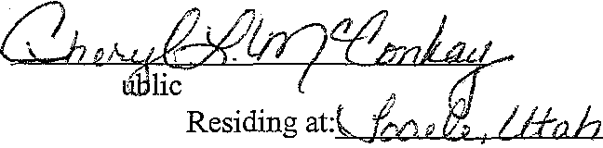a Utab corporation and managing member of Fieldstone Partners, L.L.C.

NotaryP My Commission Expires:
(_g I/j JO;t.
r I

BYLAWS
OF
ASPENGLEN AT SUN MEADOW
HOMEOWNERS ASSOCIATION
A Non-Profit Corporation of the State of Utah

Pursuant to the provisions of the Utah Non-Profit Corporations Act, the Board of Trustees of the Aspenglen at Sun Meadow Homeowners Association, Inc. hereby adopt the following By-Laws of the Aspenglen at Sun Meadow Homeowners Association, Inc.

ARTICLE I
NAME AND PRINCIPAL OFFICE

l.l Name. The name of the corporation is "Aspenglen at Sun Meadow
Homeowners Association, Inc." and it is referred to below as the "Association".

1.2 Offices. The office of the Association will be in Summit County, Utah.

ARTICLE II MEMBERS AND MEETINGS

2.1 Membership. The Members of the Association shall be the owners of Lots in Aspenglen at Sun Meadow, Summit County, Utah. Membership is deemed an appurtenance to each Lot, and shall pass automatically to the owner of each Lot upon conveyance of title.

2.2 Annual Meetings. The annual meeting of the Members of the Association shall be held on the first Monday of February at 6:00 at the offices of the Association, beginning in the year following the year in which the Association is incorporated. The Board of Trustees may designate some other time, date and place for the annual meeting by giving proper notice of the change in advance of the meeting. The purpose of the annual meeting is the election of Officers and Trustees, and to consider such other business that comes before the meeting. If the Trustees are not elected at the annual meeting, the existing Trustees shall continue to serve until their successors are named in a special meeting. The Trustees may change the date, time and place of the annual meeting as they see fit by formal resolution.

2.3 Special Meetings. Special meetings of the Members may be called by the Board of Trustees or by the President as they see fit, or by the Members of the Association representing not less than 51% of the total voting power within the Association. Any notice of special meeting shall state the time, place, and date of the meetings, and the matters to be considered at that meeting. When a special meeting is called by the Members of the Association, the notice shall be in writing, and delivered to the President.

(}i:l57..s829 8KD1335 PG0i363

2.4 Place of Meetings. All meetings will be held in Park City, Utah, unless the
Members have authorized a meeting to be held elsewhere by written waiver.

2.5 Notice of Meeting. The Board of Trustees shall cause written or printed notice of the date, time, place and purposes of all meetings of the Members to be sent to each of the Members not more than 60 but not less than 30 days prior to the meetings. Mailed notice is deemed delivered when it is deposited in the United States Mail, postage prepaid, addressed to the Member at the last known address. Each Member shall register his or her address with the Association, and it shall be the obligation of the Member to provide notice of any change of address to the Association. If no address is registered, the Association may
mail that Member's notice to the Secretary of the Association as the agent for the Member. Only one notice will be mailed for each Lot. If there are multiple owners of a Lot, they must designate one of them to receive the notice of the meeting on their behalf.

2.6 Members of Record. Upon purchasing a Lot in the Subdivision, each Owner shall promptly furnish the Association with a copy of the deed or other instrument under which he or she acquired title to the Lot. For purposes of determining a quorum, determining the persons entitled to vote, and all other matters before a meeting of the Members, the Association may designate a record date, not more than 60 days nor less than 30 days prior to the meeting date to determine the Members entitled to notice and to vote at the meeting. If no record date has been fixed, the record date is deemed to be the date on which notice of the meeting was mailed to the Members. The persons appearing as Members as of the record date are deemed entitled to notice and to vote at the meeting. Persons who become Members subsequent to the record date, or whose ownership is not registered with the Association until subsequent to the record date shall not be entitled to notice, shall not be counted in comprising a quorum, and shall not be entitled to vote at the meeting. This shall
not preclude a person who acquires his or her Membership subsequent to the record date from voting the interest of his predecessor under a written proxy.

2.7 Quorum. At any meeting of the Members, the presence of Members, in person or by proxy, holding the right to cast at least 51% of the total votes of the Association shall constitute a quorum for the transaction of business. In the event that a quorum is not present at a meeting, the Members present, in person or by proxy, though less than a quorum, may continue the meeting to a later date set by those Members present within 30 days. Notice of the continued meeting will be sent to the Members providing at least 5 days notice of the new meeting. At any continued meeting, a quorum will be deemed to exist comprised of
those Members present in person or by proxy at the re-convened meeting.

2.8 Proxies. At each meeting of the Members, each Member entitled to cast a vote shall be entitled to vote in person or by written proxy. All proxies must be in writing, signed by the Member as shown on the records of the Association. When a Membership is jointly held, the proxy must be signed by all of the joint owners of the Membership. Proxies must be presented to the Secretary of the Meeting at the beginning of the meeting for purposes

Salt!..ake-118637.1 0020472-00001 2

of determining a quorum. The secretary will make an entry of proxies in the minutes of the meeting.

2.9 Voting Rights. With respect to each matter presented to the Members, including the election of Trustees, each Member will be entitled to cast one vote for each Lot that he or she owns, except that Fieldstone Partners, L.L.C., or its assigns will be entitled to cast three votes for each Lot (including Lots anticipated on the Additional Property as that
term is defined in the Declaration of Covenants, Conditions, and Restrictions for Aspenglen at
Sun Meadow) that it owns. Lots with multiple owners will be entitled to only one vote for that Lot, and in the event that the multiple owners of that Lot are not able to agree on how to cast the vote, no vote will be cast. If only one of the multiple owners is present at the meeting, the other owners are deemed to have consented to that owner voting the interests of that Lot. fu the event of Lots held subject to Trust Deeds or Mortgages, the Trustor or Mortgagor will be entitled to vote, and the Lender shall have no right to vote; provided however that when a Lender has taken possession of any Lot, the Lender shall be deemed to have succeeded to the interest of the Trustor or Mortgagor, and shall then be entitled to cast that vote.

2.10 Simple Majority, Unless a greater vote is required by the Declaration of Covenants, Conditions and Restrictions for Aspenglen at Sun Meadow, any matter placed before the Members for a vote shall pass if there is an affirmative vote of the majority of the votes entitled to be cast by Members present at the meeting (and there is a quorum present). Election of Trustees will be by secret ballot. Other matters may be voted by secret ballot or by show of hands or such other means as the Officer conducting the meeting shall determine.

2.11 Waiver of Irregularities. Any inaccuracies, irregularities, or errors in any call for a meeting or notice of meeting, inaccuracies or irregularities in the determination of a quorum or acceptance of proxies are deemed waived unless there is a objection stated at the meeting prior to the vote being taken.

2.12 fuformal Action. Any act which is required to be taken or approved at a meeting may be taken or approved without a formal meeting if Members holding a majority of the total voting power within the Association consent to the action in writing prior to the
action being taken. The Members may hold meetings for which formal notice was not given if the Members waive notice prior to the meeting.

ARTICLE ill
BOARD OF TRUSTEES

3.1 General Powers. The Board of Trustees shall have authority to manage and control the property and affairs of the Association. The Board of Trustees may exercise all powers conferred upon them by law, by the Articles offucorporation, by these By-Laws, or the Declaration of Covenants, Conditions and Restrictions for Aspenglen at Sun Meadow,

Salt:La.ke-118637.1 0020472-00001 3

(.'iCr57..:5829 £.KD1335 Ps0i365

provided however, that those powers which are specifically reserved to the Members by law or by the Articles of Incorporation shall be exercised only by the Members. The Board may delegate to the Officers, managers, or others such of its powers as are appropriately delegated.

3.2 Number and Tenure. There shall be three Members of the Board of Trustees until the first annual meeting of the Members. Thereafter there shall be five members of the Board of Trustees. They shall serve until the next annual meeting in which Trustees are elected, and shall continue to serve until their successors have been elected and
assumed office. Immediately after the election of the Board of Trustees by the Members at the first annual meeting, the Trustees shall, by drawing Lots, divide themselves into terms of one, two and three years. Thereafter, at each annual meeting, only those Trustees whose terms
have expired will stand for election. Trustees need not be residents of the State of Utah.

3.3 Board Meetings. The Board of Trustees shall have at least one meeting per year, which shall be within the 90 days preceding the Annual Meeting of Members for the purpose of setting the agenda for that meeting. The Trustees may meet as often as they see fit, and as required by law or the Articles for purposes of approving annual reports, tax returns, and similar matters. Special meetings may be called by the President or by a majority of the Board by giving notice to the other Board members. Notice of Board meetings will be given
in writing or by telephone not more than 15 days, and not less than 5 days prior to the date of
the meeting.

3.4 Quorum. A quorum at a Board meeting will consist of a simple majority of the Board. Board members may be counted as present if they are participating in the meeting by telephone. No proxies will be given among Board members. Actions of the Board may
only be taken by formal action of the Board, and no individual Trustee shall have the authority to act on behalf of the Association.

3.5 Deadlock. In the event of a deadlock on the Board, the Board shall immediately call for a special meeting of the Members and, at the direction of the Chairman of the Board, either call for the election of a new Board, or submit the matter to the Members for determination.

3.6 Compensation. The Board of Trustees shall serve without compensation, provided that their reasonable out of pocket expenses for Association business, including the costs of attending Board meetings, may be reimbursed by the Association.

3.7 Resignation or Removal. Any Trustee may resign at any time. Any Trustee may be removed prior to the end of his or her term of office by an affirmative vote of Members holding at least 75% of the total voting power of the Association at a regular or special meeting called for that purpose.

3.8 Vacancies. Vacancies on the Board of Trustees will be filled by appointment of a successor by the remainder of the Board, provided that any such appointee will be confirmed 9r rejected at the next regular meeting of the Members. Any such Trustee is to fill the balance of the vacant term which he or she has filled, and will stand for election at the expiration of that term.

3.9 Informal Action by Trustees. The Trustees may take any action they could take in a formal meeting without a formal meeting, provided that the action is authorized in advance in writing signed by a majority of the Board, and further provided that all of the Trustees must have been given an opportunity to approve or reject the action. The Trustees may waive notice of meetings by signing written waivers at the time of the meeting. Minutes of all Board meetings will be kept, and when a meeting is held without prior notice, the minutes will reflect the written waiver of notice.

ARTICLEN OFFICERS

4.1 Number. The Officers ofthe Association shall consist of at least a President, Vice President, and a Secretary/Treasurer. The Board may establish such other Officers as it deems appropriate.

4.2 Appointment. Tenure. The Officers of the Association will be appointed by the Board of Trustees at their annual meeting, and all Officers will serve at the pleasure ofthe Board and may be removed by a majority vote of the Board in a meeting called for that purpose.

4.3 Duties of the President. The President shall preside at meetings of the Board of Trustees and at meetings of Members. He shall sign, on behalf of the Association, all legal documents approved by the Board, including deeds and mortgages and other contracts. The President shall supervise and be primarily responsible for the day to day operation of the Association's affairs, including the firing and termination of employees and subordinates. The President shall perform such other duties as assigned by the Board.

4.4 Duties of the Vice Presidents. One or more Vice Presidents will perform
the duties of the President if the President is not available, and shall perform such other duties as designated by the Board.

4.5 Duties of the Secretarv/Treasurer. The Secretary/Treasurer is responsible to keep accurate records of the Members of the Association and the transfer of their interests to others, to keep minutes at the meetings of the Association Members and the Trustees, and cause notice of any meetings to be issued as called for in these By-Laws, to file annual reports, and to perform all other assignments of the Board.

4.6 Compensation. The Officers will serve without compensation, provided
that their reasonable out of pocket expenses in performing their duties for the Association will be reimbursed. The Board may fix such other compensation as it finds appropriate given the responsibility of the Officers.

ARTICLEV INDEMNIFICATION

5.1 Indenmification Against Third Partv Actions. The Association shall defend and indemnify the Officers and Trustees against all actions, claims, and suits brought by third parties against them individually which arise from the exercise of their obligations and duties as Officers and Trustees. This shall include all civil, administrative, criminal, or investigative actions whether brought by an individual or a governmental agency. The indenmification
shall extend to the payment of reasonable attorneys fees incurred in the defense of such action, including fees for independent counsel, and the payment of any fine, settlement, or judgement. This indemnity is limited in scope to those acts or omissions arising from the good faith exercise of the authority of the office held, or the discharge of the duties as a Trustee on behalf of the Association.

5.2 Indemnification Against Member Actions. The Association shall defend and indemnify the Officers and Trustees against all actions, claims, and suits brought by Members of the Association against them individually which arise from the exercise of their obligations and duties as Officers and Trustees. This shall include all civil, administrative, criminal, or investigative actions whether brought by an individual or a governmental agency. The indemnification shall extend to the payment of reasonable attorneys fees incurred in the defense of such action, including fees for independent counsel, and the payment of any fine, settlement, or judgment. This indenmity is limited in scope to those acts or omissions arising from the good faith exercise ofthe authority of the office held, or the discharge of the duties
as a Trustee on behalf of the Association.

5.3 Request For Indenmification. When any officer, Trustee or employee of the Association receives notice of any action referred to above, he or she must give notice to the President and to the Board of Trustees, stating the nature of the claim, the claimant, and providing all pertinent information about the claim. The Board, in the case of an action
against an officer or employee, or against a single Trustee, may vote to indemnify the officer, employee or Trustee. In the event that the action is against the Board of Trustees as a whole, or names more than a single Trustee individually, and the claim is entirely covered by and within the policy limits of the Association's insurance coverage, the Board may vote to indemnify itself and the individuals named. In the event that the claim exceeds the limits of any insurance coverage, or is not covered, the Board may not agree to indemnify itself without presenting the matter to the Association for a vote at a special meeting called for that purpose.

Saltl.ake-118637.1 002C472·00001 6
C iC:t573829 Br-:01335 Pr.;Oi368

5.4 Liability Insurance. The Board shall cause the Association to purchase liability insurance in an amount not less than $2 million or such greater amount as the Board, at its discretion, may determine to cover general liability of the Association and to specifically cover the indemnity obligations described above.

ARTICLE VI AMENDMENT

6.1 Amendment. These By-Laws may be amended by the Members of the Association from time to time as the Members see fit by a majority vote at a meeting called for that purpose.

Adopted as of this 17m day of VtJ<..')"" , 2000.

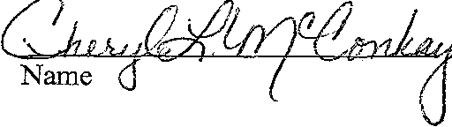Attest:

Secretary

Salti...ake-118637.1 0020472-00001 7
Name
President

ARTICLES OF INCORPORATION
for
ASPENGLEN AT SUN MEADOW HOMEOWNERS ASSOCIATION

A Non-Profit Corporation of the State of Utah

We the undersigned Incorporators, being natural persons over the age of 18 years, execute these Articles of Incorporation to form and establish a not-for-profit corporation under the provisions of the Utah Business Corporations Act, Section 16-6-1 et seq. of the Utah
Code, and adopt the following Articles of Incorporation:

1. Name. The name of the corporation is Aspenglen at Sun Meadow
Homeowners Association, Inc.

2. Duration. The duration of the corporation shall be perpetual, unless dissolved by the action of the corporation or by operation of law.

3. Purposes. The purposes of the corporation are to function as the homeowners association for Silver Summit Neighborhoods 3 and 4located in Sunnnit
County, Utah, and to enforce the covenants, conditions, and restrictions on the lots within that subdivision as set forth in the Declaration of Covenants, and to provide the other services, and perform all of the other functions set forth in the Declaration of Covenants as may become desirable or necessary for the benefit of the members. The corporation shall have all powers, rights, and privileges available to non-profit corporations under the laws of the State of Utah.

4. Membership. The Members of the corporation shall be the owners oflots in the Silver Summit Neighborhoods 3 and 4, Sununit County, Utah. Membership is deemed an appurtenance to each lot, and shall pass automatically to the owner of that lot upon
conveyance of title. The corporation shall not have stock or issue shares.

5. Voting Rights. Each Member is entitled to cast one vote for each lot he or she owns on all matters presented to the Members for approval, except that Fieldstone Partners, L.L.C., or its assigns is entitled to cast three votes for each lot that it owns. In the election of Trustees, Members may accumulate their votes.

6. Effect of Declaration of Covenants. Conditions and Restrictions. The Aspenglen at Sun Meadow Homeowners Association, Inc. shall operate in a marmer consistent with the Declaration of Covenants, Conditions and Restrictions for Silver Summit Phase 3 recorded against each lot in the Silver Summit Subdivision Phase 3 (the "Initial Property"), and subsequent phases of the Entire Property notwithstanding any inconsistent provision in these Articles or any Bylaws of the corporation.

7. Recistered Agent. The initial registered agent of the corporation is:

Mike Stewart - Fieldstone Homes, Inc.
6965 Union Park Center, #310
Midvale, UT 84047

Acceptance of Appointment

I, Mike Stewart, hereby accept the appointment as the registered agent for Aspenglen at Sun Meadow Homeowners Association, Inc.

Name

8. Bylaws. The Board of Trustees will adopt Bylaws consistent with these Articles at its first meeting. Thereafter, Bylaws may be adopted, amended, or repealed by the vote of the Members.

9. Principal Place of Business. The principal place of business of the corporation, and its initial offices are located at: 6965 Union Park Ave, Suite 310, Midvale, Utah 84047. The corporation may establish such other offices and locations as it deems appropriate for the operation of its business. The mailing address for the corporation is the same.

10. Board of Trustees. There will initially be three Trustees of the corporation. The initial Board of Trustees, who will serve until the election of officers and Trustees at the first aunual Members meeting, are:

Name Address

Mike Stewart Fieldstone Homes, Inc.
6965 Union Park Center, #310
Midvale, UT 84047

Glen Schippers Fieldstone Homes, Inc.
6965 Union Park Center, #310
Midvale, UT 84047

Cheryl McConkay Fieldstone Homes, Inc.
6965 Union Park Center, #310
Midvale, UT 84047

Salt.I...ake-121349.1 0020472-00001 2

00573829 !:);:.01335 F'&i}i371

The Trustees will elect one of them to act as Chairman until the first annual Members meeting.

11. Officers. The initial officers of the corporation are:

Mike Stewart Glen Schippers Cheryl McConkay
President
Vice President
Secretary/Treasurer

Officers serve at the pleasure of the Board of Trustees. The addresses of the officers are stated in paragraph 9.

12. Annual Meeting. The annual meeting of Members will be held on the first Monday in February at the offices of the corporation at the hour of 6:00p.m., or at such other time or place as may be stated in the notice of annual meeting.

13. Limitations on Liability. The Officers, Trustees, and Members ofthe corporation shall not be held personally liable for the debts and obligations of the corporation.

14. Incorporators. The three incorporators of the corporation are: Name Address
Mike Stewart Fieldstone Homes, Inc.
6965 Union Park Center, #310
Midvale, UT 84047

Glen Schippers Fieldstone Homes, Inc.
6965 Union Park Center, #310
Midvale, UT 84047

Cheryl McConkay Fieldstone Homes, Inc.
6965 Union Park Center, #310
Midvale, UT 84047

15. Amendment. These Articles of Incorporation may be amended from time to time as authorized by the shareholders and as permitted by law.

Sald..ake-121349.1 0020472-00001 3 J·Ci57..:>829 SK01335 Pe0i372

Wherefere the Incorporators have executed and verified these Articles this /7"11:1
day of Jt.l'-''1' , 2000.

Name

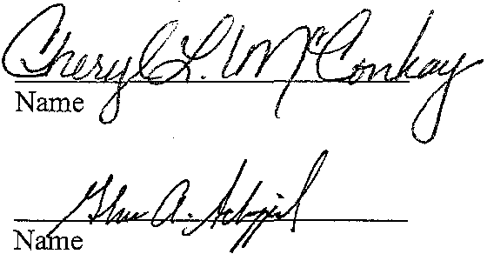

STATE OF UTAH )
:ss
COUNTY OF SALT LAKE )
Notary Public
CHERYL l.McCONKAY
294 Durocher Lane
Tooele, Utah 84074
My Commission Expires
June 11, 2002
State of Utah

On the 1.2!!::.day;.; , 2000, the foregoing instrument was acknowledged and verified before me by 3>ad ,who personally appeared before me, and
being by me duly sworn declared under penalty of peijury that he is one of the incorporators
of Aspenglen at Sun Meadow Homeowners Association, Inc., and that he signed the foregoing Articles of Incorporation of Aspenglen at Sun Meadow Homeowners Association, Inc., and that the statements contained therein are true and correct.

IN WITNESS WHEREOF, I have set my hand and seal this day July

2000.

My Commission Expires:

Not B lie . , . Residing at: \, {r,p(!p, 1/b.h
Guh

C CI5 BK01335 Pc;Oi373

STATE OF UTAH )
:ss
COUNTY OF SALT LAKE )

On the day of 2000, the foregoing instrument was acknowledged and verified before me by , who personally appeared before me, and being by me duly sworn declared under penalty of peijury that he is one of the incorporators of Aspenglen at Sun MeadowHomeowners Association, Inc., and that he signed the foregoing Articles of Incorporation of Aspenglen at Sun Meadow Homeowners Association, Inc., and that the statements contained therein are true and correct.

2000.
IN WITNESS WHEREOF, I have set my hand and seal this , day of _

My Commission Expires:
Notary Public
Residing at: _

STATE OF UTAH )
:ss
COUNTY OF SALT LAKE )

On the day of , 2000, the foregoing instrument was acknowledged and verified before me by who personally appeared before me, and being by me duly sworn declared under penalty ofpeijury that he/she is one of the incorporators of the Aspenglen at Sun Meadow Homeowners Association, Inc., and that he/she signed the foregoing Articles of Incorporation of Aspenglen at Sun Meadow Homeowners Association, Inc., and that the statements contained therein are true and correct.

2000.
IN WITNESS WHEREOF, I have set my hand and seal this __, day of _

Notary Public
Residing at: _

My Commission Expires: _

BYLAWS
OF
ASPENGLEN AT SUN MEADOW HOMEOWNERS ASSOCIATION
A Non-Profit Corporation ofthe State of Utah

Pursuant to the provisions of the Utah Non-Profit Corporations Act, the Board of Trustees of the Aspenglen at Sun Meadow Homeowners Association, Inc. hereby adopt the following By-Laws of the Aspenglen at Sun Meadow Homeowners Association, Inc.

ARTICLE I
NAME AND PRINCIPAL OFFICE

1.1 Name. The name of the corporation is "Aspenglen at Sun Meadow
Homeowners Association, Inc." and it is referred to below as the "Association".

1.2 Offices. The office of the Association will be in Summit County, Utah.

ARTICLE II MEMBERS AND MEETINGS

2.1 Membership. The Members of the Association shall be the owners of Lots in Aspenglen at Sun Meadow, Summit County, Utah. Membership is deemed an appurtenance to each Lot, and shall pass automatically to the owner of each Lot upon conveyance of title.

2.2 Aunual Meetings. The armual meeting of the Members of the Association shall be held on the frrst Monday of February at 6:00 at the offices of the Association, beginning in the year following the year in which the Association is incorporated. The Board of Trustees may designate some other time, date and place for the armual meeting by giving proper notice of the change in advance of the meeting. The purpose of the annual meeting is the election of Officers and Trustees, and to consider such other business that comes before the meeting. If the Trustees are not elected at the armual meeting, the existing Trustees shall continue to serve until their successors are named in a special meeting. The Trustees may change the date, time and place of the armual meeting as they see fit by formal resolution.

2.3 Special Meetings. Special meetings of the Members maybe called by the Board of Trustees or by the President as they see fit, or by the Members of the Association representing not less than 51% of the total voting power within the Association. Any notice of special meeting shall state the time, place, and date of the meetings, and the matters to be considered at that meeting. When a special meeting is called by the Members of the Association, the notice shall be in writing, and delivered to the President.

()i:S 5 ..-." ..:j; 829 BKO 1335 f'e!)1375

2.4 Place of Meetings. All meetings will be held in Park City, Utah, unless the
Members have authorized a meeting to be held elsewhere by written waiver.

2.5 Notice of Meeting. The Board of Trustees shall cause written or printed notice of the date, time, place and purposes of all meetings of the Members to be sent to each of the Members not more than 60 but not less than 30 days prior to the meetings. Mailed notice is deemed delivered when it is deposited in the United States Mail, postage prepaid, addressed to the Member at the last known address. Each Member shall register his or her address with the Association, and it shall be the obligation of the Member to provide notice of any change of address to the Association. If no address is registered, the Association may
mail that Member's notice to the Secretary of the Association as the agent for the Member. Only one notice will be mailed for each Lot. If there are multiple owners of a Lot, they must designate one of them to receive the notice ofthe meeting on their behalf.

2.6 Members of Record. Upon purchasing a Lot in the Subdivision, each Owner shall promptly furnish the Association with a copy of the deed or other instrument under which he or she acquired title to the Lot. For purposes of determining a quorum, determining the persons entitled to vote, and all other matters before a meeting of the Members, the Association may designate a record date, not more than 60 days nor less than 30 days prior to the meeting date to determine the Members entitled to notice and to vote at the meeting. If no record date has been fixed, the record date is deemed to be the date on which notice of the meeting was mailed to the Members. The persons appearing as Members as of the record date are deemed entitled to notice and to vote at the meeting. Persons who become Members subsequent to the record date, or whose ownership is not registered with the Association until subsequent to the record date shall not be entitled to notice, shall not be counted in comprising a quorum, and shall not be entitled to vote at the meeting. This shall
not preclude a person who acquires his or her Membership subsequent to the record date from voting the interest of his predecessor under a written proxy.

2.7 Quorum. At any meeting of the Members, the presence of Members, in person or by proxy, holding the right to cast at least 51% of the total votes of the Association shall constitute a quorum for the transaction of business. In the event that a quorum is not present at a meeting, the Members present, in person or by proxy, though less than a quorum, may continue the meeting to a later date set by those Members present within 30 days. Notice of the continued meeting will be sent to the Members providing at least 5 days notice of the new meeting. At any continued meeting, a quorum will be deemed to exist comprised of
those Members present in person or by proxy at the re-convened meeting.

2.8 Proxies. At each meeting of the Members, each Member entitled to cast a vote shall be entitled to vote in person or by written proxy. All proxies must be in writing, signed by the Member as shown on the records of the Association. When a Membership is jointly held, the proxy must be signed by all of the joint owners of the Membership. Proxies must be presented to the Secretary of the Meeting at the beginning of the meeting for purposes

Saltl...alre-118637.1 0020472-00001 2

00573829 f\Ki)1335 Pc;Oi.-376

of determining a quorum. The secretary will make an entry of proxies in the minutes of the meeting.

2.9 Voting Rights. With respect to each matter presented to the Members, including the election of Trustees, each Member will be entitled to cast one vote for each Lot that he or she owns, except that Fieldstone Partners, L.L.C., or its assigns will be entitled to cast three votes for each Lot (including Lots anticipated on the Additional Property as that
term is defined in the Declaration of Covenants, Conditions, and Restrictions for Aspenglen at
Sun Meadow) that it owns. Lots with multiple owners will be entitled to only one vote for that Lot, and in the event that the multiple owners of that Lot are not able to agree on how to cast the vote, no vote will be cast. If only one of the multiple owners is present at the meeting, the other owners are deemed to have consented to that owner voting the interests of that Lot. In the event of Lots held subject to Trust Deeds or Mortgages, the Trustor or Mortgagor will be entitled to vote, and the Lender shall have no right to vote; provided however that when a Lender has taken possession of any Lot, the Lender shall be deemed to have succeeded to the interest of the Trustor or Mortgagor, and shall then be entitled to cast that vote.

2.10 Simple Majority. Unless a greater vote is required by the Declaration of Covenants, Conditions and Restrictions for Aspenglen at Sun Meadow, any matter placed before the Members for a vote shall pass if there is an affirmative vote of the majority of the votes entitled to be cast by Members present at the meeting (and there is a quorum present). Election of Trustees will be by secret ballot. Other matters may be voted by secret ballot or by show of hands or such other means as the Officer conducting the meeting shall determine.

2.11 Waiver of Irregularities. Any inaccuracies, irregularities, or errors in any call for a meeting or notice of meeting, inaccuracies or irregularities in the determination of a quorum or acceptance of proxies are deemed waived unless there is a objection stated at the meeting prior to the vote being taken.

2.12 Informal Action. Any act which is required to be taken or approved at a meeting may be taken or approved without a formal meeting if Members holding a majority of the total voting power within the Association consent to the action in writing prior to the
action being taken. The Members may hold meetings for which formal notice was not given if
the Members waive notice prior to the meeting.

ARTICLE ill
BOARD OF TRUSTEES

3.1 General Powers. The Board of Trustees shall have authority to manage and control the property and affairs of the Association. The Board of Trustees may exercise all powers conferred upon them by law, by the Articles of Incorporation, by these By-Laws, or
the Declaration of Covenants, Conditions and Restrictions for Aspenglen at Sun Meadow,

Salti..ake-118637.1 0020472-00001 3 (1()573829 BK01335 PG0i37?

provided however, that those powers which are specifically reserved to the Members by law or by the Articles of Incorporation shall be exercised only by the Members. The Board may delegate to the Officers, managers, or others such of its powers as are appropriately delegated.

3.2 Number and Tenure. There shall be three Members of the Board of Trustees until the first annual meeting of the Members. Thereafter there shall be five members of the Board of Trustees. They shall serve until the next annual meeting in which Trustees are elected, and shall continue to serve until their successors have been elected and
assumed office. Immediately after the election of the Board of Trustees by the Members at the first annual meeting, the Trustees shall, by drawing Lots, divide themselves into terms of one, two and three years. Thereafter, at each annual meeting, only those Trustees whose terms
have expired will stand for election. Trustees need not be residents of the State of Utah.

3.3 Board Meetings. The Board of Trustees shall have at least one meeting per year, which shall be within the 90 days preceding the Annual Meeting of Members for the purpose of setting the agenda for that meeting. The Trustees may meet as often as they see fit, and as required by law or the Articles for purposes of approving annual reports, tax returns,
and similar matters. Special meetings may be called by the President or by a majority of the
Board by giving notice to the other Board members. Notice of Board meetings will be given in writing or by telephone not more than 15 days, and not less than 5 days prior to the date of the meeting.

3.4 Quorum. A quorum at a Board meeting will consist of a simple majority of the Board. Board members may be counted as present if they are participating in the meeting by telephone. No proxies will be given among Board members. Actions of the Board may
only be taken by formal action of the Board, and no individual Trustee shall have the authority to act on behalf of the Association.

3.5 Deadlock. In the event of a deadlock on the Board, the Board shall immediately call for a special meeting of the Members and, at the direction of the Chairman of the Board, either call for the election of a new Board, or submit the matter to the Members for determination.

3.6 Compensation. The Board of Trustees shall serve without compensation, provided that their reasonable out of pocket expenses for Association business, including the costs of attending Board meetings, may be reimbursed by the Association.

3.7 Resignation or Removal. Any Trustee may resign at any time. Any Trustee may be removed prior to the end of his or her term of office by an affirmative vote of Members holding at least 75% of the total voting power of the Association at a regular or special meeting called for that purpose.

3.8 Vacancies. Vacancies on the Board of Trustees will be filled by appointment of a successor by the remainder of the Board, provided that any such appointee will be confirmed 9r rejected at the next regular meeting of the Members. Any such Trustee is to fill the balance of the vacant term which he or she has filled, and will stand for election at the expiration of that term.

3.9 Informal Action by Trustees. The Trustees may take any action they could take in a formal meeting without a formal meeting, provided that the action is authorized in advance in writing signed by a majority of the Board, and further provided that all of the Trustees must have been given an opportunity to approve or reject the action. The Trustees may waive notice of meetings by signing written waivers at the time of the meeting. Minutes of all Board meetings will be kept, and when a meeting is held without prior notice, the minutes will reflect the written waiver of notice.

ARTICLEN OFFICERS

4.1 Number. The Officers of the Association shall consist of at least a President, Vice President, and a Secretary/Treasurer. The Board may establish such other Officers as it deems appropriate.

4.2 Appointment. Tenure. The Officers of the Association will be appointed by the Board of Trustees at their annual meeting, and all Officers will serve at the pleasure of the Board and maybe removed by a majority vote of the Board in a meeting called for that purpose.

4.3 Duties of the President. The President shall preside at meetings of the Board of Trustees and at meetings of Members. He shall sign, on behalf of the Association, all legal documents approved by the Board, including deeds and mortgages and other contracts. The President shall supervise and be primarily responsible for the day to day operation of the Association's affairs, including the firing and termination of employees and subordinates. The President shall perform such other duties as assigned by the Board.

4.4 Duties of the Vice Presidents. One or more Vice Presidents will perform
the duties of the President if the President is not available, and shall perform such other duties as designated by the Board.

4.5 Duties of the Secretarv/Treasurer. The Secretary/Treasurer is responsible to keep accurate records of the Members of the Association and the transfer of their interests to others, to keep minutes at the meetings of the Association Members and the Trustees, and cause notice of any meetings to be issued as called for in these By-Laws, to file annual reports, and to perform all other assigmnents of the Board.

4.6 Compensation. The Officers will serve without compensation, provided
that their reasonable out of pocket expenses in performing their duties for the Association will be reimbursed. The Board may fix such other compensation as it finds appropriate given the responsibility of the Officers.

ARTICLEV INDEMNIFICATION

5.1 Indemnification Against Third Partv Actions. The Association shall defend and indemnify the Officers and Trustees against all actions, claims, and suits brought by third parties against them individually which arise from the exercise of their obligations and duties as Officers and Trustees. This shall include all civil, administrative, criminal, or investigative actions whether brought by an individual or a governmental agency. The indemnification
shall extend to the payment of reasonable attorneys fees incurred in the defense of such action,
including fees for independent counsel, and the payment of any fme, settlement, or judgement. This indemnity is limited in scope to those acts or omissions arising from the good faith exercise of the authority of the office held, or the discharge of the duties as a Trustee on behalf of the Association.

5.2 Indemnification Against Member Actions. The Association shall defend and indemnify the Officers and Trustees against all actions, claims, and suits brought by Members of the Association against them individually which arise from the exercise of their obligations and duties as Officers and Trustees. This shall include all civil, administrative, criminal, or investigative actions whether brought by an individual or a governmental agency. The indemnification shall extend to the payment of reasonable attorneys fees incurred in the defense of such action, including fees for independent counsel, and the payment of any fine, settlement, or judgment. This indenmity is limited in scope to those acts or omissions arising from the good faith exercise of the authority of the office held, or the discharge of the duties
as a Trustee on behalf of the Association.

5.3 Request For Indenmification. When any officer, Trustee or employee of the Association receives notice of any action referred to above, he or she must give notice to the President and to the Board of Trustees, stating the nature of the claim, the claimant, and providing all pertinent information about the claim. The Board, in the case of an action against an officer or employee, or against a single Trustee, may vote to indemnify the officer, employee or Trustee. In the event that the action is against the Board of Trustees as a whole, or names more than a single Trustee individually, and the claim is entirely covered by and within the policy limits of the Association's insurance coverage, the Board may vote to indemnify itself and the individuals named. In the event that the claim exceeds the limits of any insurance coverage, or is not covered, the Board may not agree to indemnify itself without
presenting the matter to the Association for a vote at a special meeting called for that purpose.

5.4 Liability Insurance. The Board shall cause the Association to purchase liability insurance in an amount not less than $2 million or such greater amount as the Board,
at its discretion, may determine to cover general liability of the Association and to specifically cover the indemnity obligations described above.

ARTICLE VI AMENDMENT

6.1 Amendment. These By-Laws may be amended by the Members of the Association from time to time as the Members see fit by a majority vote at a meeting called for that purpose.

Adopted as of this ./?rN day of dJ..,y '2000.

Attest:
Name
President

&Name p /
Secretary

()()573829 3K01335 Ps0i381

ARTICLES OF INCORPORATION
for
ASPENGLEN AT SUN MEADOW HOMEOWNERS ASSOCIATION

A Non-Profit Corporation of the State of Utah

We the undersigned Incorporators, being natural persons over the age of 18 years, execute these Articles of Incorporation to form and establish a not-for-profit corporation under the provisions of the Utah Business Corporations Act, Section 16-6-1 et seq. ofthe Utah
Code, and adopt the following Articles of Incorporation:

1. Name. The name of the corporation is Aspenglen at Sun Meadow
Homeowners Association, Inc.

2. Duration. The duration of the corporation shall be perpetual, unless dissolved by the action of the corporation or by operation of law.

3. Purposes. The purposes of the corporation are to function as the homeowners association for Silver Summit Neighborhoods 3 and 4 located in Summit County, Utah, and to enforce the covenants, conditions, and restrictions on the lots within that
subdivision as set forth in the Declaration of Covenants, and to provide the other services, and perform all of the other functions set forth in the Declaration of Covenants as may become desirable or necessary for the benefit of the members. The corporation shall have all powers, rights, and privileges available to non-profit corporations under the laws of the State of Utah.

4. Membership. The Members of the corporation shall be the owners oflots in the Silver Summit Neighborhoods 3 and 4, Summit County, Utah. Membership is deemed an appurtenance to each lot, and shall pass automatically to the owner of that lot upon conveyance of title. The corporation shall not have stock or issue shares.

5. Voting Rights. Each Member is entitled to cast one vote for each lot he or she owns on all matters presented to the Members for approval, except that Fieldstone Partners, L.L.C., or its assigns is entitled to cast three votes for each lot that it owns. In the election of Trustees, Members may accumulate their votes.

6. Effect of Declaration of Covenants, Conditions and Restrictions. The Aspenglen at Sun Meadow Homeowners Association, Inc. shall operate in a manner consistent with the Declaration of Covenants, Conditions and Restrictions for Silver Sununit Phase 3 recorded against each lot in the Silver Sunnnit Subdivision Phase 3 (the "Initial Property"), and subsequent phases of the Entire Property notwithstanding any inconsistent provision in these Articles or any Bylaws of the corporation.

Z:)JJ573829 Br.:01335 PG0i382

7. Registered Agent. The initial registered agent of the corporation is:

Jyfike Stewart - Fieldstone Homes, Inc.
6965 Union Park Center, #310
Midvale, UT 84047

Acceptance of Appointment

I, Mike Stewart, hereby accept the appointment as the registered agent for Aspenglen at Sun Meadow Homeowners Association, Inc.

Name

8. Bylaws. The Board of Trustees will adopt Bylaws consistent with these Articles at its first meeting. Thereafter, Bylaws may be adopted, amended, or repealed by the vote ofthe Members.

9. Principal Place of Business. The principal place of business of the corporation, and its initial offices are located at: 6965 Union Park Ave, Suite 310, Midvale, Utah 84047. The corporation may establish such other offices and locations as it deems appropriate for the operation of its business. The mailing address for the corporation is the same.

10. Board of Trustees. There will initially be three Trustees of the corporation. The initial Board of Trustees, who will serve until the election of officers and Trustees at the first annual Members meeting, are:

Name Address

Mike Stewart Fieldstone Homes, Inc.
6965 Union Park Center, #310
Midvale, UT 84047

Glen Schippers Fieldstone Homes, Inc.
6965 Union Park Center, #310
Midvale, UT 84047

Cheryl McConkay Fieldstone Homes, Inc.
6965 Union Park Center, #310
Midvale, UT 84047

Salti...ake-121349.1 0020472·00001 2

The Trustees will elect one of them to act as Chairman until the first annual Members meeting.

11. Officers. The initial officers of the corporation are:

Mike Stewart Glen Schippers Cheryl McConkay
President
Vice President
Secretary/Treasurer

Officers serve at the pleasure of the Board of Trustees. The addresses ofthe officers are stated in paragraph 9.

12. Annual Meeting. The annual meeting of Members will be held on the first Monday in February at the offices of the corporation at the hour of 6:00p.m., or at such other time or place as may be stated in the notice of annual meeting.

13. Limitations on Liability. The Officers, Trustees, and Members of the corporation shall not be held personally liable for the debts and obligations of the corporation.

14. Incorporators. The three incorporators of the corporation are:

Address

Mike Stewart

Glen Schippers

Cheryl McConkay
Fieldstone Homes, Inc.
6965 Union Park Center, #310
Midvale, UT 84047

Fieldstone Homes, Inc.
6965 Union Park Center, #310
Midvale, UT 84047

Fieldstone Homes, Inc.
6965 Union Park Center, #310
Midvale, UT 84047

15. Amendment. These Articles of Incorporation may be amended from time to time as authorized by the shareholders and as permitted by law.

Saltl.ake-121349.1 0020472-00001
00576829 k01TI5 013%
3

Wherefere the Incorporators have executed and verified these Articles this h1U
day of J . <..y · , 2000. --
@
Name

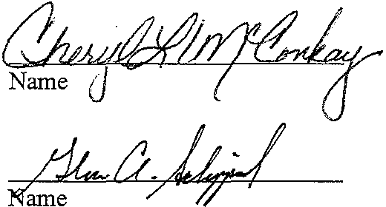

STATE OF UTAH )
:ss
COUNTY OF SALT LAKE )
Notary Public
CHERYLL. McCONKAY
294 Durocher Lane
Tooele, Utah 84074
My Commission Expires
June 11, 2002
State of Utah

On the 1:1!!:.day of I.fv /y . , 2000, the foregoing instrument was acknowledged and verified before me by mke ,.,iJ.frwad ,who personally appeared before me, and
being by me duly sworn declared under penalty of peljury that he is one of the incorporators
of Aspenglen at Sun Meadow Homeowners Association, Inc., and that he signed the foregoing Articles of Incorporation of Aspenglen at Sun Meadow Homeowners Association, Inc., and that the statements contained therein are true and correct.
IN WITNESS WHEREOF, I have set my hand and seal this day JIL/y
2000.

My Commission Expires:

()0573829 £, .:01335

Salti...ake-121349.1 0020472-00001 4

STATE OF UTAH )
:ss
COUNTY OF SALT LAKE )

On the day of , 2000, the foregoing instrument was acknowledged and verified before me by , who personally appeared before me, and being by me duly sworn declared under penalty of peijury that he is one of the incorporators of Aspenglen at Sun MeadowHomeowners Association, Inc., and that he signed the foregoing Articles of Incorporation of Aspenglen at Sun Meadow Homeowners Association, Inc., and that the statements contained therein are true and correct.

2000.
IN WITNESS WHEREOF, I have set my hand and seal this __, day of _

My Commission Expires:
Notary Public
Residing at: _

STATE OF UTAH )
:ss
COUNTY OF SALT LAKE )

On the day of , 2000, the foregoing instrument was acknowledged and verified before me by who personally appeared before me, and being byrne duly sworn declared under penalty ofpeijurythat he/she is one of the incorporators of the Aspenglen at Sun Meadow Homeowners Association, Inc., and that
he/she signed the foregoing Articles of Incorporation of Aspenglen at Sun Meadow
Homeowners Association, Inc., and that the statements contained therein are true and correct.

2000.
IN WITNESS WHEREOF, I have set my hand and seal this , day of _

Notary Public
Residing at: _

My Commission Expires: ---------

Salti..ake-121349.1 0020472-00001 5

005,&829 k01TI5P 1 6

EXHIBIT "A"

SILVER SUMMIT SUBDIVISION - PHASE 3 "INITIAL PROPERTY"

TWO PARCELS OF LAND LOCATED IN THE SOUTHEAST QUARTER OF SECTION 21
AND THE WEST HALF OF SECTION 22, BOTH WITHIN TOWNSHIP 1 SOUTH, RANGE
4 EAST, SALT LAKE BASE AND MERIDIAN, PARTICULARLY DESCRIBED AS FOLLOWS:

COMMENCING AT THE SOUTHEAST CORNER OF SECTION 21, TOWNSHIP 1 SOUTH, RANGE 4 EAST, SALT LAKE BASE AND MERIDIAN; THENCE NORTH 43°53'01" WEST, 934.96 FEET TO THE POINT OF BEGINNING THENCE NORTH 42°13'20" EAST, 1601.29 FEET; THENCE ALONG A CURVE TO THE LEFT, HAVING A RADIUS OF 545.00 FEET, THROUGH A CENTRAL ANGLE OF 78°18'10", A DISTANCE OF
744.82 FEET, SAID CURVE HAVING A CHORD OF SOUTH 15°47'16" EAST,
688.20 FEET TO A POINT OF TANGENCY; THENCE SOUTH 54°56'20" EAST,
26.68 FEET; THENCE ALONG A CURVE TO THE RIGHT, HAVING A RADIUS OF
15.00 FEET, THROUGH A CENTRAL ANGLE OF 93°40'00", A DISTANCE OF 24.52
FEET, SAID CURVE HAVING A CHORD OF SOUTH 08°06'20" EAST, 21.88 FEET
TO A POINT OF TANGENCY; THENCE SOUTH 38°43'40" WEST, 578.88 FEET;
THENCE ALONG A CURVE TO THE LEFT, HAVING A RADIUS OF 1583.23 FEET,
THROUGH A CENTRAL ANGLE OF 14°11'31", A DISTANCE OF 392.16 FEET, SAID
CURVE HAVING A CHORD OF SOUTH 31°37'54" WEST, 391.16 FEET TO A POINT
OF REVERSE CURVATURE; THENCE ALONG A CURVE TO THE RIGHT, HAVING A
RADIUS OF 536.09 FEET, THROUGH A CENTRAL ANGLE OF 09°06'08", A DISTANCE OF 85.17 FEET, SAID CURVE HAVING A CHORD OF SOUTH 29°05'13"
WEST, 85.08 FEET; THENCE NORTH 56°21'42" WEST 100.00 FEET; THENCE SOUTH 38°21'03" WEST 71.40 FEET; THENCE SOUTH 46°58'12" EAST 100.00
FEET; THENCE ALONG A CURVE TO THE RIGHT, HAVING A RADIUS OF 536.09
FEET, THROUGH CENTRAL ANGLE OF 34°26'32", A DISTANCE OF 322.26 FEET, SAID CURVE HAVING A CHORD OF SOUTH 60°15'03" WEST, 317.43 FEET;
THENCE NORTH 47°14'57" EAST 218.50 FEET; THENCE NORTH 00°04'27" EAST,
150.00 FEET; THENCE NORTH 58°30'19" WEST 220.00 FEET; THENCE SOUTH
69°35'56" WEST 130.96 FEET; THENCE SOUTH 59°07'20" WEST, 52.89 FEET;
THENCE NORTH 30°52'40" WEST, 300.96 FEET TO THE POINT OF BEGINNING.

COMMENCING AT THE SOUTHEAST CORNER OF SECTION 21, TOWNSHIP 1 SOUTH, RANGE 4 EAST, SALT LAKE BASE AND MERIDIAN; THENCE NORTH 28°54'43" EAST, 1411.70 FEET TO THE POINT OF BEGINNING; THENCE NORTH 54°56'20" WEST, 33.09 FEET; THENCE ALONG A CURVE TO THE RIGHT, HAVING A RADIUS OF 475.00 FEET, THROUGH A CENTRAL ANGLE OF 78°18'11", A DISTANCE OF
649.16 FEET, SAID CURVE HAVING A CHORD OF NORTH 15°47'14" WEST,
599.80 FEET TO A POINT OF TANGENCY; THENCE NORTH 23°21'51" EAST
229.49 FEET; THENCE ALONG A CURVE TO THE LEFT, HAVING A RADIUS OF
683.57 FEET, THROUGH A CENTRAL ANGLE OF 53°48'11", A DISTANCE OF
641.90 FEET, SAID CURVE HAVING A CHORD OF NORTH 03°32'15" WEST,
618.57 FEET TO A POINT OF TANGENCY; THENCE NORTH 30°26'20" WEST,
310.47 FEET; THENCE NORTH 59°33'40" EAST, 265.94 FEET; THENCE SOUTH
30°24'51" EAST, 21.07 FEET; THENCE SOUTH 19°31'10" EAST, 498.79 FEET;
THENCE SOUTH 10°45'20" EAST, 275.92 FEET; THENCE SOUTH 02°03'44"
EAST, 329.57 FEET; THENCE SOUTH 27°00'35" EAST, 250.60 FEET; THENCE Continued on next page

(}()?.S8?9 f':t-.:01335 Pe0i337

EXHIBIT "A" - continued

SOUTH 21°01'56" WEST, 190.73 FEET; THENCE SOUTH 54°30'50" EAST, 39.89
FEET; THENCE ALONG A CURVE TO THE RIGHT, HAVING A RADIUS OF 2980.84
FEET, THROUGH A CENTRAL ANGLE OF 05°17'59", A DISTANCE OF 275.72
FEET, SAID CURVE HAVING A CHORD OF SOUTH 36°04'40" WEST, 275.62 FEET
TO A POINT OF TANGENCY; THENCE SOUTH 38°43'40" WEST, 112.60 FEET; THENCE ALONG A CURVE TO THE RIGHT, HAVING A RADIUS OF 15.00 FEET,
THROUGH A CENTRAL ANGLE OF 86°20'00", A DISTANCE OF 22.60 FEET, SAID CURVE HAVING A CHORD OF SOUTH 81°53'40" WEST, 20.52 FEET TO THE POINT OF BEGINNING.

()()573829 s .::J1335

EXHIBIT "B" - ENTIRE PROPERTY

SILVER SUMMIT SUBDIVISION - PHASE 3

TWO PARCELS OF LAND LOCATED IN THE SOUTHEAST QUARTER OF SECTION 21
AND THE WEST HALF OF SECTION 22, BOTH WITHIN TOWNSHIP 1 SOUTH, RANGE
4 EAST, SALT LAKE BASE AND MERIDIAN, PARTICULARLY DESCRIBED AS
FOLLOWS:

COMMENCING AT THE SOUTHEAST CORNER OF SECTION 21, TOWNSHIP 1 SOUTH, RANGE 4 EAST, SALT LAKE BASE AND MERIDIAN; THENCE NORTH 43°53'01" WEST, 934.96 FEET TO THE POINT OF BEGINNING THENCE NORTH 42°13'20" EAST, 1601.29 FEET; THENCE ALONG A CURVE TO THE LEFT, HAVING A RADIUS OF 545.00 FEET, THROUGH A CENTRAL ANGLE OF 78°18'10", A DISTANCE OF
744.82 FEET, SAID CURVE HAVING A CHORD OF SOUTH 15°47'16" EAST,
688.20 FEET TO A POINT OF TANGENCY; THENCE SOUTH 54°56'20" EAST,
26.68 FEET; THENCE ALONG A CURVE TO THE RIGHT, HAVING A RADIUS OF
15.00 FEET, THROUGH A CENTRAL ANGLE OF 93°40'00", A DISTANCE OF 24.52
FEET, SAID CURVE HAVING A CHORD OF SOUTH 08°06'20" EAST, 21.88 FEET
TO A POINT OF TANGENCY; THENCE SOUTH 38°43'40" WEST, 578.88 FEET;
THENCE ALONG A CURVE TO THE LEFT, HAVING A RADIUS OF 1583.23 FEET,
THROUGH A CENTRAL ANGLE OF 14°11'31", A DISTANCE OF 392.16 FEET, SAID
CURVE HAVING A CHORD OF SOUTH 31°37'54" WEST, 391.16 FEET TO A POINT
OF REVERSE CURVATURE; THENCE ALONG A CURVE TO THE RIGHT, HAVING A
RADIUS OF 536.09 FEET, THROUGH A CENTRAL ANGLE OF 09°06'08", A DISTANCE OF 85.17 FEET, SAID CURVE HAVING A CHORD OF SOUTH 29°05'13" WEST, 85.08 FEET; THENCE NORTH 56°21'42" WEST 100.00 FEET; THENCE SOUTH 38°21'03" WEST 71.40 FEET; THENCE SOUTH 46°58'12" EAST 100.00
FEET; THENCE ALONG A CURVE TO THE RIGHT, HAVING A RADIUS OF 536,09
FEET, THROUGH CENTRAL ANGLE OF 34°26'32", A DISTANCE OF 322.26 FEET,
SAID CURVE HAVING A CHORD OF SOUTH 60°15'03" WEST, 317.43 FEET;
THENCE NORTH 47°14'57" EAST 218.50 FEET; THENCE NORTH 00°04'27" EAST,
150.00 FEET; THENCE NORTH 58°30'19" WEST 220.00 FEET; THENCE SOUTH
69°35'56" WEST 130.96 FEET; THENCE SOUTH 59°07'20" WEST, 52.89 FEET; THENCE NORTH 30°52'40" WEST, 300.96 FEET TO THE POINT OF BEGINNING.

COMMENCING AT THE SOUTHEAST CORNER OF SECTION 21, TOWNSHIP 1 SOUTH, RANGE 4 EAST, SALT LAKE BASE AND MERIDIAN; THENCE NORTH 28°54'43" EAST, 1411.70 FEET TO THE POINT OF BEGINNING; THENCE NORTH 54°56'20" WEST, 33.09 FEET; THENCE ALONG A CURVE TO THE RIGHT, HAVING A RADIUS OF 475.00 FEET, THROUGH A CENTRAL ANGLE OF 78°18'11", A DISTANCE OF
649.16 FEET, SAID CURVE HAVING A CHORD OF NORTH 15°47'14" WEST,
599.80 FEET TO A POINT OF TANGENCY; THENCE NORTH 23°21'51" EAST
229.49 FEET; THENCE ALONG A CURVE TO THE LEFT, HAVING A RADIUS OF
683.57 FEET, THROUGH A CENTRAL ANGLE OF 53°48'11", A DISTANCE OF
641.90 FEET, SAID CURVE HAVING A CHORD OF NORTH 03°32'15" WEST,
618.57 FEET TO A POINT OF TANGENCY; THENCE NORTH 30°26'20" WEST,
310.47 FEET; THENCE NORTH 59°33'40" EAST, 265.94 FEET; THENCE SOUTH
30°24'51" EAST, 21.07 FEET; THENCE SOUTH 19°31'10" EAST, 498.79 FEET;
THENCE SOUTH 10°45'20" EAST, 275.92 FEET; THENCE SOUTH 02°03'44" Continued on next page

continued ...

EAST, 329.57 FEET; THENCE SOUTH 27°00'35" EAST, 250.60 FEET; THENCE SOUTH 21°01'56" WEST, 190.73 FEET; THENCE SOUTH 54°30'50" EAST, 39.89
FEET; THENCE ALONG A CURVE TO THE RIGHT, HAVING A RADIUS OF 2980.84
FEET, THROUGH A CENTRAL ANGLE OF 05°17'59", A DISTANCE OF 275.72
FEET, SAID CURVE HAVING A CHORD OF SOUTH 36°04'40" WEST, 275.62 FEET
TO A POINT OF TANGENCY; THENCE SOUTH 38°43'40" WEST, 112.60 FEET; THENCE ALONG A CURVE TO THE RIGHT, HAVING A RADIUS OF 15.00 FEET,
THROUGH A CENTRAL ANGLE OF 86°20'00", A DISTANCE OF 22.60 FEET, SAID CURVE HAVING A CHORD OF SOUTH 81°53'40" WEST, 20.52 FEET TO THE POINT OF BEGINNING.

AND

SILVER SUMMIT SUBDIVISION - PHASE 4

PARCEL OF LAND LOCATED IN THE SOUTHEAST QUARTER OF SECTION 21 AND THE WEST HALF OF SECTION 22, TOWNSHIP 1 SOUTH, RANGE 4 EAST, SALT LAKE BASE AND MERIDIAN, MORE PARTICULARLY DESCRIBED AS FOLLOWS:

BEGINNING AT THE SOUTHEAST CORNER OF SECTION 21, TOWNSHIP 1 SOUTH, RANGE 4 EAST, SALT LAKE BASE AND MERIDIAN; THENCE NORTH 89°40'52" WEST 262.42 FEET ALONG THE SECTION LINE TO A POINT OF THE ARC OF A
616.09 FOOT RADIUS CURVE TO THE LEFT, THE CENTER OF WHICH BEARS NORTH
14°19'40" WEST; THENCE NORTHEASTERLY ALONG THE ARC OF SAID CURVE, THROUGH A CENTRAL ANGLE OF 51008'30", A DISTANCE OF 549.92 FEET TO A POINT OF THE ARC OF A 1503.23 FOOT RADIUS CURVE TO THE RIGHT, THE
CENTER OF WHICH BEARS SOUTH 65°27'51" EAST; THENCE NORTHEASTERLY ALONG THE ARC OF SAID CURVE, THROUGH A CENTRAL ANGLE OF 14°11'31", A DISTANCE OF 372.34 FEET; THENCE NORTH 38°43'40" EAST 598.42 FEET; THENCE SOUTH 52°26'21" EAST 306.51 FEET TO A POINT OF THE ARC OF A
5699.58 FOOT RADIUS CURVE TO THE RIGHT, THE CENTER OF WHICH BEARS
SOUTH 37°33'39" WEST; THENCE SOUTHEASTERLY ALONG THE ARC OF SAID CURVE, THROUGH A CENTRAL ANGLE OF 3°30'00", A DISTANCE OF 348.17
FEET; THENCE SOUTH 48°56'21" EAST 92.50 FEET; THENCE SOUTH 48°54'52" EAST 708.35 FEET; THENCE NORTH 41°05'08" EAST 5.00 FEET; THENCE SOUTH
48°54'52" EAST 314.54 FEET TO THE SOUTH LINE OF SAID SECTION 22; THENCE NORTH 89°41'50" WEST 2071.12 FEET ALONG SAID SOUTH LINE TO THE POINT OF BEGINNING.

00573829 !\.:01335 Ps0i390

EXHIBIT ''C"

SILVER SUMMIT

DESIGN GUIDELINES
& DEVELOPMENT REGULATIONS

Prepared for

Silver Scott, LLC Affordable Housing Coalition, LLC Salt Lake City, Utah

Prepared by

R. Michael Kelly
Consultant Land Planner P.O. Box 469
Millville, Utah 84326

2 Junel998

()0573329 BK01335 PG0i391

TABLE OF CONTENTS

PROJECT OVERVIEW......................................................................................1
INTRODUCTION.............................................................................................!
EXISTING SITE CHARACTERISTICS............................................................. _ .....4

COMMUNITY DESIGN GUIDELINES  COMMUNITY CHARACTER... ... ... ... ... ... .. . ... ... .. . .. . ... ... ... ... ... ... | . .........................7
Overall Layout | 7
Individual Neighborhoods | 9
Open Space | 10
Visual Sensitivity | 10
Arhitectural Theme/General Overview | 10
Landscape Theme/General Overview | 10
DEVELOPMENT STANDARDS........................................................................ 12
Level of Service Standard 12
Availability of Public Facilities 12
Watershed Protection 12
Solid Waste & Recycling 12
Revegetation/Erosion Protection/Runoff Control 12
Critical Slopes 12
Floodplains 13
Open Space 13
Water 13
Sanitary Sewer 14
Fire Protection 14
Parking Requirements 14
Access Design 15
Public Utilities 16
School Capacity 16
Neighborhood Parks & Community Open Space 16
Special Site Design Requirements & Considerations 17
NEIGHBORHOODDESIGNSTANDARDS .........................................................18
Neighborhood One 18
Neighborhood Two 22
Neighborhood Three 26
Neighborhood Four 30
Neighborhood Five 33
DETAILED FINAL PLAT, SITE PLAN,
& CONSTRUCTION PLAN SPECIFICATIONS...................................................36
Detailed Final Subdivision Plat 36
Final Subdivision Plat 37
Condominium Plats 39
Final Site Plan 39
Construction Plans 40
GUARANTEE OF DEVELOPMENT IMPROVEMENTS...........................................42
Phasing 42
Financing 42

Warranty 42
Improvement Agreement & Guarantee
of Completion of Public Improvements 42

ARCHITECTURAL GUIDELINES
Purpose and Intent 44
Massing and Form 45
RoofForms 46
Plan Forms 46
Accessory Structures 4 7
Architectural Styles 4 7
Materials 51
ARCHITECTURAL STANDARDS.....................................................................52
Architectural Styles & Motifs 52
Siding Materials 52
Exterior Wall Architecture 52
Exterior Wall Appurtenances 52
Color Palette & Texture 52
Roof Materials & Fire Ratings 53
Roof Shapes 53
Mechanical Equipment on Roofs 53
Roof Appurtenances 53
Window & Door Treatments 53
Fas:ade Length & Variations 54
Prototypical Structures 54
Interpretation of Standards 54
LANDSCAPE DESIGN GUIDELINES
LANDSCAPE CONCEPT................................................................................55
Arrival Statement The Meadow 57
Scenic Corridors 58
Edge Conditions 59
Neighborhood Concepts 60
Arrival Monument 63
Neighborhood Entries and Signage 64
Street Lighting 65
Fencing 66
Common Areas 67
Trails 70
LANDSCAPE STANDARDS AND REGULATIONS...............................................72
General Requirements 72
Materials and Installation in SFA Development 72
Landscape Buffers and Berms 74
Street Tree Plantings and R.O.W. Landscaping 74
Minimum Landscape Requirements 74
Recommended Plant Materials 75
Irrigation Systems 79
Maintenance of Common Areas 79
SIGN REGULATIONS.................................................................................... 81
Purpose 81
Permitted Signs 81
Illumination 82

005/ 829 kOG Oi 3
11

.':]

Prohibited Signs and Devices 82
Comprehensive Sign Plan 83
LIGHTING REGULATIONS..............................................................................84
Ptupose 84
Approved Materials and Methods of Installation 84
Specific Requirements for Lighting Applications & Fixtures 84

DESIGN AND DEVELOPMENT REVIEW PROCESS........................ ..................86
General Ptuposes of Design Review 86
Description of Design Review Committee 86
Approval by Committee Required 86
Development of Design Guidelines and Standards 88
Variances 88
Costs of Professional Review 89
General Design Review 89
Declarant, Trustees and Committee not Liable 90
Limitations on Review 90
County Approval 90
Landscaping Required 90
Construction Rules 91

PROTECTIVE COVENA.c,.,TS ... .......................................................................92

lll

PROJECT OVERVIEW

Project Intent

Silver Summit is situated in the rolling terrain of the Summit County East Basin Planning
Area and is located at the intersection of U.S. 40 and Silver Summit Parkway. The 1997
General Plan states that the goal for this neighborhood is to promote an appropriate diversity of uses and activities which are compatible with and promote a neighborhood scale for social interaction. These Design Guidelines are intended to meet this goal and promote the preservation of the unique natural character and scenic resources of the site.

An oveniding concern in developing the land plan was the desire to preserve a scenic conidor along Silver Summit Parkway and along Highway 40. The Silver Summit land plan locates housing well away from Silver Summit Parkway and plantings will further screen development from view.

These Design Guidelines are based upon the concept of combining the area's natural beauty with a high-quality standard ofliving. The site has been planned to sensitively integrate development into the natural environment. Architectural elements are intended to be visually pleasing and to complement the site's mountain character.

Adherence to these design guidelines will provide conformity to the 1997 Snyderville Basin General Plan. These guidelines are not intended to serve as a building code but will be used as a tool to achieve compatibility in quality and general impression while providing enough
variation in design, materials and colors to create interest. These guidelines define acceptable parameters for the development and allow considerable design freedom to encourage a
variety of building types, creative expression, and interest.

INJRODUCTION Project Goal

The primary goal which has driven design efforts is to create a distinctive neighborhood community which is sensitive to, and takes advantage of, its native surroundings; is
compatible with existing developments; and provides a variety of product types which ensures social and neighborhood diversity.

Objectives

1. To create variety in neighborhood design and product types.
2. To provide pedestrian linkages between neighborhoods through the use of regional and sub-regional trail systems.
3. To create an open space system which links public and private open space, enhances existing visual corridors, and maximizes available open space.
4. To provide visual and physical buffers between the existing and proposed developments through the use oflandscaping, setbacks, and open space.
5. To develop architectural styles which are compatible with the mountain character of Summit County, but which also provide for diversity in design and appearance.

Project Description

As the first development on Silver Summit Parkway to the west of Highway 40, Silver Summit is placed in a position of regional importance. In response, the site plan has preserved scenic corridors and open space and provides for major landscape areas. These serve as a significant statement to establish a character for development of the region.

The proposed Silver Summit consists of five neighborhoods. The design of each will create a residential development that is compatible with its surroundings and provides diversity for the residents of the Snyderville Basin and the Silver Summit Community. Silver Summit preserves more than two-thirds of the site in open space. Each neighborhood is surrounded and separated from the other neighborhoods with generous open space. Therefore, each neighborhood maintains its own identity and a strong relationship to the native landscape.

• Neighborhood One is an extension of the existing Silver Summit community. This new neighborhood consists of single family detached homes on 9,000 square foot lots. The site generally slopes to the southeast and sits above a preserved, natural drainage corridor paralleling the neighborhood in a northeasterly direction.

• Neighborhood Two is situated on the slope above Neighborhood One and well below the ridge line. Minimum 6,000 square foot single family detached lots are clustered in the areas of the most gradual slopes. T.his clustering preserves generous areas of
native open space within the neighborhood and avoids disturbance to the steeper
slopes.

• Neighborhood Three, situated around a gently rising knoll, overlooks both the Silver Sununit Parkway scenic corridor on the southeast and the natural drainage channel which separates this site from Neighborhood One. The neighborhood is sited so as to seclude it and preserve the generous scenic corridor along Silver Summit Parkway and the knoll which is a significant landscape feature. This neighborhood is comprised of single family detached dwelling units on 6,000 square foot lots.

• Neighborhood Four is the largest neighborhood in terms of both area and overall number of single family lots. Its unique identity is derived from the preservation of the "mound", rising at the northwest, next to Silver Summit Parkway. This dominant landscape feature provides effective screening from the Parkway for much of this neighborhood. These lots are 6,000 to 7,000 square feet and are situated around generous open space corridors which lead to either the village square (a major neighborhood open space/activity area) on one end or to the natural open space preserves surrounding each neighborhood in Silver Summit. Street connections and open space corridors, intended to provide linkages with future development to the south and west, are also provided.

• Neighborhood Five is a secluded enclave of single family attached homes nestled within man-made, densely landscaped berms intended to shield the neighborhood from the effects of nearby Highway 40. These units are surrounded with open space which provides connection to the other neighborhoods of Silver Summit.

()Ct:=t 7..s8 ?9 8 .:01335

EXISTING SITE CHARACIERISTICS

General Site Characteristics

Silver Swnmit is located West of U.S. 40 and South ofinterstate 80 in the East Basin Neighborhood Planning Area designated in the Snyderville Basin General Plan. The site is approximately 130 acres and is characterized by hilly terrain to the north and west, with the remainder of the site in lowland areas. Off-site, the terrain to the south and west is hilly and to the north east, the hills continue to rise above the site. This means that the site is mostly
surrounded by hills, but opens to the valley east across Highway 40.

VER-
•
•••
•.•...
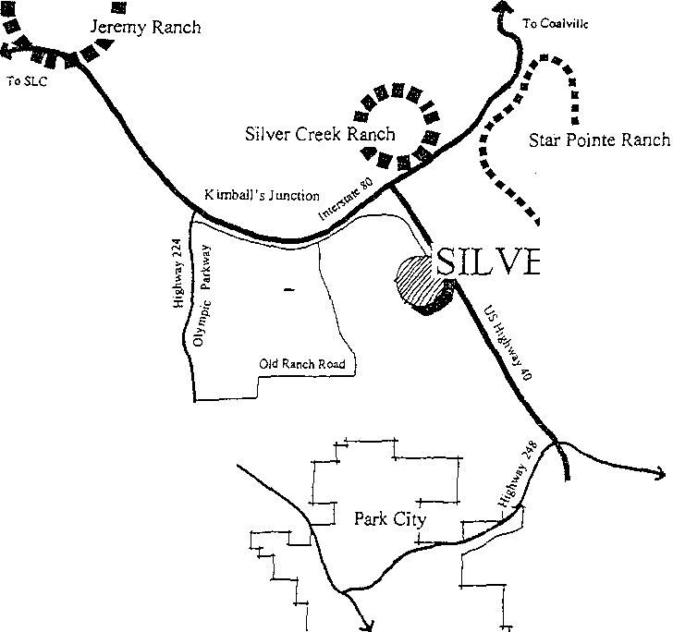SUM.MIT
•
•
• ••

: •..T•h.•e.C•.a•n.yons
• Ski Re-sort
.........---··

To Heber City

Topography

Silver Summit is located in a small valley facing generally east. The elevation is between
6530 and 6990 feet above sea level. The site is basically a valley surrounded with hillside slopes. It is generally isolated with limited views both into and out from the site.

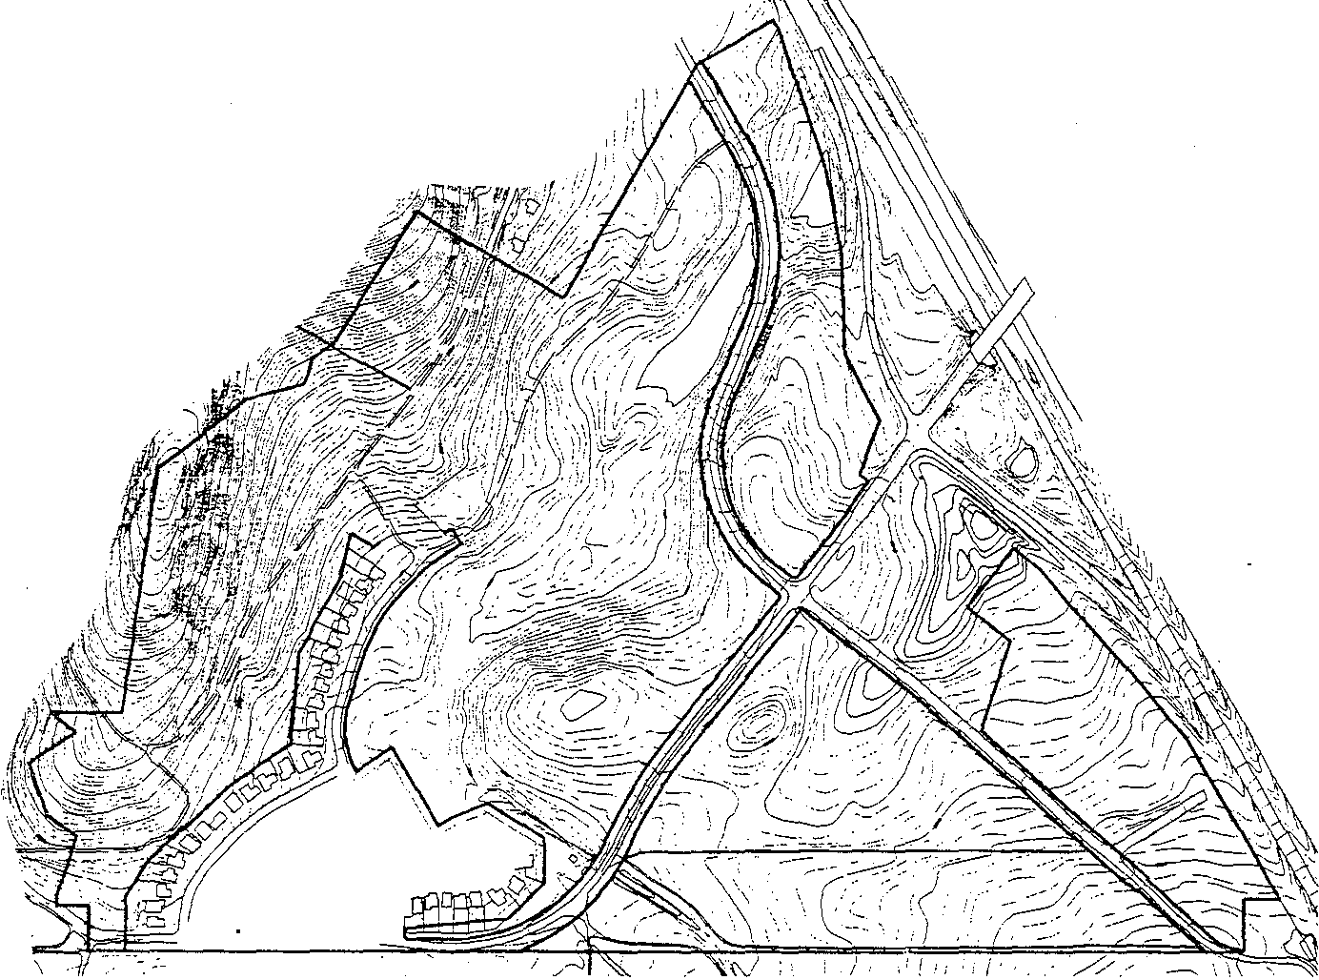

Climate

The area experiences temperatures typical to the high rocky mountain desert. Snow quantities average 300 inches annually. Temperatures fall below zero degrees Fahrenheit for approximately twenty days per year in the winter months. Snow melt is completed in May, and temperatures in the summer months range from 70 degrees to 80 degrees Fahrenheit typically. Rainfall averages !5 to 20 inches per year. The majority of rainfall occurs in the spring. In winter months, winds may be high velocity; however, the flatter areas of the site may be impacted by strong winds throughout the year.

Vegetation

· The vegetation existing on the site is a sage brush I native grass community, typical of the high mountain deserts of Northern Utah. The lower valleys in the area are predominantly covered with native grasses.

Existing Development

The Silver Summit community, Phase A, is adjacent to the proposed Neighborhoods 1, 2, and
3. This existing development contains 59 single family detached lots, all of which are fully developed. There are one or two lots which do not yet contain houses.

East of Highway 40 is the Summit County Industrial Park This is also the general location of the proposed Star Pointe Ranch development.

CO:tvfMUNITY DESIGN GUIDELINES

COMMUNITY CHARACTER

Overall Layout

• When possible, the proposed roads are in the location of existing unimproved roads. This layout also considers the location of existing utilities.
• The project is designed to minimize grading impacts, especially in the hillside areas. The proposed layout has avoided placement of building pads in areas over 30% slope.
• Lots have been clustered together to maximize project open space and provide rear yard open space around all units.
• Neighborhoods are clustered and buffered to minimize site impacts and to create neighborhood identity.
• Neighborhoods have been designed to create a physical and visual separation along the entrance corridor, the upper hillside areas and other sensitive areas, and will leave the majority of these areas in their natural state.

C'&()573829 £.r.:01335 PsGi ·Oi

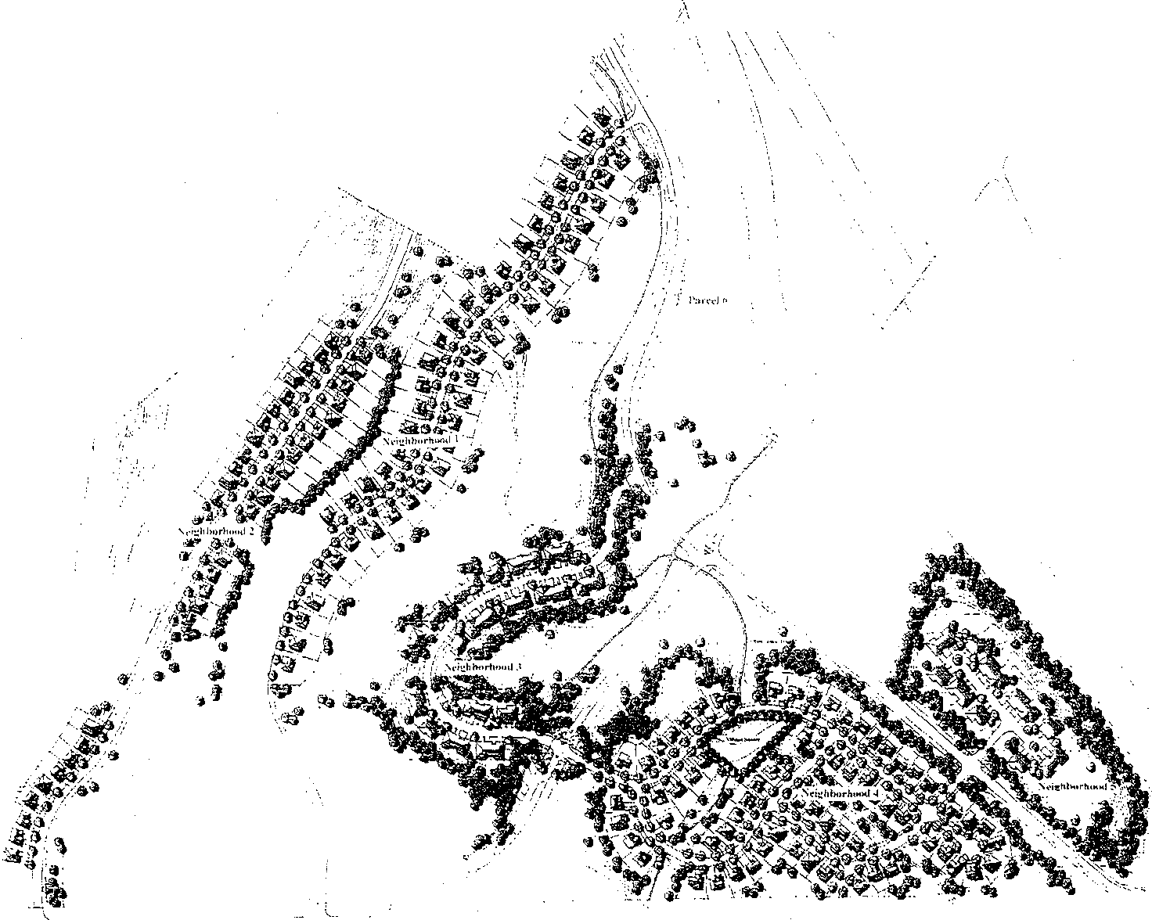

\\\\.
\\ ·. \

Cti:J573S29 g :.01335

Silver Summit Design Guidelines

Master Plan

8

Individual Neighborhoods

Neighborfuiod One

Located along Kingsford Avenue, Neighborhood One consists of 46 single family lots on 24.98 acres, a density of 1.8 units per acre.

Neighborlwod Two

Neighborhood Two lies along an extension of Crestview Drive in Highland Estates. It contains 38 single family lots on 31.7 acres, a density of 1.3 units per acre.

Neighborlwod Three

Neighborhood Three is located north of Silver Swnmit Parkway and is stnTOtmded by open space and a drainage way. It contains 28 single family detached units on 20.7 acres, a density of 1.4 units per acre.

Neighborlwod Four

Neighborhood Four is situated south of Silver Summit Parkway. It contains 66 units on 29.08 acres, a density of2.3 units per acre.

Neighborhood Five

Located between Neighborhood Four and Highway 40, Neighborhood Five contains
34 single family attached units on 12.2 acres, a density of2.8 units per acre.

Parcel Six is entirely open space and contains 11.6 acres.

Overall the site contains 212 units on 130.26 acres, a density of 1.6 units per acre. There is a total of 83.3 acres of open space, or 64% of the site.

Neighbrhd. | Gross Area | Developed  Area | Open  S[!ace |  | No. of  Units | Product  !I!:!e
1 | 24.98 | 13.88 | 11.1 | 44% | 46 | SFD
2 | 31.7 | 10.6 | 21.1 | 66% | 38 | SFD
3 | 20.7 | 6.1 | 14.6 | 70% | 28 | SFD
4 | 29.08 | 14.08 | 15.0 | 51% | 66 | SFD
5 | 12.2 | 2.3 | 9.9 | 81% | 34 | SFA
Parcel6 | 11.6 |  | 11.6 | 100%
Subtotals |  |  |  |  | 178 | SFD
 |  |  |  |  | 34 | SFA
Totals | 130.26 | 46.96 | 83.3 | 64% | 212

Open Space

The proposed plan provides large tracts of dedicated open space. This open space is a crucial element to preserve the desired character of the development and to provide habitat for wildlife. Areas designated as open space are intended, for the most part, to remain
undisturbed by development construction. The "undisturbed" open space will have developed trails constructed within them and re-vegetation of disturbed areas where necessary. Within Neighborhood 4, a "Village Square" will be developed as a park and is included in this open space calculation.

Visual Sensitivity

The majority of development takes place in the least visually sensitive areas, and, as far as possible, pristine natural views have been considered and preserved. Buildings and other man-made features are intended not to obstruct the natural views. View Corridors or visually sensitive areas exist adjacent to highway 40 and Silver Summit Parkway and, here, buildings are set back and generous open spaces are preserved and enhanced with indigenous landscaping.

Architectural Theme/General Overview

The proposed development utilizes several compatible architectural styles. These will be a blend of Craftsman, Victorian and Prairie styles which are consistent with the rural mountain character of the area.

Variations in garage setbacks will be designed to create variety and interest as viewed from the street.

The proposed buildings will not exceed 3 stories in height, the buildings roof pitch shall be between 4:12 and 8:12, and the exterior building materials will include wood, stucco, brick,
and/or stone.

Landscape Theme/General Overview
0057 829 B G 014

The landscape theme for Silver Summit is inteaded to place the development within the overall context of the native environment.

The "arrival" to Silver Summit is also the arrival for the regional development anticapated to the south and west. A large, spacious mountain meadow is proposed as an arrival feature to enhance and to identifY the community. This will be a planting of indigenous bunch grasses

and wildflowers. Some of this area may be cleared and planted with these materials, but the majority will be enhancement plantings amongst the native sagebrush community. The entire area will be surrounded with trees to enframe and contain the meadow.

Individual residences within the neighborhoods will be given latitude to design their landscaping to be livable and enjoyable environments. While it is anticipated that this will be a landscape more lush and green than the native environment, these neighborhoods should appear as "islands" in the native landscape.

The majority of the site will be preserved as open space. Most of the added plant materials will be indigenous species. The intent is to provide a very subtle transition from the developed areas to the native landscape

DEVELOPMENTSTANDARDS

1. Level of Service Standard

1.1. Compliance with level of service standards shall be measured against the development agreement between the owners of Silver Summit and Summit County.

2. Availability of Public Facilities

2.1. Public facilities shall be deemed to be available if there is an enforceable development agreement which guarantees that the facilities will be in place at the time that the impacts of development will occur.

3. Watershed Protection

3.1. There are no springs used for culinary use or public water supply within 1,500 vertical feet below or 100 vertical feet above Silver Summit. Therefore there are no restrictions for the location of structures which could pollute such sources did they exist.
3.2. There are no jurisdictional wetlands, naturally occuring streams, reservoirs, lakes or ponds within Silver Summit to restrict the location of any structure.
3.3. Silver Summit wil!be connected to the Snyderville Basin Sewer Improvement
District system, so no septic systems will restrict the location of any structure.

4. Solid Waste and Recycling

4.1. Silver Summit is not required by development agreement to have a mandatory recycling program. Therefore, development permits shall not be contingent upon any such program being put into effect.

5. Revegetation/Erosion Protection/Runoff Control

5.1. Development plans shall preserve significant existing vegetation to the extent possible.
5.2. All cut and fill slopes in excess of3:1 shall be properly stabilized and revegetated.

6. Critical Slopes

6.1. The site for Neighborhood Two contains minor areas where slopes exceed
30%. The proposed design has avoided placement oflots on slopes exceeding
30%.
6.2. There are approximately seven lots in Neighborhood Two with average slopes over 15 percent and these are generally between 15 and 16 percent. Development on slopes over fifteen (15) percent and less than thirty (30) percent shall be professionally designed. Measures will be taken to assure slope stability and to prevent accelerated runoff and erosion.

7. Floodplains

7.1. There are no FEMA floodplains within Silver Summit.

8. Open Space

8.1. Required Open Space
A. The approved development plan shows open space by neighborhood and overall totals for Silver Summit.
B. Each neighborhood is required to maintain the amount of open space
identified in the approved development plan.
C. Inclusions and Exclusions in the Open Space Calculation:
1) Open space shall include all common open space areas, open space preservation areas, parks and trails, and other such areas. Open space may also include setback areas and easements within lots on which no primary structures are located. Accessory structures may be acceptable.
2) Open space shall not include any portion of a parcel on which any primary structure or driveway is located.
8.2. Method of Owning/Maintaining Open Space
A. Within Silver Summit, common open space will be owned and maintained as active open space for public use, variously, by the three neighborhood homeowners associations. All or portions of the common open space may be dedicated to the county if approved by the County.

9. Water

9.1. Water Supply
A. The minimum size of main lines for any system will be six (6) inches in diameter and will be sized larger if flows and velocities dictate. PVC pipe may be used for the water system.
B. Fire Hydrants will be installed in accordance with Fire District requirements. .

C. The house water service line shall be at least three-quarters (3/4) inch.
9.2. Fire Flow requirements
A · The fire flow requirement will be a minimum of 1,000 gallons per minute.

10. Sanitary Sewer

10.1. Connection will be made to a public sewer system.
10.2. A line extension agreement by the Snyderville Basin Sewer Improvement
District has been approved.

11. Fire Protection

11.1. The Park City Fire Service District has established the acceptable emergency response time as ten (10) minutes or less within the District under normal circumstances. Silver Summit falls within this response time.
11.2. No fire sprinkler or suppression systems or other mitigation measures are
required for Silver Summit to comply with the required level of service standard.
11.3. No Fire Protection Mitigation Plan is required for Silver Summit.
11.4. Fuel BreaksNegetation Manipulation. If required for Silver Summit, the following criteria shall apply:
A Fuel break clearing limits around structures and development perimeters are based on the wildfire hazard rating. Use requirements for Moderate hazard:
I. Structures: 30 feet
2. Development perimeters: None
B. Hazardous fuels in the form of native vegetation will be cleared within
30 feet of a structure at the perimeter of development to assist in wildfire prevention measures.
1. Mow annual grasses to a height of 4 inches ore less within 30
feet of structures; and
2. Remove ground litter annually.
C. Since this 30 foot zone is most generally within the rear yard of houses, fuel breaks may contain individual tree specimens, ornamental plants, or other similar vegetation used as groundcover provided they are well maintained and do not provide a means of transmitting wildfire from
native vegetation to structures.

12. Parking Requirements

12.1. There shall be a minimum of two (2) spaces per single family detached or single family attached -dwelling unit.

12.2. These required parking spaces may be provided in the driveway of each unit.

13. Access Design

13.1. The site plan shows two access points for each neighborhood, with the exception of Neighborhood Five. Because it contains only 34 units on a private street and two cui de sacs of 300 feet or less, Neighborhood Five is served with only a single access. If required, an emergency secondary access will be provided in Neighborhood Five.
13.2. Road Grades
A. The maximum grade for roads varies by Neighborhood and the following section, Neighborhood Design Standards, defines maximum grades for each Neighborhood. G-rades in excess often (10) percent are used when it is determined that the steeper grade is helpful in avoiding environmental damage.
B. In all instances, the minimum road grade shall be 0.3 percent.
C. Cuts are best handled using grading solutions. The use of retaining walls should be avoided. Slopes graded at 2:1 maximum and revegetated for stabilization is the preferred solution. Fill areas should also be graded at maximum 2:1 slope and revegetated.
D. The tangent grade within one hundred (100) feet of any intersection shall not exceed three (3) percent.
E. Road Design Standards for Residential Streets
Function: Access to adjacent moderate to high density uses
Rights of way: 42- 60 feet (See Neighborhood Design
Standards, next section)
Pavement Width: 20- 24 feet (See Neighborhood Design
Standards, next section) Shoulder Width: Not applicable Drainage: Curb/gutter
Sidewalks: None
Parking Lanes: Yes, within stated pavement widths
Design Speed: 25 MPH
13.3. Driveway Access
A All individual driveway access locations shall be designed to function well with the existing conditions and layout of each residential building.
B. The maximum grade of any driveway shall not exceed 15 percent. 15
percent grades may be exceeded for short distances if approved by
PCFSD
C. The minimum width of any driveway shall be I 0 feet.
D. No retaining walls shall be required in conjunction with the grading for any driveway. .

005 .-'..5829 £;;:.01335 PsOHD9

·::".

13.4. Cul de Sacs
A. The maximum length of a cui de sac shall be 750 feet and serve not more than 13 residential lots. Any cui de sac on a private street shall not exceed 600 feet and serve not more than 35 dwelling units.
B. The cui de sac shall not be less than 60 feet in diameter. On a private cui de sac, the diameter shall not be less than 50 feet
C. A hammerhead cul de sac design may be allowed in certain instances.
D. All cui de sacs must include signage indicating that the road is a dead end road within 50 feet of the outlet. In addition, two signs will be placed on the connection road indicating that the "Next Turn is a Dead End Road".
13.5. Road Maintenance
A. Snow removal and road maintenance on private roads will be the responsibility of the respective Homeowners Association and will be noted as such on the recordation plat.
B. All public roads will be dedicated to and maintained by Summit
County.
13.6. Sidewalks and trails
A. No sidewalks are to be installed adjacent to the streets in Silver
Summit.
B. Trails are of two kinds and are described in detail in the section entitled Trails under the Landscape Concept section within these Guidelines. They shall be constructed to the following specifications:
1. Regional trail connections: These trails are intended to connect
to the regional trail system. They shall be 8 feet wide and consist of 2'' asphalt over 3" compacted base.
2. Secondary trails: These trails connect neighborhoods to the regional system. These shall be 5 feet wide and shall be constructed using native soil, bark chips or crushed gravel.

14. Public Utilities

14.1. All utilities shall be placed underground.
14.2. Existing above-ground utilities shall not be required to be placed underground.

15. School Capacity

15.1. Silver Summit shall not be required to provide a school impact analysis.

16. Neighborhood Parks and Community Open Space

16.1. Parks and open space will be provided per the site plan.

16.2. The long-term care of neighborhood parks and open space shall be the responsibility of the Homeowners Associations. The Protective Covenants for Silver Summit include language for such long-term care.

17. Special Site Design Requirements and Considerations

17.1. Site Plans
A Building site plans for single family detached residential development shall provide proposed building envelopes and associated driveways consistent with the Neighborhood Design Standards when there is steep terrain along the roadway, such as in Neighborhoods One and Two.
17.2. Side and Rear Yards
A Side and Rear yard setbacks, along with front and rear, are defined for each Neighborhood in the Neighborhood Design Standards.
B. No deck or patio, on or below grade, shall be permitted to encroach within ten feet of a side or rear lot line. Such patio or deck located ten feet from a property line shall be screened with dense plantings of shrubs or shrubs and trees.

NEIGHBORHOOD DESIGN STANDARDS

I. Neighborhood One

1.1. Existing Constraints/Conditions: The existing site includes a rough-cut, unimproved road which is an extension of the existing road in the Silver Summit, Phase A Subdivision. In addition there is an existing 8" water line and electrical and telephone services within the unimproved road and a sanitary sewer south of the site. The proposed design utilizes the existing road
alignment to the extent possible to define the proposed road and lot layout.

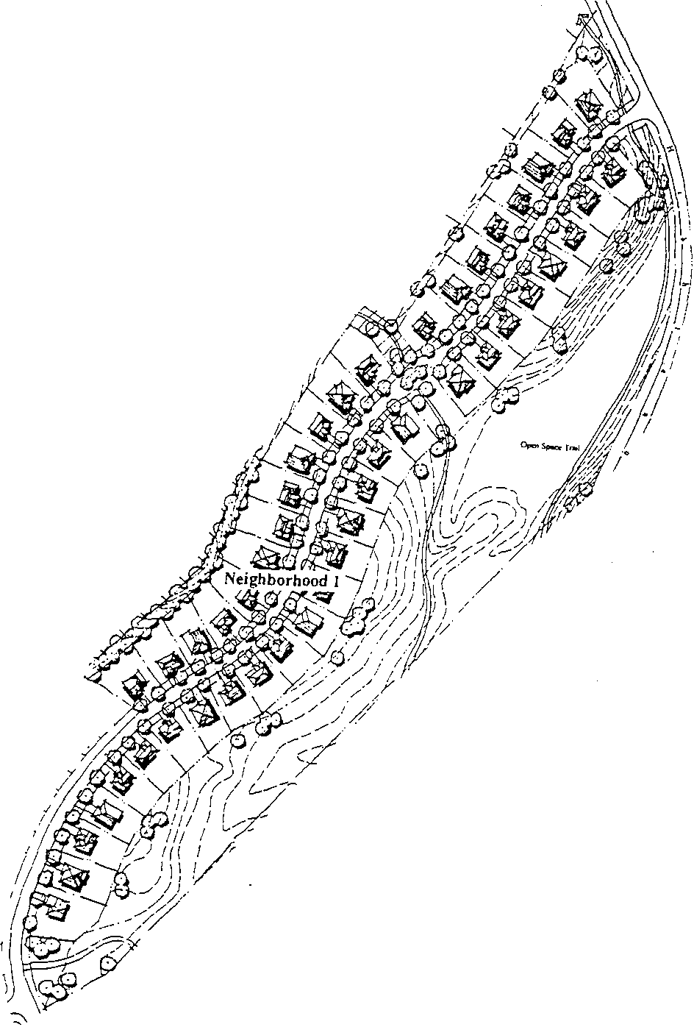1.2. Neighborhood Description: 46 Single family lots

1.3. Site Plan

CH:l5 1"'..5829 t:.f-:.01335 f'ul)i412

18

1.4. Zoning Standards!Development Guidelines
A Roadway Design Criteria:
• Roads will be dedicated Summit County Rights-of-Way.
• Roads will consist of 24 feet of asphalt plus a 2.5 foot curb and gutter on each side for an overall width of 29 feet from back of curb to back of curb
• The maximum road grades will not exceed 12 percent slope.
• A 4-foot sidewalk will be provided on one side of the street in
Neighborhood One.

12' Asphalt

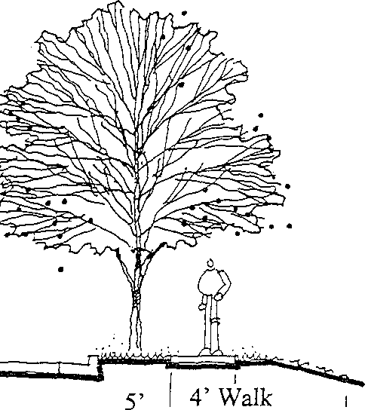60' Right of Way
15 \1,' Parkway

'(\_ 2 \1,' Curb & Gutter

---------------------

1.4. Zoning Standards/Development Guidelines/Continued

B. Minimwn Lot Size: 7,000 square feet
Average Lot Size: 9,000 square feet

C. Minimwn Lot Width: 70 feet

D. Minimwn Lot Depth: 80 feet, or as required to provide minimwn lot size

E. Front Yard Setback: Thirty five (35) feet minimum from back of curb to garage. Twenty (20) feet minimwn from back of curb to the main building.

Front setbacks of adjacent houses are to vary by at least 5 feet, unless constrained by existing slopes.

On hillside lots, minimwn setbacks may be desirable and necessary to optimize the siting of buildings on the lot. Otherwise, adjacent building setbacks should stagger.

F. Minimwn Side Yard Setbacks: Eight (8) feet with a combined total of twenty (20) feet for both side yards.

G. Minimwn Rear Yard Setback: Fifteen (!5) feet.

H. Maximwn Building Area: 50% of total lot area

15' Minimum ··

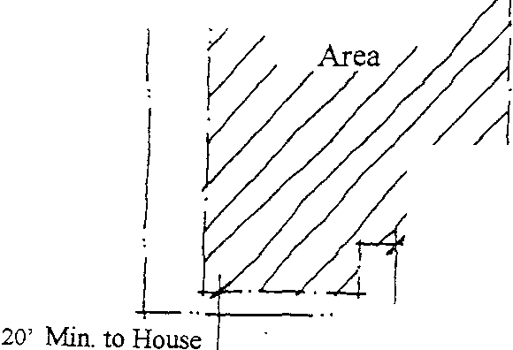I

Buildable

8' Min.
@th sides= 20' Min.
. ::..4 I.
35' Min. to Garage
--t-- .. ---1-

===-+=======-!=== = Curb

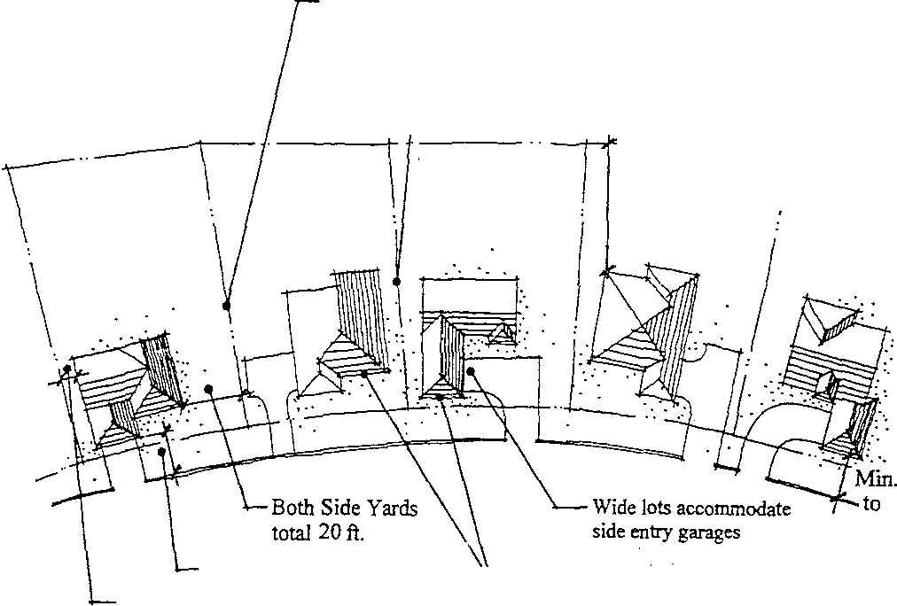Two large sideyards adjacent to each other offers variety in building spacing

garages set at min. 6 ft.
sideyard offers larger sideyard potential

Rear Yard 15ft. Min... ·I

I
)

Right of Way
Curb

20 ft. Setback
I
house!from curb

Min. 35ft. Garage Setback
Min. 8 ft. Sideyard Setback

\..- Fnont setbacks of adjacent houses are to vary by at least 5 ft., unless constrained by existing slopes

1.5. Street Lighting: No street lighting will be provided in Neighborhood One.

.C i:l57 BK0i335 h;Oi4i5

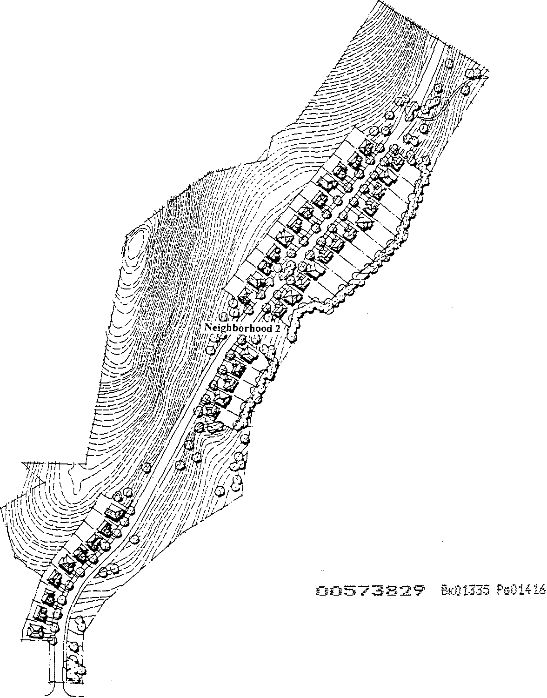2. Neighborhood Two

2.1. Existing Constraints/Conditions: The existing site for Neighborhood Two includes a rough-cut, unimproved road. This existing road has been utilized to the extent possible to define the proposed road alignment. This site also includes minor areas where slopes exceed 30%. The proposed design has clustered lots on the most gradually sloping terrain and avoids placement of lots on slopes exceeding 30%.

2.2. Neighborhood Description: 38 Single family lots

2.3. Site Plan

2.4. Zoning Standards/Development Guidelines
A. Roadway Design Criteria:
• Roads will be dedicated Summit County Rights-of-Way.
• Roads are narrow and have gentle curves.
• Roads will consist of24 feet of asphalt plus a 2.5 foot curb and gutter on each side for an overall width of29 feet from back of curb to back of curb
• The maximum road grades will not exceed 12 percent slope.
• A 4-foot sidewalk will be provided on one side of the streets in
Neighborhood Two.

-- -i"' ·m e r ··· cn · ri;, ;, ··,· - Er ;N "-
1
I I 5' 4'Wa!k
I l 'A ' I
l sphalt 10 W Parkway k 5' Snow Storage
'1!. 'f lL Easement
" 50' Right of Way · 2 W Curb & Gutter

2.4. Zoning Standards/Development Guidelines/Continued

B. Minimum Lot Size: 5,000 square feet
Average Lot Size: 6,000 square feet

C. Minimum Lot Width: 60 feet

D. Minimum Lot Depth: 80 feet, or as required to provide minimum lot size

E. Minimum Front Yard Setback: Thirty five (35) feet from back of curb to garage. Twenty (20) feet from back of curb to the main building.

Front setbacks of adjacent houses are to vary by at least 5 feet, unless constrained by existing slopes.

On hillside lots, minimum setbacks may be desirable and necessary to optimize the siting of buildings on the lot.

F. Minimum Side Yard Setback: Six (6) feet with a combined total of fifteen
(15) feet for both side yards.

G. Minimum Rear Yard Setback: Fifteen (15) feet.

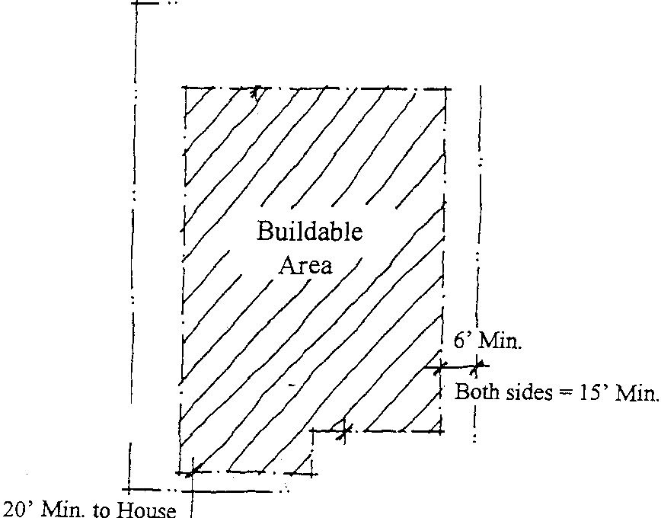H. Maximum Building Area: 70% of total lot area.

15' Minimum

35' Min. to Garage
-\--- .. ---1.

==== ====== == === Cmb

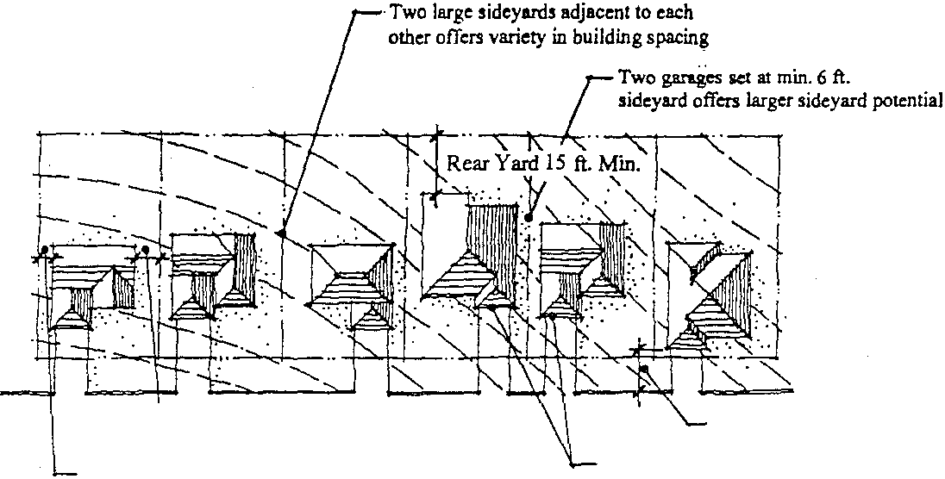Right of Way -·1-li-- =-- f---;,
Curb

Both Side Yards total 15 ft.

Min. 6ft. Sideyard Setback
Min. 35 ft. Garage Setback

Siting of houses must respond to existing slopes. but whenever possible, front setbacks should vary by at lei!st 5 ft.

2.5. Street Lighting: No street lighting will be provided in Neighborhood Two.

2.6. House Plotting: The last lot on both sides of the street at the north end of
Neighborhood Two will be restricted to single living-level homes.

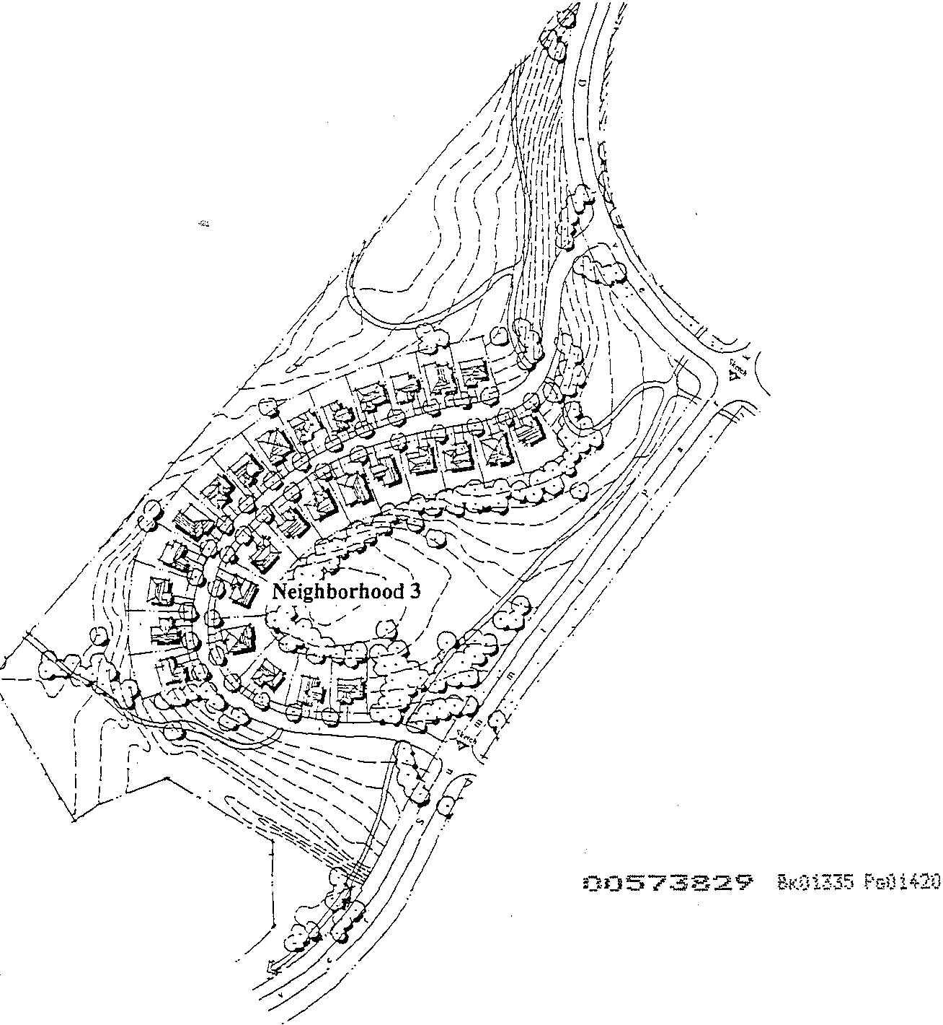3. Neighborhood Three

3.1. Existing Constraints/Conditions: This neighborhood is situated on the side­ slope of an existing knoll and has views into the significant open space surrounding the site. The top of the knoll should be preserved as a natural landscape feature. Although adjacent to Silver Summit Parkway, development is set back and buffered from it.

3.2. Neighborhood Description: 28 Single family detached residences.

3.3. Site Plan

3.4. Zoning Standards/Development Guidelines
A. Roadway Design Criteria:
• Roads will be dedicated Summit County Rights-of-way.
• Roads are narrow and have gentle curves.
• Roads will consist of 24 feet of asphalt plus a 2.5 foot curb and gutter on each side for an overall width of 29 feet from back of curb to back of curb
• The maximum road grades will not exceed 12 percent slope.
• A 4-foot sidewalk will be provided on one side of the street in
Neighborhood Three. Trail systems connect the neighborhood to open spaces and the other Silver Summit neighborhoods.

.........- ·· i.ljW :,w:::.·1r:;;;;;:J; ;;,;;;;,;;.;;;;;.;
;;;;;;;;;;;;;;;;;;;;;;;;;;;; ;r;;;;;;;Ql·fi.Au Aw « '
7
- -', f:-,;l:o>

\i"'--...

/ l 5' / 4' Walk 1
I 12' Asphalt 10 W Parkway L 5' Snow Storage
l

- ---- --------- , -- ,Easement
50' Right of Way '2 W Curb & Gutter

()CE57..s829 BK:J1335 Ps0i421

3.4. Zoning Standards/Development Guidelines/Continued

B. Minimum Lot Size: 6,000 square feet
Average Lot Size: 6,500 square feet

C. Minimum Lot Width: 60 feet
D. Minimum Lot Depth: 90 feet, or as required to provide minimum lot size. E. Minimum Front Yard Setback: Thirty five (35) feet from the back of curb
to garage for driveways. Twenty (20) feet to the building face.

Front setbacks of adjacent houses are to vary by at least 5 feet, unless constrained by existing slopes or Jot configuration.

Buildings shall be setback such that adjacent units will be staggered to avoid a long linear appearance from the street. Particular attention will be paid to the garages of each unit, with an effort to diminish the impacts of garages on the front elevation of the houses and the streetscape view.

F. Minimum Side Yard Setback: Six (6) feet with a combined total of fifteen
(15) feet for both side yards.

G. Minimum Rear Yard Setback: Fifteen (15) feet.

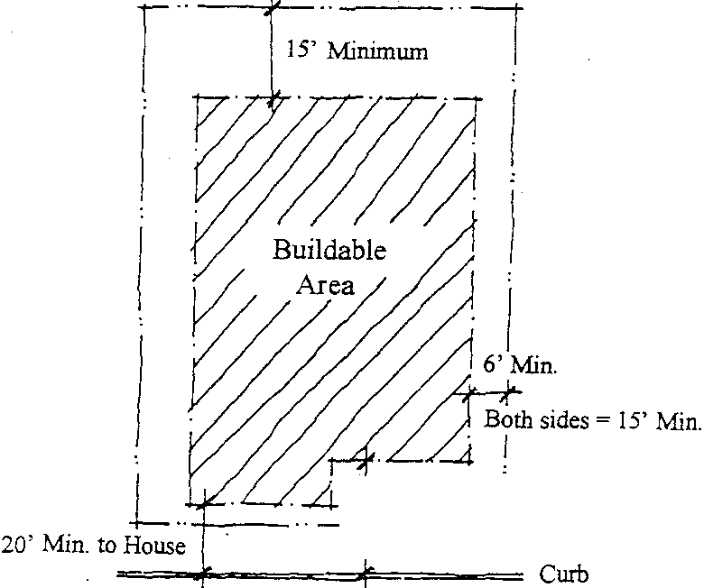H. Maximum Building Area: 70% of total lot area.

35' Min. to Garage
_, j_

Curb
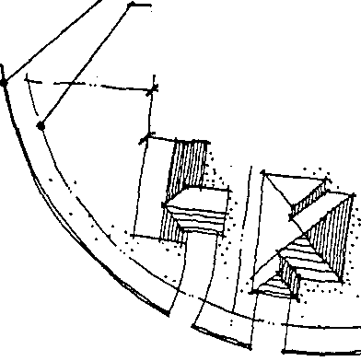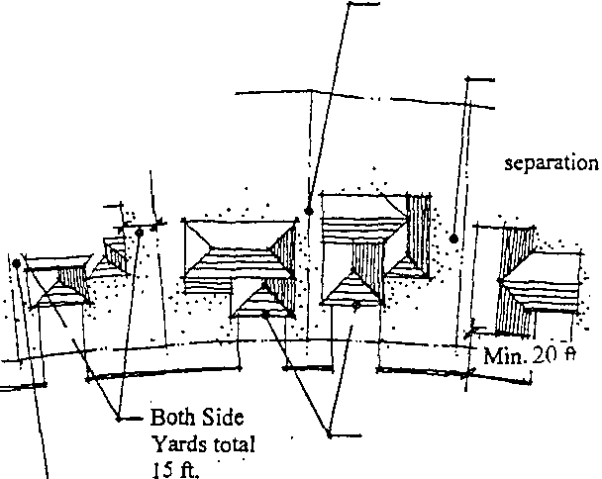Ri tofWay Two garages set at min. 6 fl
sideyard offers larger sideyard potential

Minimum 6 ft. sideyard

ear;.;d\Sft:M ---·
--11---+a
9ft. minimum sideyard

offers a significant building

I

":/
Setback to house
L.:.
. Front setbacks of adjacent houses·
are to vary by at least 5 ft.

Min. 6 ft. Sideyard
Setback

3.5. Street Lighting: Street lighting is intended to provide low levels oflighting for safety and security of the neighborhood. Street lights will be provided only at intersections. Refer to the Landscape Section of these Guidelines for the
design character of these fixtures.

3.6. · Signage/Entry Monurnentation: Refer to Landscape Section of these
Guidelines for signage/monumentation treatments.

il) 35 BKD1335 Ps0i423

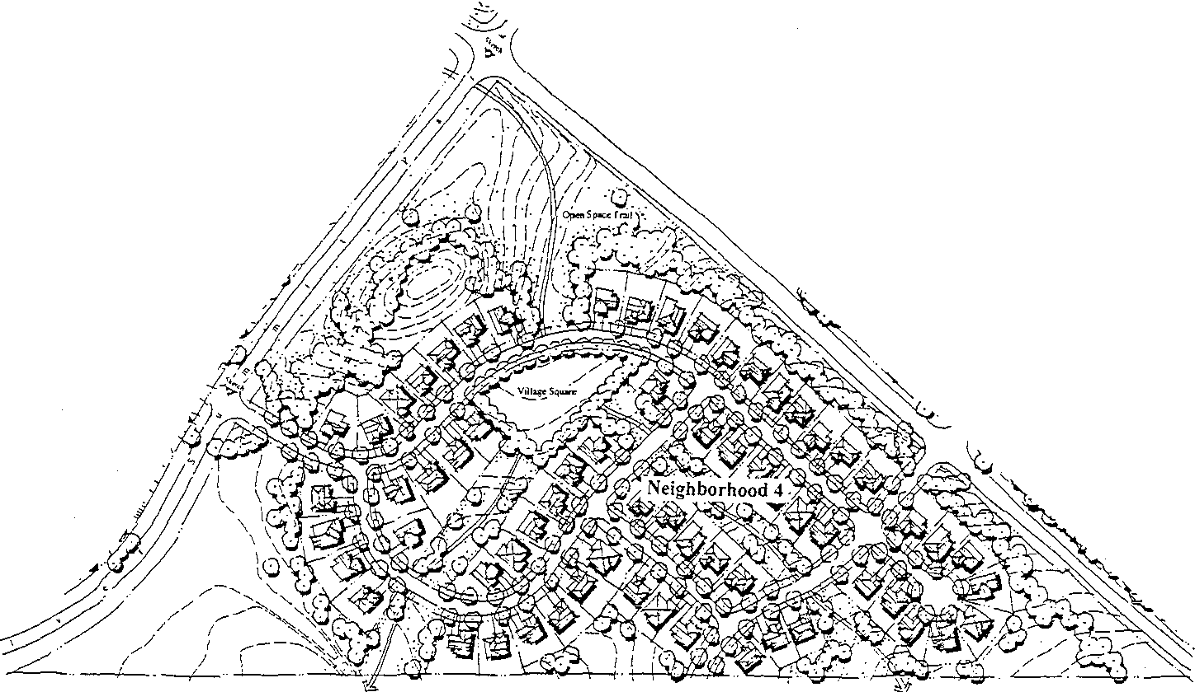4. Neighborhood Four

4.. 1. Existing Constraints/Conditions: There is a large mound between the site and Silver Summit Parkway which should be preserved as a dominant regional feature. It is valuable as a buffer to help screen development of Neighborhood
4 from the scenic corridor.
4.2. Neighborhood Description: 66 Single Family Lots
4.3. Site Plan

4.3. Zoning Standards/Development Guidelines
A Roadway Design Criteria:
• Roads will be dedicated Summit County Rights-of-way.
• Roads are narrow and have gentle curves.
• Roads will consist of a minimum of 24 feet of asphalt plus a 2.5 foot curb and gutter on each side for an overall width of 29 feet from back of curb to back of curb
• The maximum road grades will not exceed 12 percent slope.
• A 4-foot sidewalk will be provided on one side of the street in Neighborhood Four. Trail systems connect the neighborhood to open spaces and the other Silver Summit neighborhoods

. Q
-- ·s. ·..' *K · bw · ,n · r(' ,; : ·- · 4 w ,: ·· f:

2' 10 Y,' Parkway5' Snw

l 50' Right

of Way '2 W Curb

, 'I Easement
& Gutter

' ---- -----------------

B. Minimum Lot Size: 6,000 square feet
Average Lot Size: 6,500 square feet

C. Minimum Lot Width: 60 feet
Minimum Lot Width, cui de sac: 50 feet, measured at 20 foot setback.
D. Minimum Lot Depth: 90 feet, or as required to provide minimum lot size. E. Minimum Front Yard Setback: Thirty five (35) feet from the back of curb
to garage. Twenty (20) feet from the back of curb to the building face.

Front setbacks of adjacent houses are to vary by at least 5 feet, unless constrained by existing slopes or lot configuration.

Buildings shall be setback such that adjacent units will be staggered to avoid a long linear appearance from the street. Particular attention will be paid to the garages of each unit, with an effort to diminish the impacts of garages on the front elevation of the houses and the streetscape view.

F. Minimum Side Yard Setbao;;ks: Six (6) feet with a combined total of fifteen
(15) feet for both side yards.

G. Minimum Rear Yard Setback: Fifteen (15) feet.

H. Maximum Building Area: 70% of total lot area

C Ot::e l'" ..s829 r:.G1335

.. ·---r
r
15' Minimum \

If: /
I ,, ,/.,.

L'LA1-:fDtYh'sides!5' Min.
L ..Lj_ 35' Min. to Garage
"+-- --1-·· j.
20' Min. to House
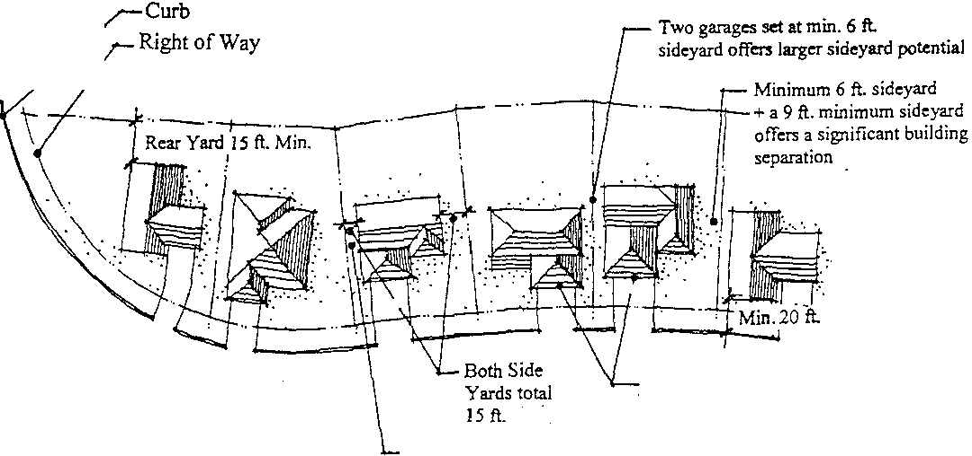!'- =!'===-=Curb

I
I

Setback to house
L.:.

Front setbacks of adjacent houses·
are to vary by at least 5 ft.

Min. 6ft. Sideyard
Setback

4.4. Street Lighting: Street lighting is intended to provide low levels of lighting for safety and security of the neighborhood. Street lights will be considered only at intersections. Refer to the Landscape Section of these Guidelines for the design character of these fixtures.

4.5. Signage/Entry Monurnentation: Refer to Landscape Section of these
Guidelines for possible signage/monurnentation treatments

0057 829 kODE Oi 6

5. Neighborhood Five

5.1. Existing Constraints/Conditions: Some moWlding has been constructed which begins to separate this site from highway 40. This moWlding will be enhanced and extended to provide a buffer from the highway.
5.2. Neighborhood Description: 34 Single Family attached residences, consisting of
2-, 3-, and 4-Wlit buildings.
5.3. Site Plan /'-.

<,-/
l
"\

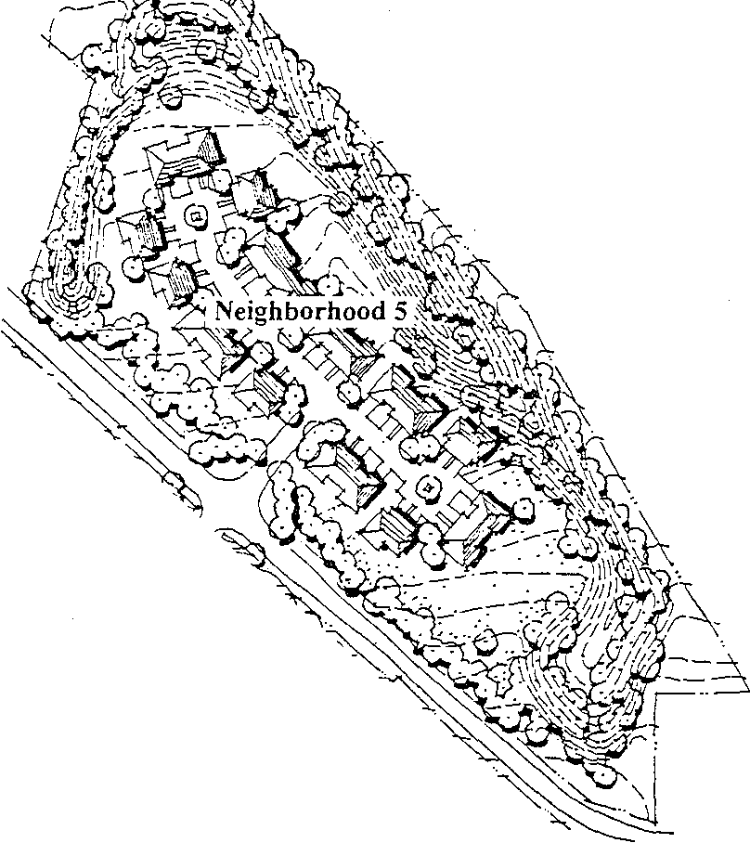/·.cJ!-' "'­

5.4. Zoning Standards/Development Guidelines
A Roadway Design Criteria:
• Roads shall be private
• Roads are narrow and have gentle curves.
• Roads will consist of a minimum of 20 feet of asphalt plus a 2.5 foot curb and gutter on each side for an overall width of24 feet from back of curb to back of curb.
• The maximum road grades will not exceed 12 percent slope.
• No street-adjacent sidewalks will be provided.

00 6829 kOE§ 01 7

5.4. Zoning Standards/Development Guidelines/Continued
• •

l 10' I )Curb & Gutter
. -------- . · · r
Asphalt

24' Private Street
C. Minimum Lot Size: Not applicable
Average Lot Size: Not applicable

B. Minimum Lot Width: Not applicable
Minimum Lot Width, cul de sac: Not applicable

C. Minimum Lot Depth: Not applicable

D. Minimum Front Yard Setback: Eighteen (18) feet from back of curb to garage for driveway. Ten (10) feet from back of curb to the building face.

Buildings shall be setback such that adjacent units will be staggered to avoid a long linear appearance from the street. Particular attention will be paid to the garages of each unit, with an effort to diminish the impacts of garages on the front elevation of the houses and the streetscape view.

E. Minimum Side Yard Setback: Fifteen (15) feet between buildings. F. Minimum Rear Yard Setback: Not applicable.
H. Maximum Building Area: Not applicable.

5.5. Street Lighting: Street lighting is intended to provide low levels oflighting for safety and security of the neighborhood. Refer to the Landscape Section of these Guidelines for the design character of these fixtures

5.6. Signage/Entry Monumentation: Refer to Landscape Section of these
Guidelines for signage/monumentation treatments.

5.7. Fencing: Privacy fencing for private patio areas is allowed. Refer to
Landscape Section of these Guidelines for possible fencing treatments.

0057s829 kOE Oi 9

DETAILED FINAL PLAT, SITE PLAN,
& CONSTRUCTION PLAN SPECIFICATIONS

1. Detailed Final Subdivision Plat

1.1. Plat Requirements
A. A subdivision plat shall conform to the following:
The plat shall be prepared by a licensed land surveyor at a convenient scale not more than 1" = 100', may be prepared in pen or pencil, and the sheets shall be numbered in sequence if more than one sheet is used. Such plat shall be of a size acceptable for filing in the office of the Summit County Recorder, but shall be 34" x 44" or larger. The map prepared for the preliminary plat may also be used for the final subdivision plat and, therefore, should be drawn on tracing cloth or reproducible mylar. Upon approval by the BCC, the plat also shall be provided to Summit County on computer disk in Autocad (DWG) file format, or other acceptable format approved by Summit County.
B. The plat shall show the following:
1) The location of property with respect to surrounding property and roads; the names of all adjoining property owners of record, or the names of adjoining developments; and the names of adjoining roads.
2) The location and dimensions of all boundary lines of the
property to be expressed in feet and decimals of a foot.
3) The location of existing roads, easements, water bodies, streams, and other pertinent features such as swamps, railroads, buildings, parks, cemeteries, drainage ditches, bridges, as determined by the BCC.
4) The location and width of all existing and proposed roads and easements, alleys, and other public ways, and easement and proposed road rights-of-way and building setback lines.
5) The locations, dimensions, and areas of all proposed or existing lots, including building area.
6) The location and dimensions of all property proposed to be set aside for trail, park or playground use, or other public or private reservation, with designation of the purpose of those set asides, and conditions, if any, of the dedication or reservation.
7) The name and address of the owner or owners ofland to be subdivided, the name and address of the subdivider if other than the owner, and the name of the land surveyor.
8) The date of the map, approximate true north point, scale, and title of the subdivision.

(.{)I'829 § .:D

9) Sufficient data acceptable to the County Engineer to determine readily the location, bearing and length of all Jines, and to reproduce such lines upon the ground; the location of all proposed monuments.
10) Names of the subdivison and all new roads as approved by the
BCC.
II) Indication of the use of any Jot (single-family, two-family) and all uses other than residential proposed by the subdivider.
12) Lots shall be consecutively numbered or lettered in alphabetical order.
13) All pertinent information shown on the sketch plan or SPA Plan shall also be shown on the Detailed Final Plat, and the
following notation shall also be shown:
• Explanation of drainage easements, if any;
• Delineation of natural features including, but not limited to, wetlands, floodplains and floodways, slopes exceeding fifteen (15) percent, vegetation areas, and threatened or endangered species habitat;
• Explanation of site easements, if any;
• Explanation of reservations, if any;
• Endorsement of owner and date of the endorsement;
• Form or endorsements by the Commission Chairman per:

Approved by Resolution/Ordinance of the BCC on
(day), (month), (year).

Chairman Date

2. Final Subdivision Plat

2.1. The final subdivision plat shall be presented in india ink on tracing cloth or reproducible mylar. The following information, in addition to the requirements of 1.1.1 above, shall be provided.
A. Notation of any self-imposed restrictions, and locations of any building
Jines proposed to be established in this manner;
B. All monuments erected, comers, and other points established in the field in their proper places. The material of which the monuments, comers, or other points are made shall be noted at the representation thereof or by legend, except that lot comers need not be shown. The legend for metal monuments shall indicate the kind of metal, the diameter, length, and weight per lineal foot of the monuments.

2.2. The final subdivision plat shall be prepared by a land surveyor licensed by the
Statof Utah.
2.3. In addition to the requirements of l.l.l.B., above, final subdivision plats shall conform to current surveying practice and shall show the following information:
A. A title block giving the subdivision's name and quarter section, section, township, range, principal median, and County of its location;
B. The exterior boundaries of the platted area giving lengths and bearings of the boundary lines;
C. A notation of any adjoining plats or certificates of survey and titles thereto;
D. The basis of bearings used and a north arrow;
E. Scale, not smaller than 1" = I 00';
F. All existing monuments found during the course of the survey, including a physical description;
G. All existing easements or right-of-way, including those contiguous to
the platted area, their nature, width, and the book and page number of their recording in the County's records;
H. All lots, blocks, rights-of-way, and easements and trails (including open space) created by the subdivision with their boundary, bearings, lengths, widths, name, number, or purpose.
I. All monuments set during the course of the survey with physical description, including appropriate witness monuments;
J. The area of all lots or parcels created by the subdivision and, in a separate table or in the owner's certificate, a summary of total acreage, total acreage in lots, and total acreage in roads or other dedicated parcels;
K. A vicinity map locating the subdivision within the section identifying adjoining or nearby plats or certificates of survey and showing prominent landmarks;
L. The owner's certificate of consent (signed, dated, and notarized)
including a legal description of the subdivision's boundaries and the dedication of public ways or spaces. This certificate should include a reference to any covenants that may be declared and blanks where the County Recorder may enter the book and page number of their recording;
M. A certificate of consent (signed, dated, and notarized) from any and all
mortgagor, lien holders,or others with a real property interest in the subdivision;
N. A certificate (signed & dated) showing the name and registration
number of the surveyor responsible for making the survey;

0. Endorsement on the plat by every person having a security interest in the subdivision property that they are subordinating their liens to all covenants, servitudes and easements imposed on the property;
P. Signature blocks prepared for the dated signatures of:
1) Chairpersons of the Commission;
2) Chairpersons of the BCC;
3) Summit County Recorder;
4) County Engineer;
5) County Attorney;
6) Summit County Health department;
7) Utah Power;
8) Snyderville Basin Special Recreation District; and
9) Snyderville Basin Sewer Improvement District.
2.4. Plats may be prepared on linen or on mylar and may be either
18" x 24" or 24" x 36". Three paper copies shall be submitted along with the linen or film copy. A copy must also be provided on 18" x 18" mylar or linen.
2.5. Multiple sheet plats may be used. All sheets shall be numbered and referenced
to an index map, and all required certificates shall appear on a single sheet.
2.6. Bearings shall be shown to the nearest second, lengths to the nearest hundredth foot, and areas to the nearest hundredth acre.
2.7. A plat showing all required improvements shall be submitted upon their completion. The "As-built" plat shall show typical road sections, typical culvert installations, and similar information to facilitate long-run maintenance
of the improvements.

3. Condominium Plats

3.1. Building permits for condominium units can be issued following approval of the final plat by the Commission and the BCC as provided. The building permit will be issued based upon a certified architectural plan of the building elevation and floor plans as approved by the Building Official.
3.2. All condominium plats shall be filed in the office of the Summit County Recorder following completion of construction and before acceptance of improvements.

4. Final Site Plan

4.1. The approved site plans for Neighborhoods One through Four of Silver
Summit as shown in these Design Guidelines constitute a Development Permit and represent sufficient approval for the development of all single family detached neighborhoods.

4.2. Single family attached product shown in Neighborhood Five requires specific design of structures and layout, and therefore, only this neighborhood requires a fin ll
information and data on site development, architecture, and landscaping to show conformance with these Design Guidelines. The density and unit count of this neighborhood is as approved in these Design Guidelines.

5. Construction Plans

5. I. Construction plans shall be prepared for all required improvements. Plans shall be drawn at a scale of no more than 1" =50', and map sheets shall be of the same size as the preliminary plat. The following shall be shown:
A Profiles showing existing and proposed elevations along center lines of all roads. Where a proposed road intersects an existing road or roads, the elevation along the center line of the existing road or roads within one hundred (100) feet of the intersection shall be shown.
Approximate radii of all curves, lengths of tangents, and central angles
on all roads shall be shown.
B. The BCC may require, where steep slopes exist, that cross-sections of all proposed roads be shown.
C. Plans and profiles showing the locations and typical cross-section of
roads, including pavements, curbs and gutters, easements, utilities, and other underground utilities or structures.
D. Location, size, elevation, and other appropriate descriptions of any existing facilities or utilities.
E. Topography at the same scale as the sketch plan with a contour interval of two feet, referred to sea-level datum.
F. All specifications and references required by the County's construction standards and specifications, including a site-grading plan for the entire subdivision.
G. Notation of approval as follows:

Owner Date

Chairman, Date
Board of County Commissioners
H. Title, name, address, and signature of professional engineer and surveyor, date and revision dates.
5.2. Construction plans shall be prepared by or under the supervision of a
professional engineer or architect registered in the State of Utah.

0057 829 kOGTI Oi04

5.3. Copies of the construction plans, and the required number of copies of the plat shall be submitted to the Director for final approval. The plans shall contain
all necessary information for construction of the project. Each plan shall
include space for the notation of revisions, to be entered with each revision, its nature and date. Upon release of the plans by the County Engineer, each contractor shall maintain one set of plans, stamped and signed by the County, on the project at all times during construction.
5.4. Prior to authorizing construction, the County Engineer shall be satisfied that the following conditions have been met
A The preliminary plat shall have been approved as required in this regulation.
B. All required contract documents shall be completed and filed with the
County Engineer.
C. A complete list of the contractors, their representatives on the site, and telephone numbers where a responsible party may be reached at all times must be submitted to the County Engineer.
D. All applicable fees must be paid to the County.

()10073829 BK01335 Fs0i4.35

GUARANTEE OF DEVELOPMENT IMPROVEMENTS

1. Phasing

1.1. For site plan improvements, installation may be phased in accord with an approved phasing plan submitted with the application for a permit and approved by the BCC. In subdivisions a separate final plat or site plan shall be filed on each phase of the development.

2. Financing

2.1. Installation of the improvements required in a development or development phase may be guaranteed by provision of security for installation of improvements as provided in section- below.

3. Warranty

3.1. All improvements shall be warranted by the applicant for one full year's normal operation. The County shall either
• retain ten (10) percent of the bond or escrow total, or
• require a bond or escrow equal to ten (10) percent of the required total improvement costs
until twelve months from the date of completion of the improvements and acceptance thereof by the County as warranty should the improvements prove to be defective during said twelve month period.

4. Improvement Agreement and Guarantee of Completion of Public Improvements

4.1. The property owner shall enter into an Improvement Agreement incorporating approved development plans and by which the owner covenants to complete
all required public improvements no later than twenty four (24) months following the date upon which the final plat is approved. The Improvement Agreement shall contain such other terms and conditions as agreed to by the property owner and County.
4.2. Security: Whenever the County permits a property owner to enter into an agreement after approval of a final plat or site plan, it shall require the owner to provide sufficient security, to ensure completion of the required public improvements. The security shall be in the form of either:
A A letter of credit, in the amount of one hundred twenty (120) percent of the estimated cost of improvements, drawn upon a state or national bank; or

B. Establishment of an escrow account or one hundred twenty (120) percent surety bond for the estimated cost of the with the guarantee that all improvements shall be installed within two (2) years or the account or bond will be called by the County to complete the improvements.
C. In addition to all other security, for completion of those public improvements where the County participates in the cost, the owner shall provide a performance bond from the contractor, with the County as a co-obligee. The issuer of any surety bond and letter of credit shall be subject to the approval of the County Attorney.

()()57..:S829 Br-:01335 Ps0i437

ARCIDTECTURAL GUIDELINES

Purpose and Intent

Silver Summit will offer a variety of housing product types ranging from Single Family homes to attached housing which will combine architectural elements of Craftsman, Victorian, and Prairie styles. Through these styles, architectural and visual variety can be provided while creating a cohesive neighborhood which is complementary to the existing development and the character of the surrounding environs.

Important design elements of these styles are: simple forms, detailed gables, higher pitched roofs, decorative porches, combinations of wood siding, stone, and stucco. These will be used to develop a distinct character, which is functional and aesthetically pleasing.

Massing and Form

Single- and two-story homes will be combined within each neighborhood to enhance the street scene. Variations in the setbacks of buildings and garages will further enhance the visual interest of the street and prevent a garage-dominated view. Porches will be encouraged to provide architectural interest from the street, to provide a means of "stepping" from single­ to two-story elements, and to provide opportunities for increased social interaction.

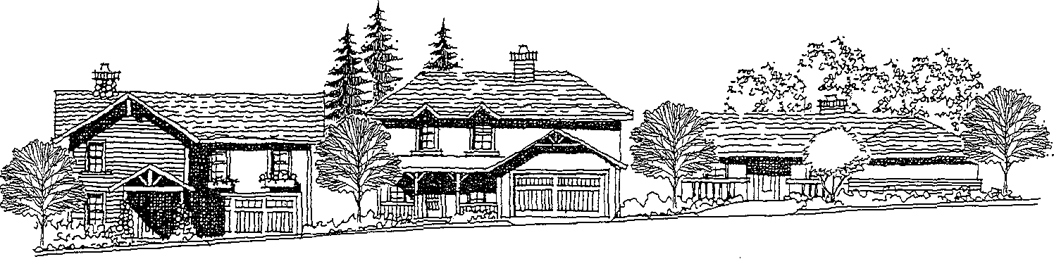

Attached homes will incorporate the same architectural elements as single family detached homes. Attached homes shall express individuality through careful massing, clearly identifiable entries and private outdoor spaces.

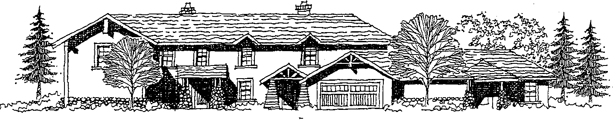

005, 829 B G P iQ9

Roof Forms

Variation in roof forms and ridgelines will provide added visual interest and serve to break down massing. Varying vs. repetitive roof forms are encouraged. Major roof forms shall predominantly run parallel to the street so that the buildings' roof materials are visually pronounced. Gable ends should be located on the side elevations where they are less visible. Variations in roofing materials and color will be encouraged to provide added interest.

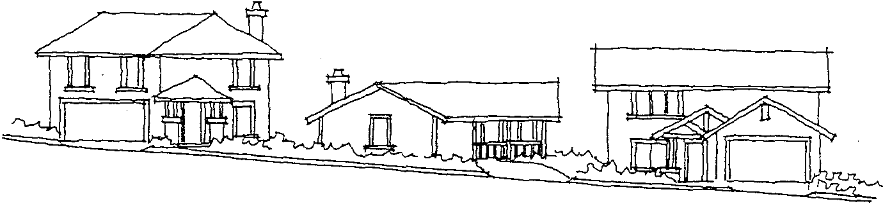

Plan Forms

Consistent with the architectural styles selected, plan forms will be simple yet provide enough variety to create visual interest. Decorative porches will be a design element, which is encouraged. Location and position of the garage, as it relates to the street, should be varied. Two story homes will be fully stacked and representative of a traditional architectural treatment, with single story homes intermixed to provide street scene variety.

Floor plans will be designed to meet the needs of the marketplace. Special emphasis will be placed on the function of the plan and its relationship to private and public exterior spaces. The goal is to design homes which provide adequate privacy for the homeowner but also encourage interaction within the neighborhood.

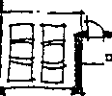II_

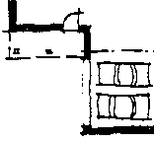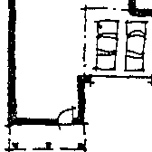

Garage locations, as they relate to the street, will vary. ..

CZtD:::J: .£ ...:£829 §r.:01335 Ps Ji44-0

Accessory Structures

Accessory structures such as mailboxes and trash enclosures shall be designed to be compatible with the neighborhood architecture and, where possible, sited so as to be the least obtrusive visually. Equipment such as air conditioning units, antennae, and satellite dishes shall be placed in locations which afford the least impact as well. Any solar collection panels must be integrated into the roof design and match the slope of the roof. Any exposed metal surfaces shall be colored to match the roof.

Architectural Styles

The architectural vocabulary for Silver Summit will combine elements of Craftsman, Victorian and Prairie style architecture. The vernacular of the styles will be the foundation upon which the project architecture is developed.

The following sections describe and illustrate compatible elements of each of these architectural styles. These elements may be used in an authentic character or in a contemporary interpretation. The intent is to encourage the development of product types, which are designed within the framework of these styles and the community theme, resulting in a distinct look, which is compatible with the area's mountain character.

Craftsman Style

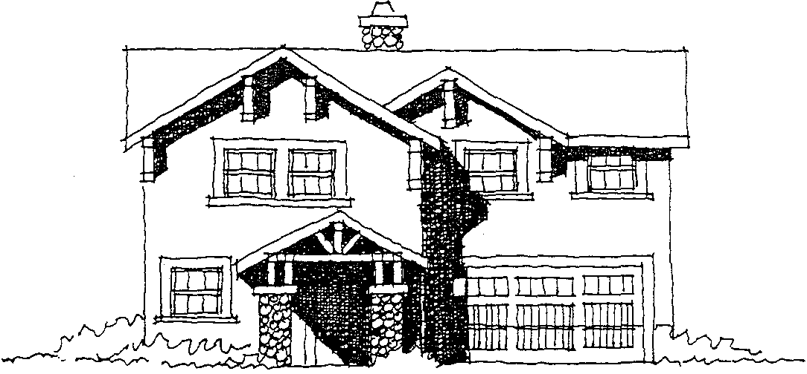

l()i]!S .r ..:s829 Bt:Oi335 Ps0i441

The Craftsman style of architecture is characterized by the following elements: A Character/Form
• Simple, clean forms
• One and two story elements combined to provide variety in the elevation
• Moderate roof pitches
B. Materials
• Wood, brick, and stone
C. Details
• Horizontal grouping of Multi-paned windows trimmed in wood
• Fancy exposed truss connections at gable ends
• Bracketed beam outlookers with proportions close to square
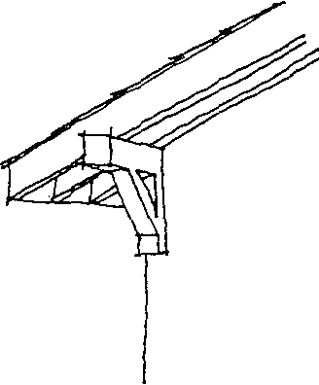

• Multiple wood porch columns, in combination of wood and stone or brick
• Tapered columns

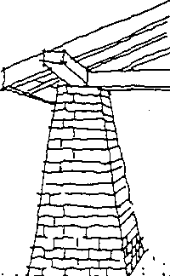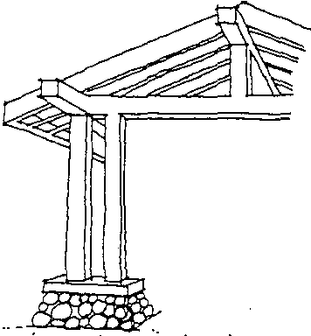

D. Color
• Warm earth tones

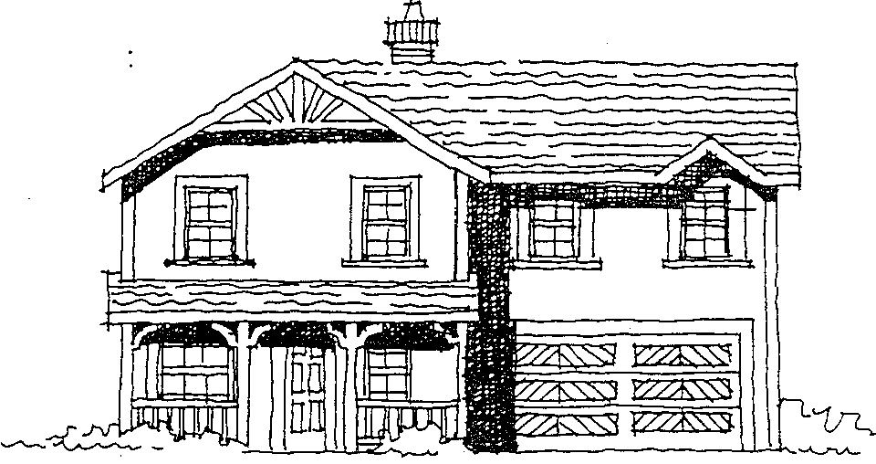Victorian Style

A. Character/Form
• Ornate detailing
• Tall, two story structures with generous porches and ornate detailing
• Steep roof pitches
B. Materials
• Brick and siding
C. Details
• Multi-paned windows with openings trimmed in wood

• Fancy exposed truss connections at gable ends

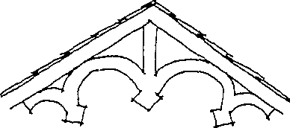

:)()5 .s329 § :01335

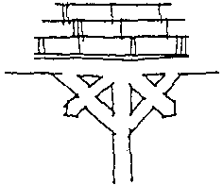• Detailed and intricately cut brackets at the juncture of porch posts and earns

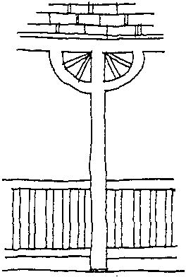

;::

• Wood railings with closely spaced vertical balusters
D. Color
• Rich, vibrant colors

Prairie Style

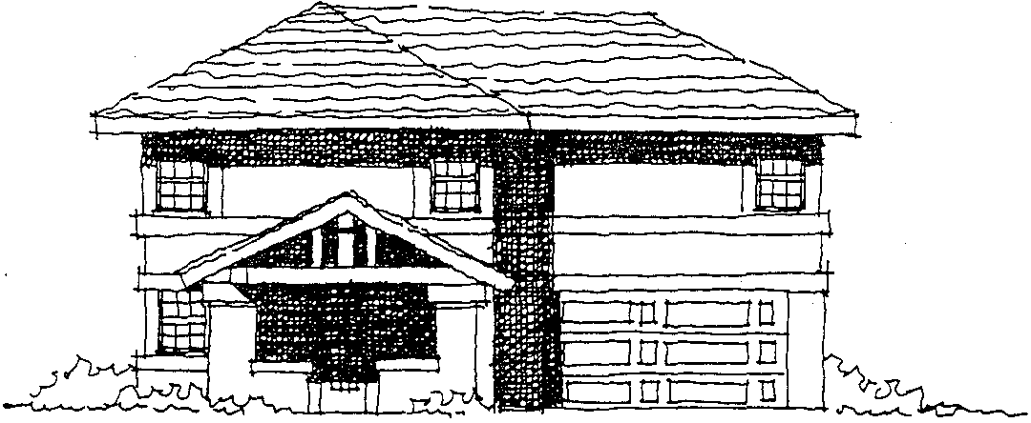

A Character/Form
• Simple, clean forms
• One and two story elements combined to provide variety in the elevation
• Hipped roof forms

;
:C !::"-Horizontal Banding with
Wood trim

• Moderate roof pitches
B. Materials
• Wood, brick, and stucco
C. Details
• Horizontal grouping of Multi-paned windows trimmed in wood

EEl
IL _l J
 | EE
 | H | -i

EE
I

Horizontal groupings of windows
Typical of "Craftsman" and "Prairie"

II I I I I I

style architecture ..

• Fancy exposed truss connections at gable ends
• Horizontal banding of wood trim
• Wide columns of stucco or brick; multiple wood posts similar to craftsman style offer a complimentary alternative
D. Color
• Warm earth tones

Materials

All housing types will utilize high quality and cost-effective materials, with a special emphasis on durability and low maintenance. Through the utilization of these materials, neighborhood quality and a consistent visual appearance will be maintained.

0057 829 kOUTI 01«5

Architectural Criteria Matrix

Item | Architectural Criteria
1 . Architectural Style | A. Combination of Craftsman, Prairie, and Victorian  elements utilized together to create a motif consistent with the mountain character of Summit County.
2. Plan Form | A. Combination of single- and two-story plans.  B. Combination of front, side, and rear positioned garages to create  variety  c. Simple plan forms utilizing elements of Craftsman, Prairie, and  Victorian architectural styles in combination with each other.
3. Exterior Elevations | A. A minimum of three (3) elevations per plan will be developed. B. Elevations will combine elements of wood, stucco, and stone.  c. Elevations for the same plan will be differentiated from each other  through changes to roofforms, material treatments, and exterior  detailing.
4. Exterior Detailing  4.I. Porches  4.2. Window detailing  ' | A. Front porches will be incorporated into each plan. A. Window patterns will be divided to achieve variety.  B. Window detailing will be emphasized through the use of stucco and wood trim details consistent with the Craftsman, Prairie, and Victorian architectural styles.
5. Exterior Materials  5. 1. Masonry  5.2. Wood  5.3. Stucco | A. A variety of masonry details will be utilized, including wainscoting and full height treatments, and column detailing.  B. Masonry will be used to create variety and emphasis at key exterior elements (i.e., porches, entries, and "popouts").  A Wood will be used primarily as a detail element or as a means of emphasizing a particular architectural fa9ade.  B. Siding will include combinations of horizontal and Board and  Batten patterns.  c. Wood will be used in some cases for window trim detailing.  A. Stucco is the primary exterior material treatment.  B. Stucco detailing in the form of window trims and horizontal banding will be utilized.
6. Color Schemes | A. A minimum of eight (8) color schemes will be developed for this project. Each <;:olor scheme will include stucco, wood, and masonry color treatments and material types.  B. The predominant color tones will be warm, earthy tones or muted  natural colors. Colors found in mountain forests, meadow grasses,  and hillside vegetation are appropriate.  c. Accent colors may be used but should not distract form the overall  design.

Item, continued | Architectural Criteria, continued
7. Site Planning and Plotting | A Homebuyers will be allowed to select the home of their choice, exterior elevation, color scheme, and the lot on which the home is to be plotted.  B. Individual plot plans with all homes that will fit on any given lot  will be developed consistent with the setback criteria established in the Design Guidelines for each Neighborhood.  c No two of the same color schemes may be plotted on adjacent lots.
8. Architectural Review | A For single family detached units, architectural review will be conducted by the Silver Summit Homeowners Association and shall comply with this matrix and architectural guidelines outlined  in the Silver Summit Design Guidelines. No futther County staff review will be required.  B. For single family attached units (Neighborhood Five), final  architecture and site planning will be reviewed and approved by the Planning Commission per the architectural and site planning criteria outlined in the Silver Summit Design Guidelines.

ARCHITECTURAL STANDARDS

1. Architectural Styles and Motifs

1.1. The architectural styles and motifs for Silver Summit are described in the Architectural Design Guidelines and combine elements of Craftsman, Victorian, and Prairie styles.
1.2. Prohibited Architectural styles and motifs are as follows: A-frame or Geodesic
dome structures; Mediterranean, Tudor or mock-tudor, Ornate Victorian, or
Colonial styles; and Swiss Chalet or Tyrolean motifs.

2. Siding Materials

2.1. The siding materials considered most typical of the mountain environment are wood siding, log, heavy timber, and glu-lam materials; angular native stones; and stucco. These principal materials shall be incorporated into each building design consistent with the design objectives in the Architectural Design Guidelines. Concrete products that replicate native stone may be used.
2.2. Variety in wall treatments shall be encouraged while achieving an appropriate
balance of harmonious materials
2.3. Stone or other accent materials used as a wainscot on the base of buildings is appropriate and consistent with the Architectural Design Guidelines.

3. Exterior Wall Architecture

3.1. Where the side of a building is visible from a public area, such as another roadway (i.e., a corner lot) or park, the visible side wall treatment shall be of similar character and quality as the front of the building.

4. Exterior Wall Appurtenances

4.1. Features such as awnings, flower boxes, balconies, exterior decks, and other similar enhancements shall be considered. All such features shall be scaled appropriately the building.
4.2. Balusters and railings, when used, should be designed in a simple straight­
forward manner.

5. Color Palette and Texture

00;:)7...5829 3 ::)1335

5.I. The predominant tones shall be colors which are warm earthy tones or a muted natural color.
5.2. Light to dark shades of wood are appropriate.

5.3. The colors found in the mountain forest, the meadow grasses, and hillside vegetation are appropriate.
5.4. Moimtain flower colors are appropriate accents. But accents should not be glaring and should not detract from the overall design.
5.5. Uniform color and texture for walls should not be discouraged, but should be used judiciously as architectural elements.

6. Roof Materials and Fire Ratings

6.1. The materials used on a pitched roof shall complement the building design.
6.2. Reflective materials or bright colored materials are prohibited on a roof.
6.3. Roof materials shall be constructed with minimum UL listed Class A fire rated roofing materials. Such may include asphalt shingles, tile, metal, sheet iron, and other appropriate materials. See Architectural Design Guidelines for specifics.
6.4. Chimneys or stovepipes on any solid or liquid fuel-burning appliance must have spark arresters or screens.

7. Roof Shapes

7.1. Variation in roof forms and ridgelines to provide interest is described in the
Architectural Design Guidelines and shall be followed.
7.2. Single family attached buildings should also exhibit variation in form and should have an overhang appropriate to the scale of the building. Refer to the Architectural Design Guidelines.
7.3. Roof design techniques that help to minimize the scale of two- and three-story buildings will be incorporated.

8. Mechanical Equipment on Roofs

8.1. Mechanical equipment on a roof must be hidden with a visual barrier so it is not readily visible from adjacent properties or public roadways, parks, or other public spaces.

9. Roof Appurtenances
 | 9.1. | Features such as dormers or other articulation of the roof consistent with the
 |  | Architectural Design Guidelines shall be considered on pitched roofs to add
 |  | visual interest and character. Such features shall be in scale with the roof and
 |  | shall not dominate the architecture.
10. | Win | ow and Door Treatments

d

10.1. Architecturally significant and appropriate window treatment is encouraged, particularly where there is an associated pedestrian streetscape.
10.2. Untreated aluminum or metal window frames are prohibited. Windows shall be appropriately trimmed on the exterior and the size of the trim shall be in scale with the building fa9ade.
10.3. Mirrored glass is not permitted.

11. Fa ade

11.1. All walls described in Section 3 above that are greater than 60 feet, but less than 100 feet in length, must exhibit a prominent shift in the fa9ade of the structure. The shift shall be a minimum of 5 feet. A series of shifts may be appropriate provided that the cumulative off-set is at least 5 feet. A coordinated shift of both roofline and fa9ade is encouraged.
11.2. A long horizontal building shall include vertical design elements to break up the building mass. The number and scale of such elements shall be appropriate for the length of the fa9ade.
11.3. Required vertical and horizontal elements shall not be created by using paint schemes on the siding material.

14. Interpretation of Standards

14.1. The above architectural standards shall be promoted in all applicable designs.
Appropriate latitude shall be allowed and creativity promoted to achieve interest and vitality within Silver Summit.

15. Site Plan Considerations

15.1. It is the Developers intent to allow homebuyers the ability to choose their home, lot, exterior elevation, and exterior color scheme. While providing this flexibility, it is also important to assure neighborhood diversity within this process. To ensure this desired diversity, the following guidelines shall apply to all single family detached neighborhoods:
A No more than two of the same homes may be plotted next to each
other, and in this case, the exterior elevations must be different for each home.
B. No two homes next to each other may have the same exterior color scheme. Exterior color schemes shall be used to provide variety while ensuring compatibility.
C. Individual homes will be designed with varying garage locations to aid
in providing more diversity in the streetscape.

(JiJ!S /-6329 B- -:Oi-335

LANDSCAPE DESIGN GUIDELINES

LANDSCAPE CONCEPT

Silver Summit is situated in the rolling terrain of the East Basin Neighborhood Planning Area. The dominant vegetation consists of a sagebrush I native grass community. There are no
trees existing on the property.

The landscape concept envisioned for Silver Summit attempts to place this development within the natural surroundings with a design that attempts to be sensitive and compatible with the native landscape. The majority of the site will be preserved in open space-and, much of that will be preserved as native open space..

The proposed planting scheme draws upon the natural setting and incorporates a plant palette sensitive to the existing plant community. Because development is being introduced, the result will not, of course, be a pure recreation of the native landscape. However, the final
plan seeks to blend the proposed homes and supporting infrastructure into the landscape.
Immediately adjacent to the proposed homes, the landscape will be developed more intensively, but seeks to create a nearly seamless interface with the preserved native areas.

Several elements will combine together to help create this landscape approach. These are described within this section.

\
\

\
I

I
I
J

Legend

Qj
883-J
Scenic Corridors
• Native Revegetation & Enhanced Plantings
Arrival
• Enhanced Plamings
Neighborhood Street Trees

Open Space Corridors
• Native Revegetation
Enhanced Landscape for SFA Neighborhoods

Buffer
• Native Revegelation & Enhanced Plantings
Village Square
• Lawn & Trce Plamings!Active Recreation Area

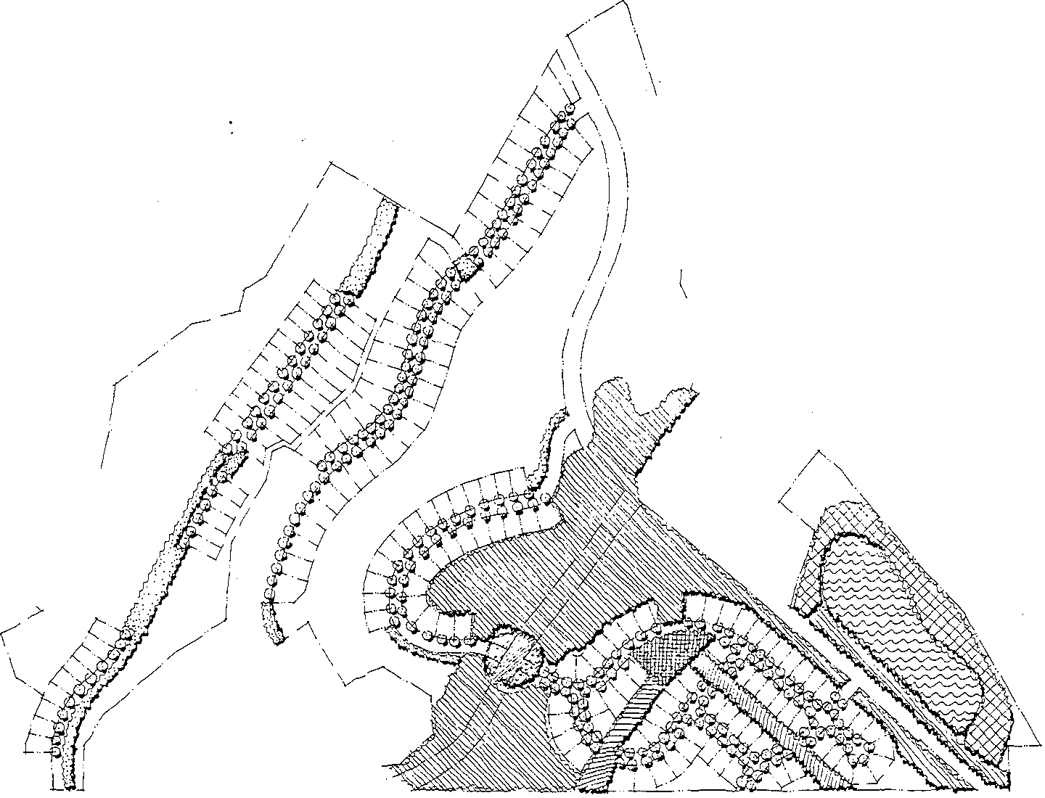0 Native Revegetation

Silver Summit Design Guidelines
Landscape Concept Plan

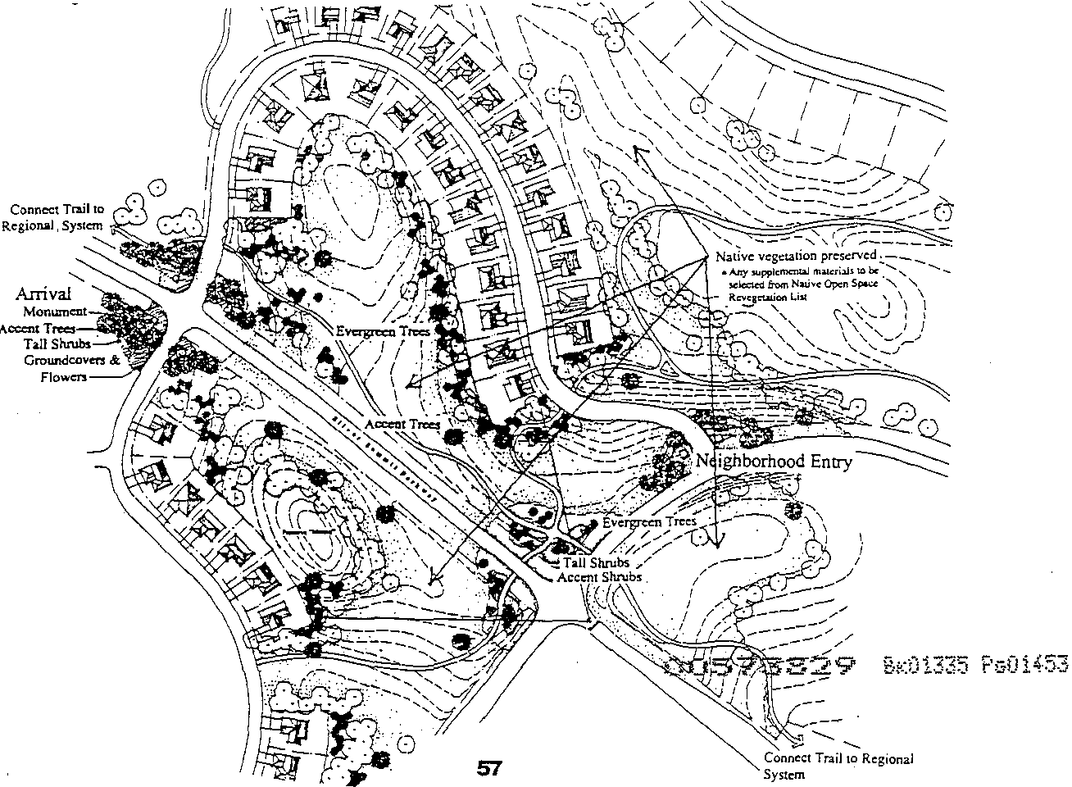Arrival Statement: .The Meadow

A large and spacious meadow dramatically announces arrival to Silver Summit. It surrounds the intersection of Silver Summit Parkway and Highland Drive and extends to Highway 40. This generous meadow preserves much of the existing open space and sets the tone for the open character and natural landscape treatment of Silver Summit. The scale of this space makes it a dominant feature and appropriate arrival for this and any expanded development that may occur further along Silver Summit Parkway.

The meadow is a combination of preserved native vegetation and supplemental plantings of native grasses and indigenous wildflowers surrounded and contained by masses of tree plantings. The wildflowers will provide a delightful and dramatic display of color throughout the growing season. The trees are a combination of evergreen and deciduous species to offer variety as well as strategic screening at edges of development. The screening is enhanced
with the use oflarge shrubs.

It is intended that drip irrigation will provide water to the trees and possibly to the planted shrubs; but all other vegetation, i.e., the existing community and the supplemental grasses and wildflowers, will survive without supplemental irrigation.

The meadow will dominate the landscape and help to relegate any development to a secondary role.

Scenic Conidors

Silver Summit Padcway is to be maintained as a visual corridor. Housing units have been set back from the road to provide the generous open space corridor. The meadow described above becomes a major element in this visual corridor. Its wildflowers provide color and interest. Tree plantings surrounding the meadow will help to screen and interrupt views of houses from motorists traveling Silver Summit Parkway.

The site plan has preserved the two "mounds" situated on the north and south sides of the parkway. These significant features provide topographical interest within the scenic corridor and also provide a physical and visual separation for much of Neighborhoods Three and Four. The site plan also provides a major open space corridor into and through Neighborhood Four from the intersection of Silver Summit Parkway and Highland Drive. These site plan
elements along with plantings of indigenous trees and shrubs will protect and enhance this
scenic corridor.

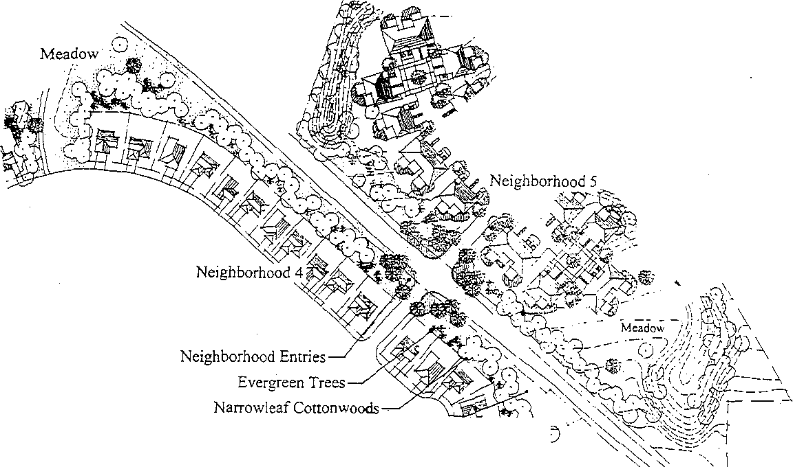South Highland Drive is a narrower corridor than the one provided for Silver Summit Parkway but is still generous in size. It also incorporates deciduous and evergreen trees to screen houses. Meadow plantings provide color, interest, and blend it into the native surroundings. Two major landscape elements within Neighborhood Five have a strong influence on this Drive. The berming around the neighborhood and the large meadow within both come up to Highland Drive to provide topographic interest and flower color.

Meadow -?Z---!;(o 'c_-,

Native Vegetation Preserved- -EtL--

Edge Conditions

Within Silver Summit the edges of development have received special consideration. To separate development from Highway 40, an entire parcel ofland (Parcel6) located between Highland Drive and the Highway has been dedicated to open space. This parcel provides a buffer of 190 to 540 feet for an effective physical and visual separation.

The development Plan provides for Neighborhood 5 to be located near Highway 40 south of Silver Summit Parkway. In order to screen the development, it will be set back from the highway a minimum of 150 feet and surrounded with a berm. The berming will be gentle undulating forms varying in height up to fifteen feet. The berm's screening effect will be enhanced with plantings of indigenous trees and native sagebrush community understory plantings.

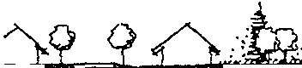_::· ..·.. ' ·va"· •( t' •'"(5$
 |  |  | Neighborhood 5 | US Highway 40

I

Neighborhood 4
.,
l Open Space Buffer

Where housing development meets open space, it is intended that there be an immediate transition from that development returning to the native landscape. Plant palettes for the development areas have been carefully formulated to provide compatibility and natural transitions to the native landscape. Where it may be necessary to reclaim disturbed areas, these will be revegetated with native materials enhanced with appropriate trees and native
flowers.

.-.··

Neighborhood 1 Open Space

Native Vegetation to Remain
Neighborhood 3
L E'nhanced Landscape
l
>

Transition Zone Enhanced with Native Trees, Shrubs and Flowers

Neighborhood Concepts

Neighborhoods One, Two, and Three will be lined with traditional plantings of street trees to define and give scale to the neighborhood streets.

Front yard landscaping will be done by individual homeowners, and will be an important addition to the streetscape in these neighborhoods.

When the natural open space comes up to meet the neighborhood street, the street trees will drop away and the native landscape will be dominant. Any disturbance, through construction, of these areas will be repaired following the guidelines given in "Native open space restoration" within the section titled "Common Areas" in these landscape guidelines. These native areas may be supplemented with indigenous trees and native flowers to enhance the screening of adjacent homes and heighten the visual interest of these native open spaces.

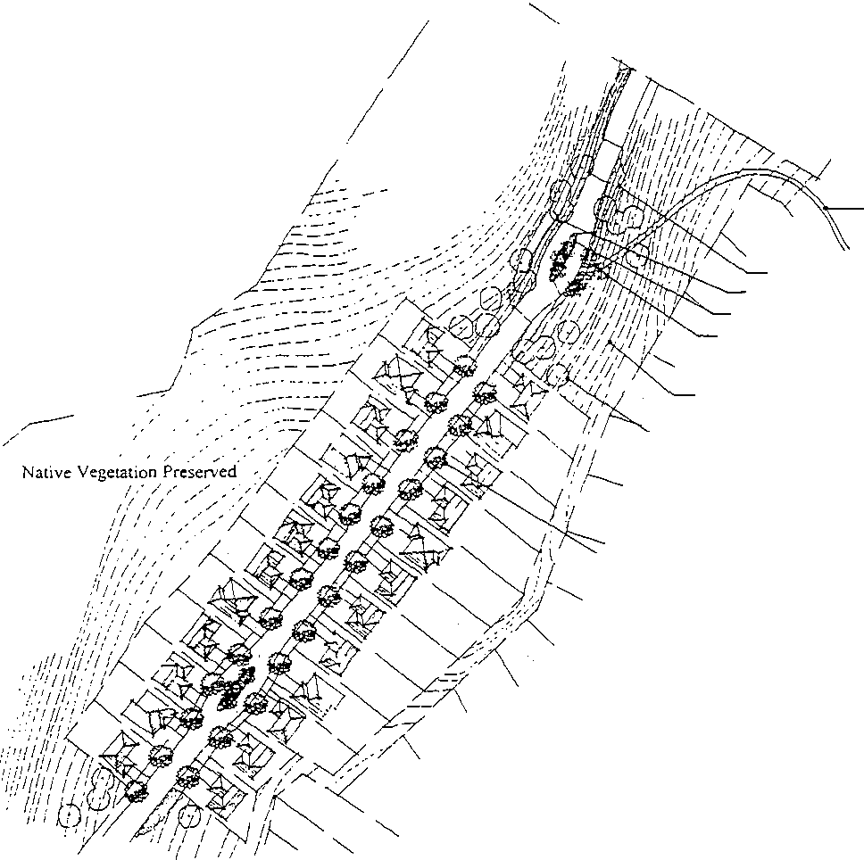I

Trail

Native Revegetation
4 ft. high Retaining WaH
Landscaped Median
Accent Trees

.-- Native Vegetation Preserved
Narrowleaf Cottonwood

/

/
Street Trees/Typical
( .! SO' o.c.

30573829 g :.01335

Neighborhood Four is also a Single Family detached neighborhood, and like Neighborhoods Two and Three the.homes are located on smaller lots, providing more open space around the lots. The planting scheme for this neighborhood also incorporates a traditional street tree planting while providing uninterrupted views into the open space areas.

Neighborhood Four is sited around a central village square. This significant open space will be discussed in "Common Areas" below, but will incorporate a traditional street tree planting.

On the interior of the neighborhood streets, open space corridors are an important part of the site plan. These corridors play a dominant role in defining the character of the landscape. Their treatment is described under "Common Areas", below. Outside the streets, the landscaping of corridor connections will respond to the native plant community. Enhancements will be made using indigenous trees and native flowers.

As in Neighborhoods One, Two, and Three, the front yard landscaping is to be done by individual homeowners and will make a significant contribution to the streetscape.

Common Area Meadow

Open Space Corridor
Meadow Planting

Native Vegetation Preserved
Street Trees/Typical
:t 50'o.c.

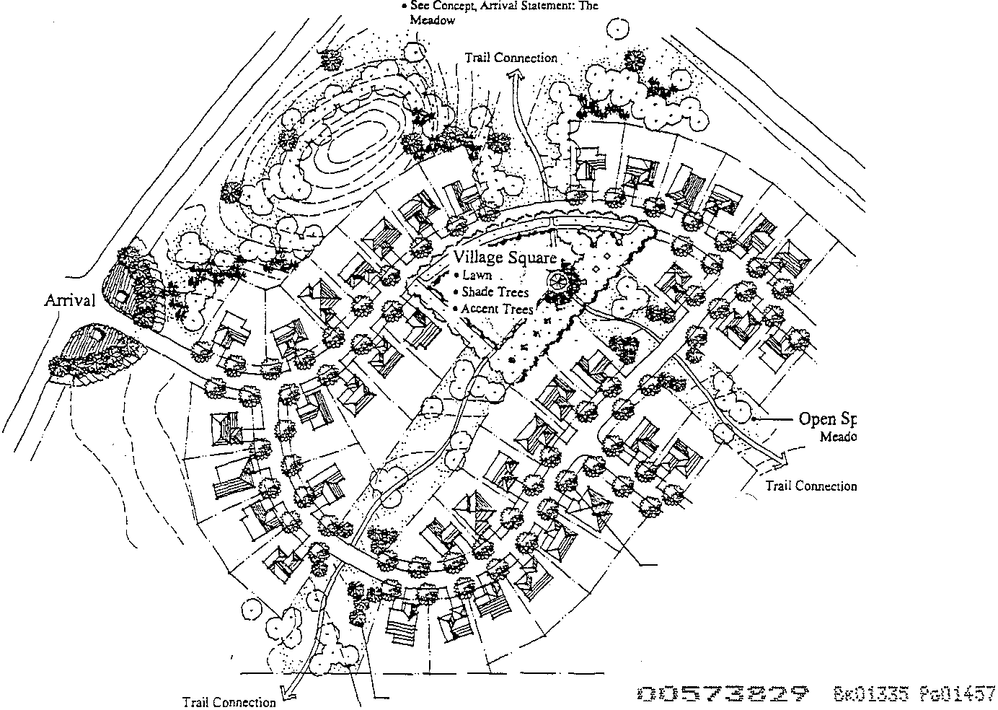

Accent Tr esffypical
\.... J>larr·owlleafCononwood

. Neighborhood Five, is a Single Family attached neighborhood. Extensive.open space has been preserved and surrounds the units. The planting scheme for this neighborhood incorporates an informal massing of trees and front yard plantings of shrubs, groundcovers, and limited lawn areas along the streetscape. Rear yards may be fenced and may include patios or decks. Shrub plantings will soften and enhance these rear yards. Lawn pathways connect units to each other and to a potential useable lawn area.

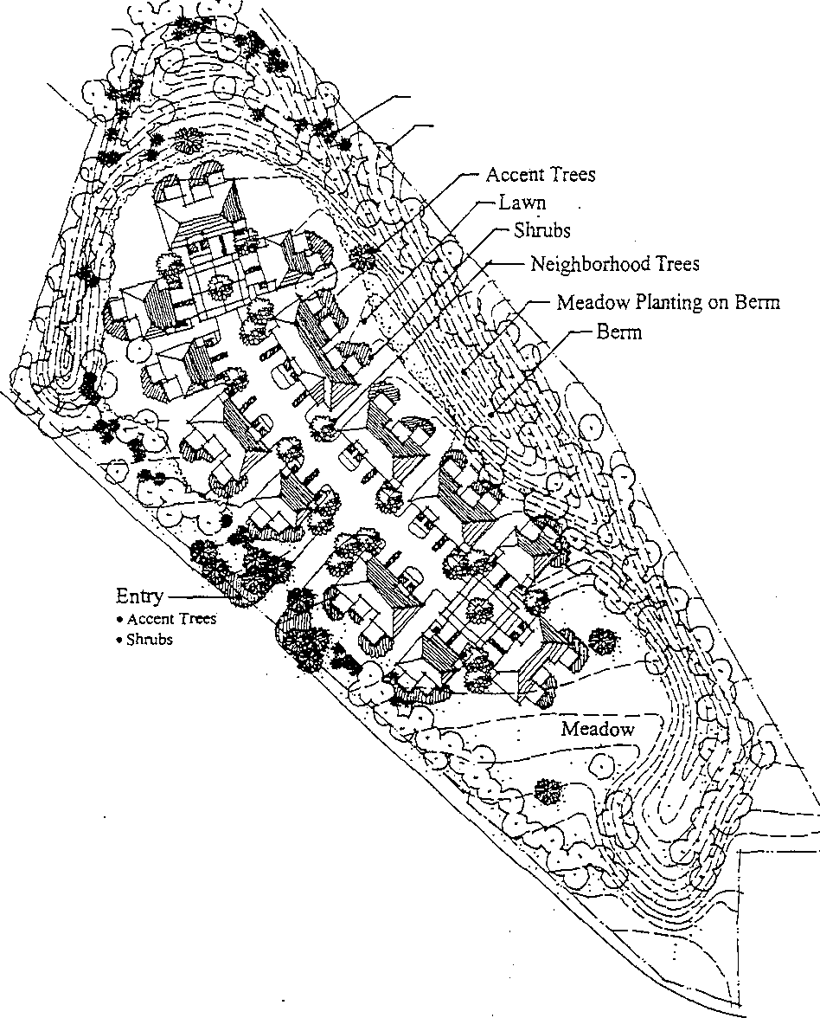Although the plan calls for major re-grading of the site to create the proposed benning, the attempt will be to create a landscape that simulates the natural landscape. Because so much of the site will be disturbed through grading, a significant portion of the landscape restoration should rely on meadow plantings to blend with the native landscape.

Evergreen Trees
Narrowleaf Cottonwood

Aunrival onurnent

At the Northwest end·ofthe Meadow(descnbed above), this anival statement is terminated with anode identified as the "Arrival". This anival consists of a pair of stone monuments-one at each comer to the south side of the intersection formed where the streets to Neighborhoods Three and Four meet Silver SlUili!lit Parkway. These monuments are intended to consist of a pilaster approximately 6 feet square at the base, 5 feet square at the top, and 8 feet tall. Attached to the pilaster is a 6 feet tall stone wall Which projects away from the road approximately 30 feet in length until it disappears into the slope of an artificially created berm. Each wall will have a sign identifying Silver Summit The scale of these monuments has been determined to be in scale with the anival meadow, Which will be a significant open space feature with grand proportions.

Surrounding these monuments is an informal planting of accent trees, shrubs, groundcovers, and perennial wildflowers for interest.

These elements are intended to combine to form a bold arrival statement which will effectively identifY Silver Summit at its gateway position within the regional development. The concept described is illustrated below.

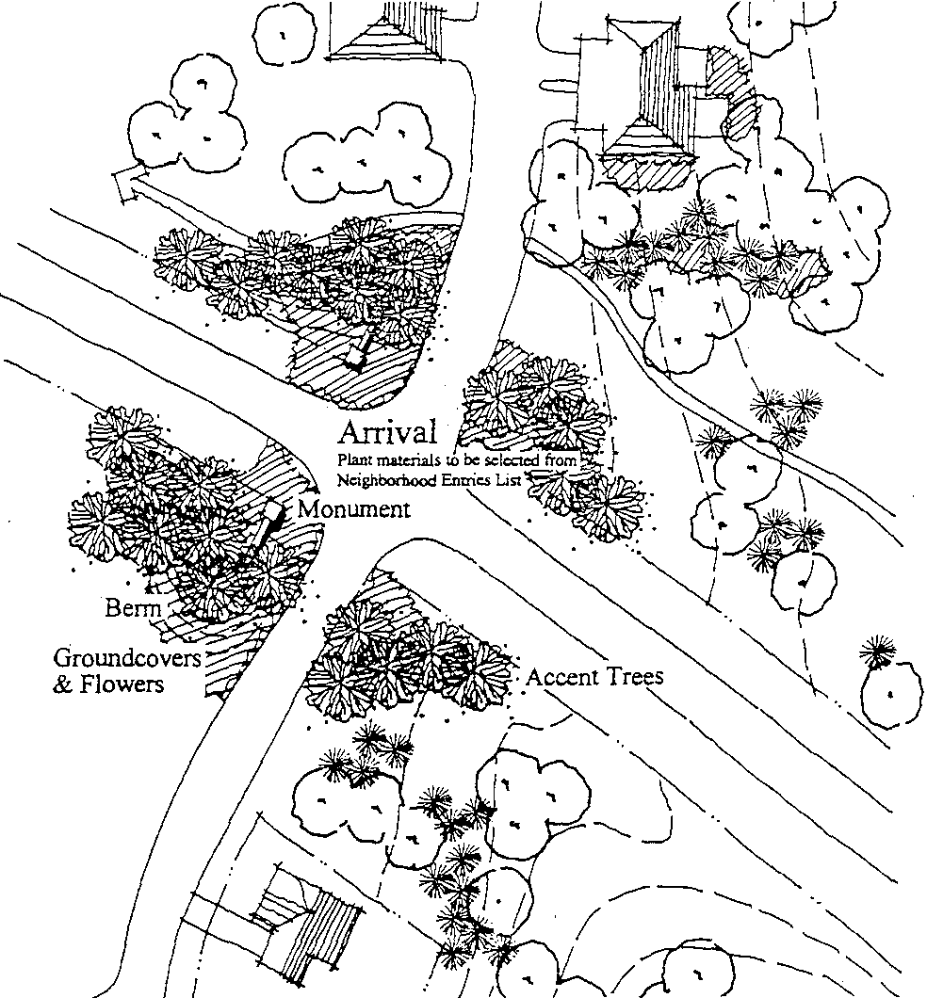

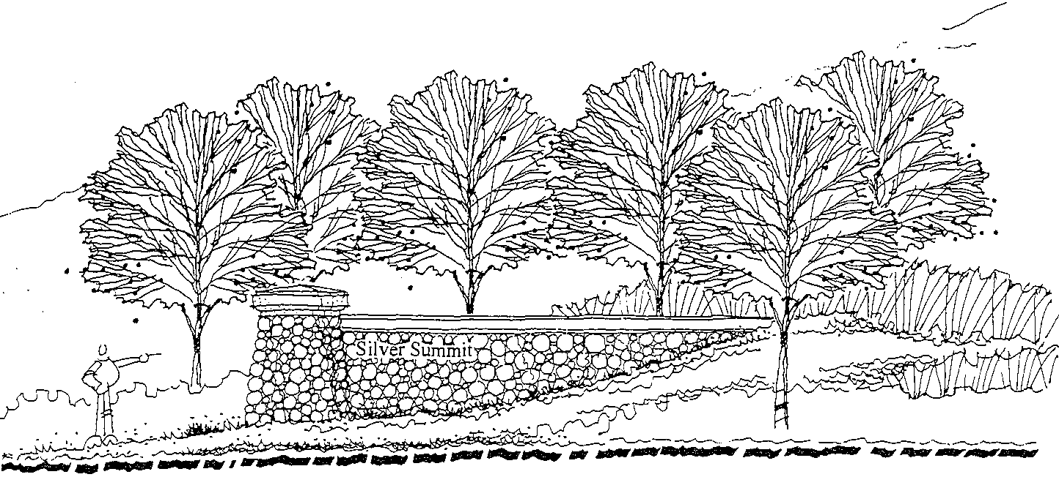

Neighborhood Entries and Signage

The opportunity exists to identify each neighborhood with individual signage and/or monumentation. Possible locations for these entries are shown on the plan.

Whether or not a neighborhood is identified by signage or monumentation, plantings will be used to enhance and identify each entry. Special accent trees will mark these locations and simple under-story plantings with generous use of native wildflowers will identify these entries as special features.

Refer to the Sign Regulations, contained herein, for standards related to temporary marketing/sales signage.

DCtS ..". ' ...sS29 Bt-.:01335 Pu0i4·60

Street Lighting

Street lighting is intended to provide low levels of lighting for safety and security of the neighborhood. The use of energy efficient light fixtures is encouraged. Light design and fixture type shall be similar to that illustrated.

0
"">"
"'@
0
0 0"
0
<2
-
-

0057..s829 g;:.01335 f's01461

Fencing

Fencing of the yards is not intended as part of the project development, but guidelines are offered for individual residents to enclose their yards as desired. However, the goal is to keep the overall landscape of Silver Summit open. The proposal provides for open rail fences to provide boundary definition with unobstructed views. Ideally, these fences should be three feet tall, but never more than four feet tall.

Some privacy fencing may be desirable around the small exclusive use (patio) areas at the attached housing in Neighborhood Five. Here, a solid fence should be an architectural extension of the building. These fences should be five feet tall and six feet maximum.

0

3 ft.
4ft. Max.

Open Fencing

- f' -

6, {,
:

5 ft.
6ft. Max.

- .---

Privacy Fencing

005/ 829 Bril 5P i%2

Common Areas

Native open space restoration
The native, or "natural", environment of Silver Summit is considered a valuable asset. And since so much of each site is being preserved as open space, this landscape will continue to dominate the overall character. Whenever construction disturbs this vegetation, replacement will incorporate the major species of the plant community. Along roadways within the neighborhoods, this revegetation will additionally incorporate indigenous wildflowers to enhance the open space and provide the neighborhood additional color and interest.

Village Square
The village square in Neighborhood Four is a special place and will receive special landscape attention. This square serves not only as a neighborhood focal point for activity, but also as a terminus for a proposed vehicular/pedestrian link with future development to the southwest.

The overall landscape theme will accentuate the square with a ring of linear tree plantings. Large flat lawn areas will provide opportunity for varied activities, ranging from small group and family play to community functions or celebrations. It is intended to be a high use activity area.

Situated in the center of the square will be a pavilion to provide a traditional character to the square as well as to provide opportunities for picnicing and anticipated community activities.

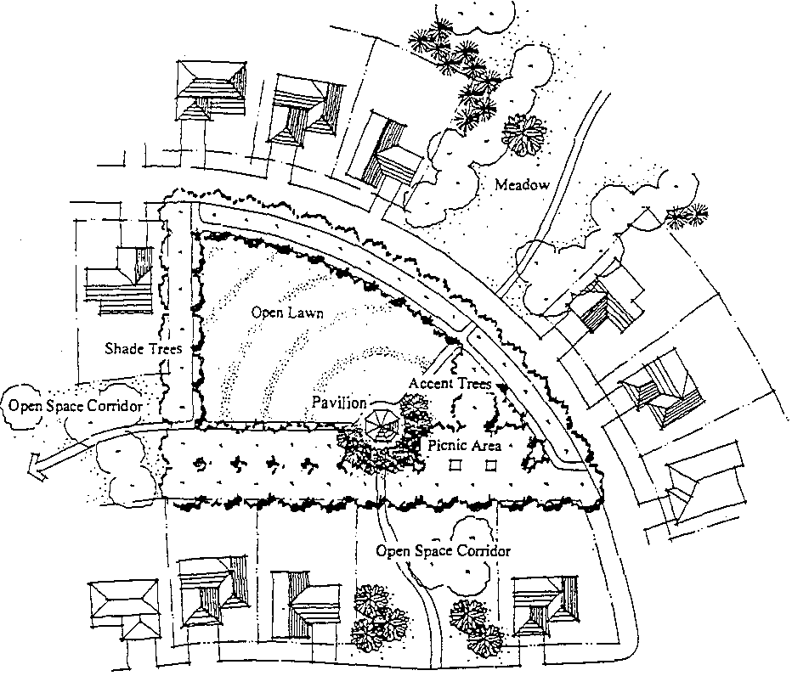

00 / 829 k01TI5 014

--,

Open space corridors
Each Neighborhood in Silver Summit is surrounded by and incorporates open space corridors which provide a unique openness and trail opportunities_ In Neighborhoods Two, Three, and Four lots are made smaller and clustered to provide added open space. In Neighborhood Five, attached units provide increased open space opportunity_ The site plan provides some distinct open space advantages and opportunities. A positive visual impact begins at the project arrivaL All the way from Silver Summit Parkway and Highland Drive a major open space corridor disguises the surrounding homes. From the streets within each neighborhood, these open space corridors offer frequent "windows" which provide visual relief and long views
into the open space.

Another advantage is the activity opportunities provided by this open space. Opportunities exist for play areas as well as hiking and biking trails with anticipated connections to regional trails well beyond the Silver Summit Community boundaries_

These open space corridors will be either preserved as native landscape or will be landscaped as "mountain meadows" with native grasses and wildflowers. The particular landscape treatment in each neighborhood is illustrated on the Conceptual Landscape Plan.

Maintenance
Maintenance of these significant open spaces is of utmost concern. Homeowner Associations will be formed and eventually operated by the residents of Silver Summit These associations will have the responsibility to care for these permanent open space environments.

68

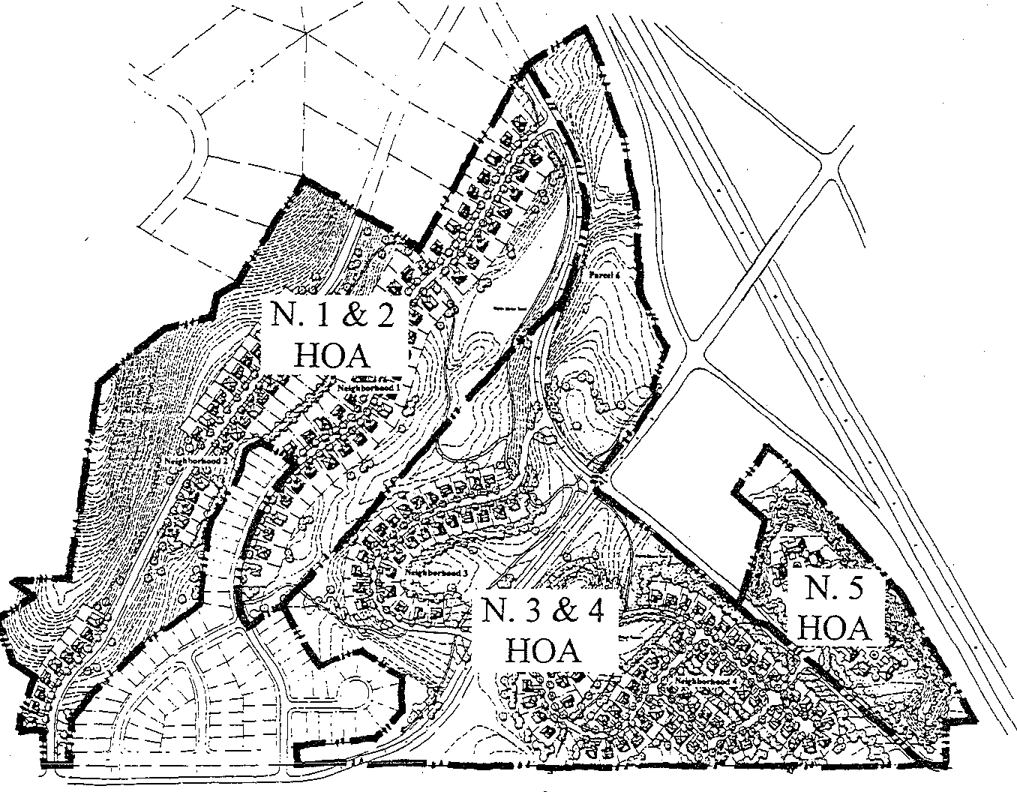

Notes
• Regional trails are to be maintained by the Snyderville Basin Special Recreation
District
• Except for private streets in Neighborhood Five, all other neighborhoods contain dedicated public streets. This graphic does not imply private maintenance of public streets or utilities.

Silver Summit Design Guidelines
Open Space Maintenance Responsibilities

69

Trails

Neighborhoods within Silver Summit will be connected with trail systems. These trails will connect neighborhoods with one another and to regional trails beyond Silver Summit's boundaries. These trails meander through open space corridors within Neighborhoods Three and Four and then extend through the native open space areas between and surrounding each neighborhood.

Off-site trail connections are anticipated to extend trails through Silver Summit to other destination points in Summit County. Consistent with the Conceptual Trails and Parks Master Plan for the Snyderville Basin, 1996, two regional trails traverse Silver Summit.
(1) An east-west connection lies within the Silver Summit Parkway scenic corridor;
and
(2) A north-south trail runs from Silver Summit Parkway and through Neighborhood
Four to eventually connect Silver Summit to the regional park to the west.

There are two hierarchies of trails envisioned:
1. The regional trail connections described above will be paved with asphalt. These trails shall be 8 feet wide and accommodate both bicycle and pedestrian traffic.
2. Secondary trails connect neighborhoods to regional systems and shall be 5 feet wide and may be constructed of either a loose natural surface, such as bark chips crushed gravel or native soil to provide a suitable surface for pedestrians; or compacted road base to provide a biking surface.

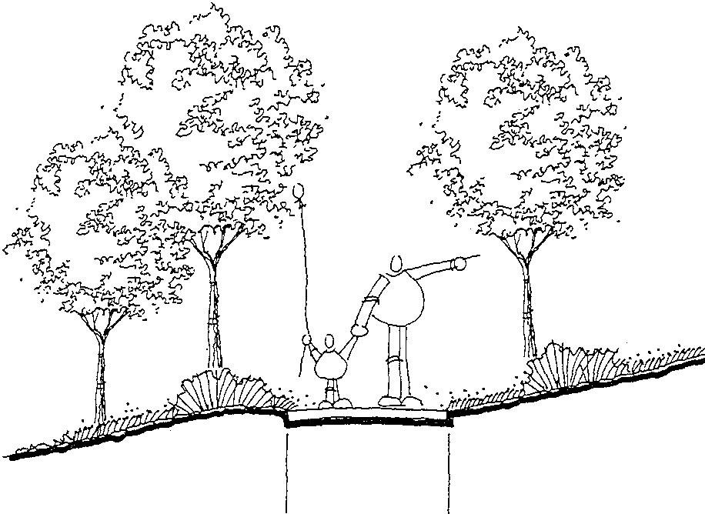

8ft. Regional Trail I Asphalt
5 ft. Secondary Trail/ Soft Surface

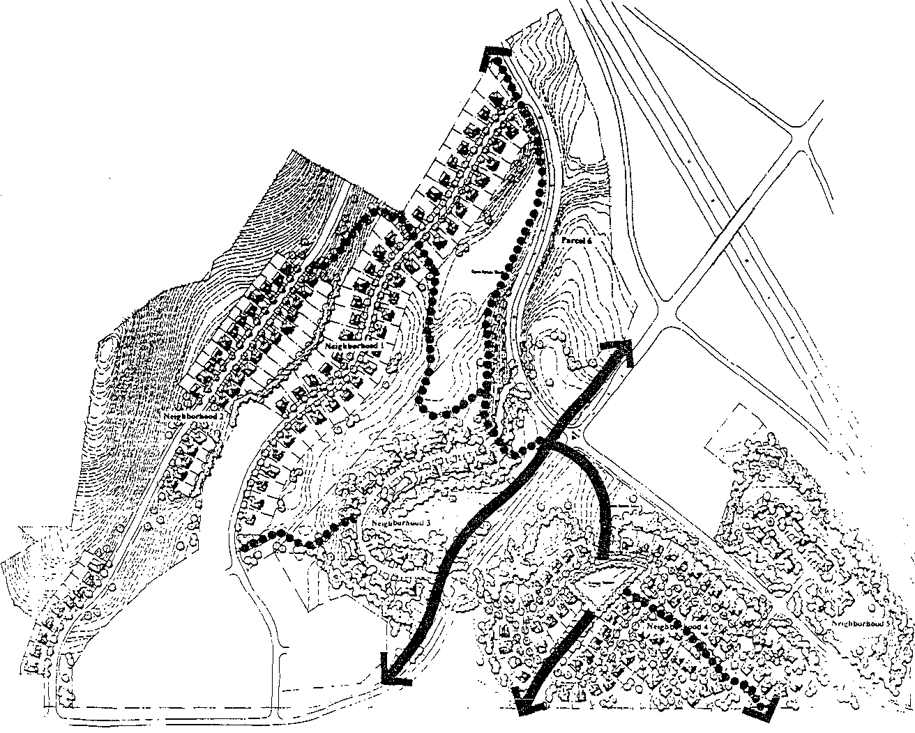

Legend

Regional Trail Connections
•••••• Secondary Trails

\ ' .,

Silver Summit Design Guidelines
Trails Plan

LANDSCAPE STANDARDS AND REGULATIONS

1. General Requirements

1.1. Where trees and shrubs are cleared from a site, the clearing created shall maintain a non-linear edge, along which the disturbed portions of the site blend effectively with the natural vegetation.
1.2. There are no trees existing on the site, but development shall preserve existing healthy shrubs or vegetation wherever possible. A limit of disturbance fence may be required to minimize impact on the natural vegetation.
1.4. Plantings shall be contained so as not to grow into and obstruct views and so as not to interfere with utility lines or road illumination, and so as not to obstruct the line-of-sight needed for road and trail intersections.
1.5. The plant materials listed in section 6 Recommended Plant Materials are designed to complement native species and provide continuity with the surroundings. The use of drought tolerant species and species tolerant to the climatic conditions of Summit County is encouraged. The use of flowering shrubs, groundcovers, and perennials in strategic locations is encouraged.
1.6. The specifications for all plant materials to be used in the development of Silver Summit shall accompany the application for development approval. Specifications for all plantings shall be in conformance with the American Standard for Nursery Stock. The materials proposed for use shall be suitable for the area's elevation and climate.
1. 7. Any areas intended to remain as native but disturbed during construction shall
be restored, using materials identified. Then beyond restoration, visible areas may be enhanced with trees and native flowers.
1.8. Replacement plantings shall comply with the approved landscaping plan or alternative plantings as approved by the Department of Community Development.
1.9. Grass, seed, sod and other materials shall be clean and reasonably free of
weeds and noxious pests and insects.
1.10. Trees shall be massed in conjunction with open spaces to reinforce and define areas and to encourage their use and attractiveness.

2. Materials and Installation in Single Family Attached Development: Neighborhood Five

2.1. Required landscape clusters
00573829 8 .:0

A In addition to landscape required throughout a project area, Neighborhood 5 shall include clustered landscaped areas appropriately situated along the scenic corridor and between buildings so as to serve

as an effective screening device for each structure as viewed from the road or other structures. The location and area of such clusters shall be determined during site plan review. However, each cluster shall be appropriately proportioned for the area to be landscaped.
B. Within each cluster, landscape materials shall comply with the following standards. These standards may be increased when buildings are large-scale in nature.
1) Coniferous trees shall be planted to provide additional year­ round screening. They should be placed in tight groupings and should be spaced irregularly to provide a natural appearance. Placement should provide for some, but not all trees to touch branches at maturity. Coniferous trees, at planting, shall be at least four (4) feet in height.
2) Deciduous trees shall be planted at an appropriate spacing for the mature size of the particular specie. They should not be spaced evenly, but should be located randomly for a natural appearance. Deciduous trees, at planting, shall be at least 1 Yz" caliper.
2.2. All other deciduous and coniferous trees required
A All other common areas shall be planted using 50% minimum 1 Yz" caliper trees and the balance using 1 W' caliper trees, unless the tree is a fast-growing specie (e.g., Populus angustifolia), in which case a five gallon container tree is acceptable.
B. All other c.ommon areas shall be planted with coniferous trees as
appropriate using minimum four (4) feet high material.
2.3. Grass lawn areas may be provided. Such areas should generally be kept to a minimum. It is appropriate to use lawn in activity areas and where it is useful to residents. Otherwise, it is more appropriate to maintain natural vegetation or to use another plant palette, such as the meadow described herein.
2.4. Wildflowers should be used in visually sensitive areas to provide visual interest, but should not be overused so as to dilute their effectiveness.
2.5. All required landscaped areas shall be provided with an adequate and
inconspicuous irrigation system as described in section 7 entitled Irrigation
Systems.
2.6. Soil preparation plans prepared by a qualified landscape architect or similar individual shall be required. The plan shall define planting procedures, soil composition and enhancement techniques and measures for maintaining proper soil pH.
2. 7. Careful consideration shall be given to proper planting techniques, ensuring
that vegetation is planned in proper locations based on availability or lack of sun exposure, wind, water, and other factors.
2.8. The use of mulch in shrub and perennial planting areas is encouraged to enhance water retention and weed control. A minimum 2 inch layer is

recommended. However, extensive use of mulch solely as a decorative element is discouraged. Mulched areas exceeding 100 square feet shall be planted with appropriate plant materials to provide coverage within 3 years.

3. Landscape Buffers and Berms

3.1. All landscape buffers shall be of sufficient width to accommodate plant materials to provide effective visual screening. Landscape buffers may be traversed by walkways, trails, or driveways.
3.2. Earthen berms shall be provided in Neighborhood Five. Berms shall have side slopes that do not exceed three (3) feet of horizontal distance for each one (1) foot in height.
3.3. In areas where there is a transition from structures to an identified viewshed (e.g., broad open meadows), landscape clusters that meet the standards in section 2.1 above shall be established to create an appropriate edge between developed and undeveloped areas.

4. Street Tree Plantings and Rights-of-Way Landscaping

4.1. Neighborhoods One, Two, Three, and Four are to be planted with formal street trees.
4.2. Optimal spacing for street trees is 50 feet on center. Adjustments must be
made for driveway locations and street intersections.
4.3. Street tree plantings must also respond to entry treatments which use accent trees for highlight.
4.4. Street trees will be located three (3) feet minimum from the back edge of a curb.
4.5. Street trees shall be a minimum 1 Yz" caliper size.
4.6. Lawn shall be planted and maintained within the street right-of-way to the edge of the curb by the homeowner.

5. Minimum Landscape Requirements

5.1. Shrubs in common areas or at entries shall be generally five-gallon minimum, but smaller-growing accent shrubs may be two-gallon.
5.2. Groundcovers shall be planted from flats or !-gallon containers.
5.3. Native wildflowers shall be planted from either 1 gallon or 4" containers.

5.4. Neighborhoods One, Two, and Three:
A Street trees shall be installed by the developer.
B. · Parkways shall be planted with turf by the homeowner.

5.5. Neighborhood Four:
A The Village Green will be basically level, with gradually sloping grades to fit the natural terrain, and planted with turf.
B. The perimeter of the village green will be lined with trees spaced at
±30 feet on center.
C. Shrubs and/or groundcovers may be used in the village green to enhance and define use areas or special features.
D. The open space corridors will be hydroseeded with a mixture of bunch grasses and native wildflowers.
E. Paths through the open space corridors shall be constructed by using compacted road base to provide a walking and biking surface, while keeping the materials compatible with the natural environment.

5.6. NeighborhoodFive:
A Landscaping immediately adjacent to the buildings shall be turf and ornamental plantings. These plantings will transition to the native plant palette.
B. Trees will screen and buffer buildings from the scenic corridor; will be
used to complement the siting of the buildings; and to reinforce open space areas.

6. Recommended Plant Materials

Plant materials have been selected to be compatible and complementary to the area. Materials used in the final landscape design shall be selected from these plant lists.

6.I. Scenic Corridors
Buffer plantings along Highway 40 and Silver Summit Parkway shall be selected from this list. Where scenic corridors bisect the "Meadow", see 6.2
Open Space Meadow.

A Trees: Abies concolor Acer glabrum Pinus aristata
Populus angustifolia
Prunus virginiana
Prunus virginiana 'Canada Red'

White Fir
Rocky Mountain Maple Bristlecone Pine Narrowleaf Cottonwood Choke Cherry
Canada Red Choke Cherry

Pseudotsuga menziesii
Quercus gambelii
Douglas Fir
Gambel Oak

B. Shrubs: Amelanchier alnifolia Cercocarpus ledifolia Physocarpus monogynous Rhus trilobata
Ribes alpinum
Rosa woodsii

Saskaton Serviceberry Mountain Mohogany Mountain Ninebark Oakbrush Sumac Alpine Currant
Woods Rose

6.2. Open Space Meadow

A Trees: Abies concolor Acer glabrum Pinus aristata
Populus angustifolia
Populus tremuloides
Prunus virginiana
Prunus virginiana 'Canada Red' Pseudotsuga menziesii
Quercus gambelii

White Fir
Rocky Mountain Maple Bristlecone Pine Narrowleaf Cottonwood Quaking Aspen
Choke Cherry
Canada Red Choke Cherry
Douglas Fir
Gambel Oak

B. Perennials Aquilegia spp. Baileya multiradiata
Balsamorihiza sagitta/a Castillega chromosa Cleome serrulata Gaillardia aristata Linum lewisii
Lupinus sericeus Penstemon cyanthus Penstemon eatoni

Columbine Desert Marigold Balsam Root Indian Paintbrush
Rocky Mountain Beeplant
Blanket Flower
Blue Flax Silky Lupine Wasatch Penstmon Scarlet Penstemon

C. Annuals
Coreopsis
Escholzia californica
Papaver rhoeas

Plain Coreospsis California Poppy Flanders Poppy

;JC 5 .r ...s829 £.t:Oi335 PuOi-{.72

6.3. Native Open Space Revegetation

A Tree:
Populus angustifolia
Juniperus scopulorum

Narrowleaf Cottonwood
Rocky Mountain Juniper

B. Shrubs and flowers:
Artemesia cana Artemesia cyanthus Atriplex canesceus Ceanothus martini

Hoary Sagebrush
Big Sagebrush
Four wing Saltbrush
Martin Snowbrush

Balsamorhiza sagittata Castillega chromosa Cleome serrulata Linum lewisii
Lupinus sericeus
Penstemon cyanthus
Balsam Root
Indian Paintbrush
Rocky Mountain Beeplant
Blue Flax Silky Lupine Wasatch Penstemon

C. Native Grasses

6.4. Neighborhood Entries

A Trees:
Acer grandidentatum Crataegus phaenopyrum Populus tremuloides
Prunus virginiana 'Canada Red'

Big Tooth Maple Washington Thorn Quaking Aspen
Canada Red Choke Cherry

B. Shrubs and Groundcovers: Arctostaphyllos uva-ursi Artemesia frigida
Comus stolonifera Mahonia repens Pachystima myrsinites Spiraea bumalda

Kinnickinnick Fringed Sagebrush Red-Osier Dogwood
Creeping Oregon Grape
Mountain Lover
Dwarf Red Spiraea

i:)iJ573829 gK01335 Pe0i473

C. Flowers: Aquilegia spp. Coreopsis lanceolata Delphinium elatum Echinacea purpurea

Columbine
Coreopsis
Candle Delphinium
Purple Coneflower

Lupinus Russel Hybrids Penstemon cyanthus Perlstemon eatoni

6.5. Street Trees

Acer grandidentatum Alnus tenuifolia Celtis occidentalis
Fra.xinus pennsylvanica 'Patmore'

6.6. Village Square

A. Tree:
Quercus macrocarpa

B. Accent Tree:
Crataegus phaenopyrum

C. Shrubs and flowers:
Aquilegia spp. Cornus stolonifera Lupinus sericeus Pachystima myrsinites Ribes aureum

6.7. Neighbomoods Three and Five

A Trees:
Acer grandidentatum Alnus tenuifolia Celtis occidentalis Populus angustifolia
Fra.xinus pennsylvanica 'Patmore'

B. Shrubs, groundcovers, and flowers
Aquilegia spp.
Asperula odorata Cornus stolonifera Gaillardia aristata
Russel Hybrid Lupine Wasatch Penstmon Scarlet Penstemon

Big Tooth Maple Mountain Alder Common Hackberry Patmore Ash

Bur Oak Washington Thorn Columbine
Red-Osier Dogwood
Silky Lupine Mountain Lover Golden Currant

Big Tooth Maple Mountain Alder Common Hackberry Narrowleaf Cottonwood Patmore Ash

Columbine
Sweet Woodruff
Red Osier Dogwood
Blanket Flower

Lupinus sericeus
Mahonia aquifolium compacta
Mahonia repens Pachystima myrsinites Potentilla fruticosa Ribes aureum
Spiraea bumalda
Silky Lupine
Compact Oregon Grape Creeping Oregon Grape Mountain Lover
Shrubby Ciquefoil
Golden Currant
Dwarf Red Spiraea

7. Irrigation Systems

7.1. Plant palettes are designed to provide predominantly drought resistant materials. But most plants installed will require some level of irrigation.

A Hydroseeded materials may require some type of general overhead water application to provide adequate moisture for germination and occasional watering to maintain optimum viability.
B. Shrub and tree plantings can be effectively irrigated with drip systems,
which are highly effective in conserving water.
C. Lawns, which have the highest water requirement are used sparingly.
The Village Green of Neighborhood Four is intended to be a high-use activity area. Therefore, lawn is an appropriate play surface. The private living areas of each yard throughout Silver Summit are also anticipated to contain lawn areas for private use. Lawn areas are most appropriately irrigated with overhead spray systems.
D. Irrigation systems shall be designed to minimize water loss to evaporation. The systems shall be designed appropriately to account for different water requirements between grass and planting areas, which may include shrubs, trees, and other similar materials

8. Maintenance of Common Areas

8.1. Common areas shall be maintained by one of the Silver Summit Homeowner
Associations.
8.2. The owner, tenant and/or their agent, if any, shall be jointly and severally responsible for the maintenance of all landscaping. All required landscaping shall be properly maintained at all times. All plant material shall be maintained in a healthy condition as is appropriate for the season of the year.
8.3. Landscape maintenance shall be ongoing and shall consist of mowing, edging, pruning, fertilizing, watering, and weeding, and other such activities common to the maintenance of landscaping.

JCI5.r 3.8?'9 Bt-:01335 Ps0i 75

8.4. Landscaped areas shall be kept free of trash and litter, weeds, and other such material or plants not part of the landscaping.
8.5. Dead plant materials shall be replaced promptly.
8.6. Irrigation systems shall be kept in good working order.

SIGN REGULATIONS

1. Purpose

I .1. The purpose of the sign standards is to promote and protect property values and enhance the aesthetic appearance of the community.

2. Permitted Signs

2. I. Arrival Monuments
A The monument illustrated within these Design Guidelines is intended to identifY the arrival to the region around Silver Summit.
B. Each of these distinctive monuments is intended:
I) To have a pilaster approximately 6 feet square at the base,5 feet square at the top and 8 feet tall;
2) To have an attached wall 6 feet tall and approximately 30 feet
long;
3) To be constructed of stone;
4) To have a metal sign of individual letters approximately 12" tall to identifY the Silver Summit community; and
5) May be lighted.

2.2. Neighborhood Entry Monuments
A Other Free Standing Monuments are permitted as neighborhood identification and are to comply with the following:
1) Monument base shall be compatible with the architectural materials used on the buildings within the neighborhood. A base of stone, consistent with the arrival monuments, is preferable.
2) In no case shall the display area exceed 64 square feet per side.
The display area of a sign, which may be double or four sided, shall include any architectural embellishments or background materials that are an integral part of the display and intended to help attract attention to the sign.
3) In no case shall the height exceed seven (7) feet.
4) All free standing monuments shall be located within a landscaped area. Landscaping shall be designed to complement the monument. Consider designs that integrate the monument into landforms.
5) Monuments shall not encroach into a road right-of-way and
shall not interfere with vehicular sight distance.
6) Monuments may be lighted.

2.3. Temporary construction site or marketing/sales signs shall be provided for during the entirt! construction and sales phases of the project
A These signs may be:
1) free-standing;
2) double sided or V-shaped;
3) supported by wood posts;
4) maximum 20 feet in height;
5) maximum 96 square feet;
6) in colors compatible with architecture and project marketing;
7) displayed during the marketing of the project until sales are complete;
8) two signs per development parcel;
9) lighted;
10) highlighted with flags. B. These signs shall not:
1) encroach on rights-of-way; or
2) be situated to interfere with vehicular sight distances measured
25 feet, as a triangle, from the edge of pavement.
2.4. Real Estate Signs are those which advertise the sale of the individual real estate (lot or unit) upon which said sign is located. These shall not exceed twenty (20) square feet. Real estate signs may remain in place during the time the property is listed for sale or rent, and shall be removed no later than one (I) week after the sale or rental of the property. No more than one (1) real estate sign shall be allowed per property, except that a comer lot may have one (1) sign per street front.
2.5. Informational signs which are not more than eight (8) square feet and no more than eight (8) feet in height and which are used to direct vehicular and pedestrian traffic or to direct parking and traffic circulation on private
property. Advertising is not permitted on these signs. These signs shall not be permitted in a right-of-way.
2.6. Flags and/or banners may be used at the locations of model home complexes and sales offices.

3. Illumination

3.1. Monuments and signs may be lighted. Sign illumination may be cast directly onto the face of the sign, provided that such illumination in no way adversely affects pedestrian and/or vehicular traffic.

4. Prohibited Signs and Devices

4.1. The following signs shall be prohibited in Silver Summit:

A. Flashing signs;
B. Roof mounted signs; C. Moving signs;
D. Neon signs;
E. Signs advertising home occupations;
F. Strings of pennants, banners, ribbons, streamers, balloons, spinners, or other similar moving or fluttering devices; and
G. Mobile signs.

5. Comprehensive Sign Plan

5.1. It is recognized that there are special circumstances that deserve flexibility from these sign standards. The purpose of the comprehensive sign plan is to afford such flexibility so long as the proposed plan still meets the intent of these sign regulations.

LIGHTING REGULATIONS

1. Purpose

1.1. The purpose of this section is to regulate the use of outdoor artificial illuminating devices emitting undesirable light rays into the night sky, or onto private properties which have a detrimental effect on the rural mountain environment. Standards for controlling lighting and glare are set forth to reduce the annoyance and inconvenience to property owners and traffic hazards to motorists. These standards are intended to allow reasonable enjoyment of adjacent and nearby property by their owners and occupants.
1.2. All outdoor artificial illuminating devices shall be installed in conformance
with these regulations.

2. Approved Materials and Methods of Installation

2.1. Lamp Source: High pressure sodium is the lamp source that will be utilized within Silver Summit for all roadway, pathway, area, and building fa<;ade illumination.
2.2. No flood lighting shall be permitted except at model homes for the duration of their operation. Such lighting is intended to highlight the model home and surrounding landscaping.

3. Specific Requirements for Lighting Applications & Fixtures

3.1. Walkway/Pathway Lighting
A Nothing in these regulations shall imply that walkway/pathway lighting is mandatory. Some level oflighting on pathways may prove to be desirable, in the opinion of the developer. If so, the following regulations shall guide design of the lighting.
B. All pathway pole-top fixtures shall not be mounted more than I 0 feet above grade directly below the fixture, as measured to the top of the fixture or a horizontal plane being lit by the fixture.
C. The fixture shall house a high pressure sodium lamp, with not more than I 00 watts of lamp per pole. The fixtures can be used along a pathway, at an intersection of the pathway, or at the termination of a pathway. A full cut-offvariety shall be used. There shall be no more than ten (10) percent of the total lumen output of the fixture will come out at 90 degrees about the horizontal plane of the fixture from nadir.
D. The fixture shall be equivalent or similar to that described within these
Design Guidelines.

E These fixtures shall be located at appropriate distance from a property boundary in order to ensure that light does not inappropriately spill onto adjacent properties.
F. The fixtures shall be spaced so that the foot candles produced on the
ground shall not exceed the following:
I) Average foot candles 1 or less
2) Maximum foot candles 10
G. These fixtures shall shield the lamp in such a way as to provide total cut-offwhen viewed from 70 feet or more from the light source.
3.2. Roadway Lighting
A Roadway pole fixtures shall not exceed twenty five (25) feet in height on a collector road (Silver Summit Parkway or Highland Drive).
B. Roadway pole fixtures shall not exeed sixteen (16) feet in height on a neighborhood street.
C. The fixture shall house a high pressure sodium lamp, with not more than !50 watts oflamp per pole. A full cut-offvariety shall be used. There shall be no more than ten (10) percent of the total lumen output of the fixture will come out at 90 degrees about the horizontal plane of the fixture from nadir.
D. The fixture should produce photometries so that the following foot
candles are achieved.
1) Average foot candles 1 or more
2) Maintained minimum 0.I 0
3.3. Park Lighting
A The Village Square in Neighborhood Four may have any or all of the following:
I) Lighting within the pavilion for night use;
2) Walkway lighting for security;
3) Lighting of the open play area for night use.

!]!0573829 Br.:01335 P$01481

DESIGN & DEVELOPMENT REVIEW PROCESS

1. General Purposes of Design Review

1.1. It is the intention and purpose of the following design review process to allow the Silver Summit Design Review Committee (1) to implement the Declaration of Covenants, Conditions and Restrictions for Silver Summit or any neighborhood thereof(A Declaration) and the Silver Summit Design Guidelines (Design Guidelines), including architectural and landscape standards, in reviewing and requiring modifications to proposed houses and landscaping so as to encourage the construction of houses that are visually compatible in terms of architectural style, lot coverage; proportion, materials,
colors, landscaping and general appearance, while providing for an appropriate
mix of specific styles, materials and setbacks, and (2) to impose construction rules on construction other than that performed by the Declarant under the Declaration (A Declarant). To accomplish this goal, the Declarant has established the Design Review Committee, which is empowered to develop and enforce design standards and construction rules.

2. Description of Design Review Committee

2.1. The Design Review Committee will consist of three members, at least two of whom shall be members of the Board of Trustees of the Silver Summit Homeowners Association. The initial committee will consist of three people appointed by the Declarant, who do not need to be Owners. At the time 50% of the Lots are sold to persons other than the Declarant, one member of the Design Review Committee will be elected from the Board of Trustees, other than a representative of the Declarant. At the time that 75% of the Lots are sold to persons other than the Declarant, two members of the Design Review Committee will be elected by the Owners from the Board of Trustees. At the time that 90% of the Lots are sold to persons other than the Declarant, all of the members of the Design Review Committee will be elected by the Owners.

3. Approval by Committee Required

3.1. Other than improvements constructed by Declarant or its designated successor, no improvements of any kind, including without limitation the construction of any house, garage, out-building, parking area, driveway, walkway, or other
hard surfaced area in excess of 200 square feet, swimming pools, outdoor hot

.::,

tubs or spas, walls, curbs, poles, satellite dishes or antenna, solar panels, or any other permanent structure may be constructed, erected, or installed in Silver Surrimit without the prior consent of the Design Review Committee. Approval of the Design Review Committee will be sought in the following manner.

A Plans Submitted. Plans for the construction of any improvements by any person other than Declarant or its designated successor must be submitted to the Design Review Committee for review. An owner should submit a preliminary plan before incurring the expense of final drawings. The plan must be in sufficient detail to show the location on the Lot of the exterior walls of any house and all other structures proposed to be built; detailed drawings of all elevations of all proposed buildings showing locations of windows, doors, roof pitches, decks and other exterior elements; a list of exterior siding and roofing materials and/or a sample, including color samples; and a landscape plan
showing the location oflandscaped areas, driveways, walkways, patios, decks and other hard surfaced or irrigated areas and the areas to be disturbed by construction and the means of restoring those areas. In the case of an addition or modification of an existing structure, the Design Review Committee may waive any of the foregoing it feels are unnecessary to its review of the remodel or addition.

B. Review Fee. The applicant will pay a review fee to the Design Review Committee.._in an amount necessary to cover the costs of review and the administration of the program in an amount to be established from time to time by the Design Review Committee. The initial review fee shall be$ 250.00 for each new Dwelling,$ 100.00 for each addition or remodel, or$ 50.00 for construction that makes no structural changes. In addition, the Design Review Committee may assess a fee for the professional review of the plans as provided below. The primary purpose of the fee is to document the date of submission, but the
Design Review Committee may also use the proceeds to pay for its expenses in reviewing the plans and giving notice of meetings. No fee will be accepted until the Chairman of the Design Review Committee considers the submission complete.

C. Review. Within 30 days from receipt of a complete submission, the Design Review Committee will review plans and make an initial determination whether or not the plans comply with the conditions imposed by the Declaration and the standards developed by the Design Review Committee. If they do not, the plans will be rejected. If they are in compliance, the Design Review Committee will approve the plans. The Design Review Committee may also approve the plans

005/ 829 01 5 01 3

subject to specific modifications or conditions. Owners may desire to submit preliminary plans for review. The Design Review Committee will review preliminary plans, without fee, and make its comments known to the Owner, provided, however, that no preliminary approval is to be considered a final approval, and no final approval will be granted on less than a complete submission. Upon approval, the Design Review Committee and the Owner will each sign.a copy of the plans, which shall be left with the Design Review Committee. No construction that is not in strict compliance with the plans approved will be permitted.

D. Written Record. The Design Review Committee will maintain a written record of its actions, and maintain in its files a copy of all plans approved or rejected for a period of five years. The Design Review Committee will also provide evidence of this approval for the County if requested by the Owner.

E. Failure to Act. If the Design Review Committee has not approved or rejected any submission within 30 days after payment of the review fee and submission of complete plans, the submission is deemed to have been disapproved.

4. Development of Design Guidelines and Standards

4.1. The Design Review Committee shall develop and modifY design guidelines and standards to ensure all improvements are generally compatible with the houses constructed in Silver Summit by Declarant with regard to size, colors, materials, architectural style and design and one consistent with the Silver Summit Design Guideline Architectural Standards.

- Variances

5.1. Variances to the design standards contained in the Declaration or the Design Guidelines may be granted by the Design Review Committee when strict application would create an unforeseen or unreasonable hardship to the owner of any lot. Each such variance must be approved by a majority of the members of the Design Review Committee. If required by the Declaration, such
variance must also be approved by the Trustees. The granting of a variance shall not operate to waive or to render unenforceable any of terms and provisions of the Declaration or the Design Guidelines for any purpose except as to the particular Lot and the provisions and circumstances covered by the

variance, nor shall the granting of a variance be deemed to set a precedent with respect to any subsequent requests for variances. No variance shall be granted if tliat variance has the effect of modifYing applicable County zoning or building code regulations. Any request for variance must be in writing and specifY the variance requested and the reasons for such variance. A request for
variance shall be reviewed by the Design Review Committee within 30 business days after the Associations receipt of a written request for same. The Design Review Committee shall provide written notification of approval or disapproval. Notification of disapproval shall include a reasonably detailed explanation of the reasons for such disapproval. In the event that the Trustees shall fail to act within the 30 day period, the requested variance shall be deemed disapproved.

6. Costs of Professional Review

6.1. The Design Review Committee may engage the services of an architect, or civil or structural engineer to assist in its review of any proposed improvements on a case-by-case basis or may elect to require the review of a design professional for every application. All costs of such additional review will be paid by the Applicant in addition to the application fee, provided, however, that no architect or engineer will be hired without advance notice to the Applicant of the intention to hire a review architect or engineer and the estimated cost of that review. The costs of such review must be paid by the applicant prior to the commencement of any review. If the applicant does not withdraw the proposal within five days after receipt of that notice, he is deemed to have consented to the Design Review Committee retaining such professional assistance. Whenever the Design Review Committee retains outside professional services in its review, the reviewing architect or engineer
is acting only in an advisory capacity, and all owners within Silver Summit and the applicant, for himself and his successors and assigns, waive any and all claims against the Design Review Committee in the event that advice from, or conditions imposed by, the reviewing professional prove ineffective, unnecessary, or inappropriate to the circumstances.

7. General Design Review

7.1. The Design Review Committee will use reasonable efforts and judgment to encourage a pattern of development that is consistent with the standards of the Declaration and the Design Guidelines. These standards are, of necessity, general in nature, arid it is the Design Review Committee's responsibility to

apply them in a good faith attempt to achieve a high quality, attractive, and well-. designed community.

8. Declarant, Trustees and Committee not Liable

8.1. The Declarant, the Trustees, and the Design Review Committee and its members shall not be liable to the applicant for any damages, or to the owners of any lots within the Silver Summit for their actions, inactions, or approval or disapproval of any set of plans submitted to the Design Review Committee for rev1ew.

9. Limitations on Review

9.1. The Design Review Committee's review is limited to those matters expressly granted by the Declaration or the Design Guidelines. The Design Review Committee shall have no authority over the enforcement of building codes, zoning ordinances, or other statutes, laws, or ordinances affecting the development or improvement of real property and shall have no liability to any owner whose plans were approved in a manner that included any such violation. Corrections or changes in plans to bring them into conformity with applicable codes must be approved by the Design Review Committee prior to construction.

10. County Approval

10.1. The powers and approvals of the Design Review Committee shall be subject to the powers and approvals of the County.

11. Landscaping Required

11.1. Each applicant shall be required to submit landscape plans for the landscaping of all disturbed portions of the lot to the Design Review Committee and shall complete the installation oflandscaping within sixty days after completion of construction of the residence on a lot, weather permitting. The landscaping plan must also provide for automatic sprinklers to water all planted and grass areas.

12. Construction Rules

12.1. Other than construction performed by the Declarant or its designated successor, with regard to any construction project affecting the exterior of any structure and any construction of residences, the Design Review Committee may impose reasonable rules and regulations to minimize the inconvenience to adjoining owners during the periods of construction. The Design Review Committee may impose rules requiring pre-construction conferences and regulations regarding portable offices and trailers, construction debris removal, construction area appearance, sanitary facilities, construction parking and vehicles, construction signs, hours of work, soil conservation and dust,
removal of mud, and duration of construction.

PROTECTIVE COVENANTS

::)()57..s:S29 §r.:01.335 f'&Oi438

Silver Summit Design Guidelines
MasterPlan

WHEN RECORDED RETURN TO:

Mike Stewart ..
6965 Union Park Center Suite 310
Midvale, Utah 84047

FIRST SUPPLEMENTAL DECLARATION OF COVENANTS, CONDITIONS AND RESTRICTIONS FOR ASPENGLEN AT SUN MEADOW
SUMMIT COUNTY, UTAH

THIS FIRST DECLARATION OF COVENANTS, CONDITIONS AND RESTRICTIONS FOR ASPENGLEN AT SUN MEADOW is made as of this 20th day of March, 2001, by FIELDSTO:N'E PARTNERS, L.L.C., a Utah limited liability company, referred to below as "Declarant."

RECITALS:

A. Fieldstone Partners, L.L.C. is the Declarant under that certain Declaration of Covenants, Conditions and Restrictions for Aspenglen at Sun Meadow, Summit County, Utah dated July 17,2000 and recorded as Entry Number 00573829 in Book 01335 at Pages 1337-1489 of the Official Records of the Summit County Recorder (the "Declaration"). All capitalized
terms contained herein shall have the definitions set forth herein or the Declaration.

B. Declarant is the owner of certain real property located in Summit County, Utah, which is more particularly described in Exhibit A (the "Additional Property," also referred to in the Declaration as "Phase 4" and "Neighborhood 4").

C. Declarant intends to continue to develop Aspenglen at Sun Meadow (the "Subdivision") as a residential subdivision on the Additional Property subject to the general plan of development, and subject to certain protective covenants, conditions and restrictions all as set forth in the Declaration, and which are deemed to be covenants running with the land mutually burdening and benefitting each of the Lots within the Subdivision including the Additional Property.

SUPPLEMENTAL DECLARATION:

DECLARANT HEREBY DECLARES that all of the Lots within the Additional Property shall be held, sold, conveyed, encumbered, leased, used, occupied and improved subject to the protective covenants, conditions, restrictions and equitable servitudes set forth in the Declaration, the terms of which Declaration are deemed incorporated herein by this reference. The covenants, conditions, and restrictions are intended to, and shall in all cases run with the title of the land,
and be binding upon the successors, assigns, heirs, lien holders, and any other person holding any interest in the Lots, and shall inure to the benefit of all other Lots in the Subdivision to be

located on the Entire Property. The covenants, conditions and restrictions shall be binding upon the Declarant as well as its successors in interest, and may be enforced by the Declarant or by any Owner, of a Lot within the Subdivision on the Entire Property.

THIS SUPPLEMENTAL DECLARATION was executed as ofthe date stated above.

FIELDSTONE PARTNERS, L.L.C. a Utah Limited Liability Company
By Fieldstone Homes, inc., a Utah Corporation
Its Managing Member

By:6P

STATE OF UTAH )

COUNTY OF SALT LAKE)

ss:

The foregoing instrument was acknowledged before me on the cl i day of fJ, 6lV d1
2001, by Mtiu-hb;IMA"Vl- , an officer ofFieldstone Homes, Inc., a Utah corporation
and managing member of Fieldstone Partners, L.L.C.

l!itV

Notary Public
Notary Public
JERYL L. LATIMER

Res1 rr--:- --:::---:--------,-----;----
2423 Quail Hollow Dr.
Sand Lnah
y Commission Expires

My Commission Expires: 0 /\ o4
M
August 31, 2004
State of Utah

EXHIBIT "A"

A PARCEL OF LAND LOCATED IN THE SOUTHEAST QUARTER OF SECTION 21 AND THE WEST HALF OF SECTION 22, TOWNSHIP 1 SOUTH, RANGE 4 EAST, SALT LAKE BASE AND MERIDIAN, MORE PARTICULARLY DESCRIBED AS FOLLOWS:

BEGINNING AT THE SOUTHEAST CORNER OF SECTION 21, TOWNSHIP 1 SOUTH, RANGE 4 EAST, SALT LAKE BASE AND MERIDIAN; THENCE NORTH 89°40'52" WEST 262.42 FEET ALONG THE SECTION LINE TO A POINT OF THE ARC OF A
616.09 FOOT RADIUS CURVE TO THE LEFT, THE CENTER OF WHICH BEARS NORTH
14°19'40" WEST; THENCE NORTHEASTERLY ALONG THE ARC OF SAID CURVE,
THROUGH A CENTRAL ANGLE OF 5}008'30", A DISTANCE OF 549.92 FEET TO A POINT OF THE ARC OF A 1503.23 FOOT RADIUS CURVE TO THE RIGHT, THE CENTER OF WHICH BE.i'-.RS SOUTH 65°27'51" EAST; THENCE NORTHEASTERLY
.ALONG THE ARC OF SAID CURVE, THROUGH A CENTRAL ANGLE OF 14°11'31" , A
DISTANCE OF 372.34 FEET; THENCE NORTH 38°43'40" EAST 598.42 FEET; THENCE SOUTH 52°26'21" EAST 306.51 FEET TO A POINT OF THE ARC OF A
5699.58 FOOT RADIUS CURVE TO THE RIGHT, THE CENTER OF WHICH BEARS
SOUTH 37°33'39" WEST; THENCE SOUTHEASTERLY ALONG THE ARC OF SAID CURVE, THROUGH A CENTRAL ANGLE OF 03°30'00", A DISTANCE OF 348.17
FEET; THENCE SOUTH 48°56'21" EAST 92.50 FEET; THENCE SOUTH 48°54'52" EAST 708.35 FEET; THENCE NORTH 41"05'08" EAST 5.00 FEET; THENCE SOUTH
48°54'52" EAST 314.54 FEET TO THE SOUTH LINE OF SAID SECTION 22; THENCE NORTH 89°41'50" WEST 2071.12 FEET ALONG SAID SOUTH LINE TO THE
POINT OF BEGINNING.

Notes
• Regional trails are to be maintained by the Snyderville Basin Special Recreation
District
• Except for private streets in Neighborhood Five, all other neighborhoods contain dedicated public streets. This graphic does not imply private maintenance of public streets or utilities.

Silver Summit Design Guidelines
Open Space Maintenance Responsibilities

69

Trails

Neighborhoods within Silver Summit will be connected with trail systems. These trails will connect neighborhoods with one another and to regional trails beyond Silver Summit's boundaries. These trails meander through open space corridors within Neighborhoods Three and Four and then extend through the native open space areas between and surrounding each neighborhood.

Off-site trail connections are anticipated to extend trails through Silver Summit to other destination points in Summit County. Consistent with the Conceptual Trails and Parks Master Plan for the Snyderville Basin, 1996, two regional trails traverse Silver Summit.
(1) An east-west connection lies within the Silver Summit Parkway scenic corridor;
and
(2) A north-south trail runs from Silver Summit Parkway and through Neighborhood
Four to eventually connect Silver Summit to the regional park to the west.

There are two hierarchies of trails envisioned:
1. The regional trail connections described above will be paved with asphalt. These trails shall be 8 feet wide and accommodate both bicycle and pedestrian traffic.
2. Secondary trails connect neighborhoods to regional systems and shall be 5 feet wide and may be constructed of either a loose natural surface, such as bark chips crushed gravel or native soil to provide a suitable surface for pedestrians; or compacted road base to provide a biking surface.

8ft. Regional Trail I Asphalt
5 ft. Secondary Trail/ Soft Surface

Legend

Regional Trail Connections
•••••• Secondary Trails

\ ' .,

Silver Summit Design Guidelines
Trails Plan

LANDSCAPE STANDARDS AND REGULATIONS

1. General Requirements

1.1. Where trees and shrubs are cleared from a site, the clearing created shall maintain a non-linear edge, along which the disturbed portions of the site blend effectively with the natural vegetation.
1.2. There are no trees existing on the site, but development shall preserve existing healthy shrubs or vegetation wherever possible. A limit of disturbance fence may be required to minimize impact on the natural vegetation.
1.4. Plantings shall be contained so as not to grow into and obstruct views and so as not to interfere with utility lines or road illumination, and so as not to obstruct the line-of-sight needed for road and trail intersections.
1.5. The plant materials listed in section 6 Recommended Plant Materials are designed to complement native species and provide continuity with the surroundings. The use of drought tolerant species and species tolerant to the climatic conditions of Summit County is encouraged. The use of flowering shrubs, groundcovers, and perennials in strategic locations is encouraged.
1.6. The specifications for all plant materials to be used in the development of Silver Summit shall accompany the application for development approval. Specifications for all plantings shall be in conformance with the American Standard for Nursery Stock. The materials proposed for use shall be suitable for the area's elevation and climate.
1. 7. Any areas intended to remain as native but disturbed during construction shall
be restored, using materials identified. Then beyond restoration, visible areas may be enhanced with trees and native flowers.
1.8. Replacement plantings shall comply with the approved landscaping plan or alternative plantings as approved by the Department of Community Development.
1.9. Grass, seed, sod and other materials shall be clean and reasonably free of
weeds and noxious pests and insects.
1.10. Trees shall be massed in conjunction with open spaces to reinforce and define areas and to encourage their use and attractiveness.

2. Materials and Installation in Single Family Attached Development: Neighborhood Five

2.1. Required landscape clusters
00573829 8 .:0

A In addition to landscape required throughout a project area, Neighborhood 5 shall include clustered landscaped areas appropriately situated along the scenic corridor and between buildings so as to serve

as an effective screening device for each structure as viewed from the road or other structures. The location and area of such clusters shall be determined during site plan review. However, each cluster shall be appropriately proportioned for the area to be landscaped.
B. Within each cluster, landscape materials shall comply with the following standards. These standards may be increased when buildings are large-scale in nature.
1) Coniferous trees shall be planted to provide additional year­ round screening. They should be placed in tight groupings and should be spaced irregularly to provide a natural appearance. Placement should provide for some, but not all trees to touch branches at maturity. Coniferous trees, at planting, shall be at least four (4) feet in height.
2) Deciduous trees shall be planted at an appropriate spacing for the mature size of the particular specie. They should not be spaced evenly, but should be located randomly for a natural appearance. Deciduous trees, at planting, shall be at least 1 Yz" caliper.
2.2. All other deciduous and coniferous trees required
A All other common areas shall be planted using 50% minimum 1 Yz" caliper trees and the balance using 1 W' caliper trees, unless the tree is a fast-growing specie (e.g., Populus angustifolia), in which case a five gallon container tree is acceptable.
B. All other c.ommon areas shall be planted with coniferous trees as
appropriate using minimum four (4) feet high material.
2.3. Grass lawn areas may be provided. Such areas should generally be kept to a minimum. It is appropriate to use lawn in activity areas and where it is useful to residents. Otherwise, it is more appropriate to maintain natural vegetation or to use another plant palette, such as the meadow described herein.
2.4. Wildflowers should be used in visually sensitive areas to provide visual interest, but should not be overused so as to dilute their effectiveness.
2.5. All required landscaped areas shall be provided with an adequate and
inconspicuous irrigation system as described in section 7 entitled Irrigation
Systems.
2.6. Soil preparation plans prepared by a qualified landscape architect or similar individual shall be required. The plan shall define planting procedures, soil composition and enhancement techniques and measures for maintaining proper soil pH.
2. 7. Careful consideration shall be given to proper planting techniques, ensuring
that vegetation is planned in proper locations based on availability or lack of sun exposure, wind, water, and other factors.
2.8. The use of mulch in shrub and perennial planting areas is encouraged to enhance water retention and weed control. A minimum 2 inch layer is

recommended. However, extensive use of mulch solely as a decorative element is discouraged. Mulched areas exceeding 100 square feet shall be planted with appropriate plant materials to provide coverage within 3 years.

3. Landscape Buffers and Berms

3.1. All landscape buffers shall be of sufficient width to accommodate plant materials to provide effective visual screening. Landscape buffers may be traversed by walkways, trails, or driveways.
3.2. Earthen berms shall be provided in Neighborhood Five. Berms shall have side slopes that do not exceed three (3) feet of horizontal distance for each one (1) foot in height.
3.3. In areas where there is a transition from structures to an identified viewshed (e.g., broad open meadows), landscape clusters that meet the standards in section 2.1 above shall be established to create an appropriate edge between developed and undeveloped areas.

4. Street Tree Plantings and Rights-of-Way Landscaping

4.1. Neighborhoods One, Two, Three, and Four are to be planted with formal street trees.
4.2. Optimal spacing for street trees is 50 feet on center. Adjustments must be
made for driveway locations and street intersections.
4.3. Street tree plantings must also respond to entry treatments which use accent trees for highlight.
4.4. Street trees will be located three (3) feet minimum from the back edge of a curb.
4.5. Street trees shall be a minimum 1 Yz" caliper size.
4.6. Lawn shall be planted and maintained within the street right-of-way to the edge of the curb by the homeowner.

5. Minimum Landscape Requirements

5.1. Shrubs in common areas or at entries shall be generally five-gallon minimum, but smaller-growing accent shrubs may be two-gallon.
5.2. Groundcovers shall be planted from flats or !-gallon containers.
5.3. Native wildflowers shall be planted from either 1 gallon or 4" containers.

5.4. Neighborhoods One, Two, and Three:
A Street trees shall be installed by the developer.
B. · Parkways shall be planted with turf by the homeowner.

5.5. Neighborhood Four:
A The Village Green will be basically level, with gradually sloping grades to fit the natural terrain, and planted with turf.
B. The perimeter of the village green will be lined with trees spaced at
±30 feet on center.
C. Shrubs and/or groundcovers may be used in the village green to enhance and define use areas or special features.
D. The open space corridors will be hydroseeded with a mixture of bunch grasses and native wildflowers.
E. Paths through the open space corridors shall be constructed by using compacted road base to provide a walking and biking surface, while keeping the materials compatible with the natural environment.

5.6. NeighborhoodFive:
A Landscaping immediately adjacent to the buildings shall be turf and ornamental plantings. These plantings will transition to the native plant palette.
B. Trees will screen and buffer buildings from the scenic corridor; will be
used to complement the siting of the buildings; and to reinforce open space areas.

6. Recommended Plant Materials

Plant materials have been selected to be compatible and complementary to the area. Materials used in the final landscape design shall be selected from these plant lists.

6.I. Scenic Corridors
Buffer plantings along Highway 40 and Silver Summit Parkway shall be selected from this list. Where scenic corridors bisect the "Meadow", see 6.2
Open Space Meadow.

A Trees: Abies concolor Acer glabrum Pinus aristata
Populus angustifolia
Prunus virginiana
Prunus virginiana 'Canada Red'

White Fir
Rocky Mountain Maple Bristlecone Pine Narrowleaf Cottonwood Choke Cherry
Canada Red Choke Cherry

Pseudotsuga menziesii
Quercus gambelii
Douglas Fir
Gambel Oak

B. Shrubs: Amelanchier alnifolia Cercocarpus ledifolia Physocarpus monogynous Rhus trilobata
Ribes alpinum
Rosa woodsii

Saskaton Serviceberry Mountain Mohogany Mountain Ninebark Oakbrush Sumac Alpine Currant
Woods Rose

6.2. Open Space Meadow

A Trees: Abies concolor Acer glabrum Pinus aristata
Populus angustifolia
Populus tremuloides
Prunus virginiana
Prunus virginiana 'Canada Red' Pseudotsuga menziesii
Quercus gambelii

White Fir
Rocky Mountain Maple Bristlecone Pine Narrowleaf Cottonwood Quaking Aspen
Choke Cherry
Canada Red Choke Cherry
Douglas Fir
Gambel Oak

B. Perennials Aquilegia spp. Baileya multiradiata
Balsamorihiza sagitta/a Castillega chromosa Cleome serrulata Gaillardia aristata Linum lewisii
Lupinus sericeus Penstemon cyanthus Penstemon eatoni

Columbine Desert Marigold Balsam Root Indian Paintbrush
Rocky Mountain Beeplant
Blanket Flower
Blue Flax Silky Lupine Wasatch Penstmon Scarlet Penstemon

C. Annuals
Coreopsis
Escholzia californica
Papaver rhoeas

Plain Coreospsis California Poppy Flanders Poppy

;JC 5 .r ...s829 £.t:Oi335 PuOi-{.72

6.3. Native Open Space Revegetation

A Tree:
Populus angustifolia
Juniperus scopulorum

Narrowleaf Cottonwood
Rocky Mountain Juniper

B. Shrubs and flowers:
Artemesia cana Artemesia cyanthus Atriplex canesceus Ceanothus martini

Hoary Sagebrush
Big Sagebrush
Four wing Saltbrush
Martin Snowbrush

Balsamorhiza sagittata Castillega chromosa Cleome serrulata Linum lewisii
Lupinus sericeus
Penstemon cyanthus
Balsam Root
Indian Paintbrush
Rocky Mountain Beeplant
Blue Flax Silky Lupine Wasatch Penstemon

C. Native Grasses

6.4. Neighborhood Entries

A Trees:
Acer grandidentatum Crataegus phaenopyrum Populus tremuloides
Prunus virginiana 'Canada Red'

Big Tooth Maple Washington Thorn Quaking Aspen
Canada Red Choke Cherry

B. Shrubs and Groundcovers: Arctostaphyllos uva-ursi Artemesia frigida
Comus stolonifera Mahonia repens Pachystima myrsinites Spiraea bumalda

Kinnickinnick Fringed Sagebrush Red-Osier Dogwood
Creeping Oregon Grape
Mountain Lover
Dwarf Red Spiraea

i:)iJ573829 gK01335 Pe0i473

C. Flowers: Aquilegia spp. Coreopsis lanceolata Delphinium elatum Echinacea purpurea

Columbine
Coreopsis
Candle Delphinium
Purple Coneflower

Lupinus Russel Hybrids Penstemon cyanthus Perlstemon eatoni

6.5. Street Trees

Acer grandidentatum Alnus tenuifolia Celtis occidentalis
Fra.xinus pennsylvanica 'Patmore'

6.6. Village Square

A. Tree:
Quercus macrocarpa

B. Accent Tree:
Crataegus phaenopyrum

C. Shrubs and flowers:
Aquilegia spp. Cornus stolonifera Lupinus sericeus Pachystima myrsinites Ribes aureum

6.7. Neighbomoods Three and Five

A Trees:
Acer grandidentatum Alnus tenuifolia Celtis occidentalis Populus angustifolia
Fra.xinus pennsylvanica 'Patmore'

B. Shrubs, groundcovers, and flowers
Aquilegia spp.
Asperula odorata Cornus stolonifera Gaillardia aristata
Russel Hybrid Lupine Wasatch Penstmon Scarlet Penstemon

Big Tooth Maple Mountain Alder Common Hackberry Patmore Ash

Bur Oak Washington Thorn Columbine
Red-Osier Dogwood
Silky Lupine Mountain Lover Golden Currant

Big Tooth Maple Mountain Alder Common Hackberry Narrowleaf Cottonwood Patmore Ash

Columbine
Sweet Woodruff
Red Osier Dogwood
Blanket Flower

Lupinus sericeus
Mahonia aquifolium compacta
Mahonia repens Pachystima myrsinites Potentilla fruticosa Ribes aureum
Spiraea bumalda
Silky Lupine
Compact Oregon Grape Creeping Oregon Grape Mountain Lover
Shrubby Ciquefoil
Golden Currant
Dwarf Red Spiraea

7. Irrigation Systems

7.1. Plant palettes are designed to provide predominantly drought resistant materials. But most plants installed will require some level of irrigation.

A Hydroseeded materials may require some type of general overhead water application to provide adequate moisture for germination and occasional watering to maintain optimum viability.
B. Shrub and tree plantings can be effectively irrigated with drip systems,
which are highly effective in conserving water.
C. Lawns, which have the highest water requirement are used sparingly.
The Village Green of Neighborhood Four is intended to be a high-use activity area. Therefore, lawn is an appropriate play surface. The private living areas of each yard throughout Silver Summit are also anticipated to contain lawn areas for private use. Lawn areas are most appropriately irrigated with overhead spray systems.
D. Irrigation systems shall be designed to minimize water loss to evaporation. The systems shall be designed appropriately to account for different water requirements between grass and planting areas, which may include shrubs, trees, and other similar materials

8. Maintenance of Common Areas

8.1. Common areas shall be maintained by one of the Silver Summit Homeowner
Associations.
8.2. The owner, tenant and/or their agent, if any, shall be jointly and severally responsible for the maintenance of all landscaping. All required landscaping shall be properly maintained at all times. All plant material shall be maintained in a healthy condition as is appropriate for the season of the year.
8.3. Landscape maintenance shall be ongoing and shall consist of mowing, edging, pruning, fertilizing, watering, and weeding, and other such activities common to the maintenance of landscaping.

JCI5.r 3.8?'9 Bt-:01335 Ps0i 75

8.4. Landscaped areas shall be kept free of trash and litter, weeds, and other such material or plants not part of the landscaping.
8.5. Dead plant materials shall be replaced promptly.
8.6. Irrigation systems shall be kept in good working order.

SIGN REGULATIONS

1. Purpose

I .1. The purpose of the sign standards is to promote and protect property values and enhance the aesthetic appearance of the community.

2. Permitted Signs

2. I. Arrival Monuments
A The monument illustrated within these Design Guidelines is intended to identifY the arrival to the region around Silver Summit.
B. Each of these distinctive monuments is intended:
I) To have a pilaster approximately 6 feet square at the base,5 feet square at the top and 8 feet tall;
2) To have an attached wall 6 feet tall and approximately 30 feet
long;
3) To be constructed of stone;
4) To have a metal sign of individual letters approximately 12" tall to identifY the Silver Summit community; and
5) May be lighted.

2.2. Neighborhood Entry Monuments
A Other Free Standing Monuments are permitted as neighborhood identification and are to comply with the following:
1) Monument base shall be compatible with the architectural materials used on the buildings within the neighborhood. A base of stone, consistent with the arrival monuments, is preferable.
2) In no case shall the display area exceed 64 square feet per side.
The display area of a sign, which may be double or four sided, shall include any architectural embellishments or background materials that are an integral part of the display and intended to help attract attention to the sign.
3) In no case shall the height exceed seven (7) feet.
4) All free standing monuments shall be located within a landscaped area. Landscaping shall be designed to complement the monument. Consider designs that integrate the monument into landforms.
5) Monuments shall not encroach into a road right-of-way and
shall not interfere with vehicular sight distance.
6) Monuments may be lighted.

2.3. Temporary construction site or marketing/sales signs shall be provided for during the entirt! construction and sales phases of the project
A These signs may be:
1) free-standing;
2) double sided or V-shaped;
3) supported by wood posts;
4) maximum 20 feet in height;
5) maximum 96 square feet;
6) in colors compatible with architecture and project marketing;
7) displayed during the marketing of the project until sales are complete;
8) two signs per development parcel;
9) lighted;
10) highlighted with flags. B. These signs shall not:
1) encroach on rights-of-way; or
2) be situated to interfere with vehicular sight distances measured
25 feet, as a triangle, from the edge of pavement.
2.4. Real Estate Signs are those which advertise the sale of the individual real estate (lot or unit) upon which said sign is located. These shall not exceed twenty (20) square feet. Real estate signs may remain in place during the time the property is listed for sale or rent, and shall be removed no later than one (I) week after the sale or rental of the property. No more than one (1) real estate sign shall be allowed per property, except that a comer lot may have one (1) sign per street front.
2.5. Informational signs which are not more than eight (8) square feet and no more than eight (8) feet in height and which are used to direct vehicular and pedestrian traffic or to direct parking and traffic circulation on private
property. Advertising is not permitted on these signs. These signs shall not be permitted in a right-of-way.
2.6. Flags and/or banners may be used at the locations of model home complexes and sales offices.

3. Illumination

3.1. Monuments and signs may be lighted. Sign illumination may be cast directly onto the face of the sign, provided that such illumination in no way adversely affects pedestrian and/or vehicular traffic.

4. Prohibited Signs and Devices

4.1. The following signs shall be prohibited in Silver Summit:

A. Flashing signs;
B. Roof mounted signs; C. Moving signs;
D. Neon signs;
E. Signs advertising home occupations;
F. Strings of pennants, banners, ribbons, streamers, balloons, spinners, or other similar moving or fluttering devices; and
G. Mobile signs.

5. Comprehensive Sign Plan

5.1. It is recognized that there are special circumstances that deserve flexibility from these sign standards. The purpose of the comprehensive sign plan is to afford such flexibility so long as the proposed plan still meets the intent of these sign regulations.

LIGHTING REGULATIONS

1. Purpose

1.1. The purpose of this section is to regulate the use of outdoor artificial illuminating devices emitting undesirable light rays into the night sky, or onto private properties which have a detrimental effect on the rural mountain environment. Standards for controlling lighting and glare are set forth to reduce the annoyance and inconvenience to property owners and traffic hazards to motorists. These standards are intended to allow reasonable enjoyment of adjacent and nearby property by their owners and occupants.
1.2. All outdoor artificial illuminating devices shall be installed in conformance
with these regulations.

2. Approved Materials and Methods of Installation

2.1. Lamp Source: High pressure sodium is the lamp source that will be utilized within Silver Summit for all roadway, pathway, area, and building fa<;ade illumination.
2.2. No flood lighting shall be permitted except at model homes for the duration of their operation. Such lighting is intended to highlight the model home and surrounding landscaping.

3. Specific Requirements for Lighting Applications & Fixtures

3.1. Walkway/Pathway Lighting
A Nothing in these regulations shall imply that walkway/pathway lighting is mandatory. Some level oflighting on pathways may prove to be desirable, in the opinion of the developer. If so, the following regulations shall guide design of the lighting.
B. All pathway pole-top fixtures shall not be mounted more than I 0 feet above grade directly below the fixture, as measured to the top of the fixture or a horizontal plane being lit by the fixture.
C. The fixture shall house a high pressure sodium lamp, with not more than I 00 watts of lamp per pole. The fixtures can be used along a pathway, at an intersection of the pathway, or at the termination of a pathway. A full cut-offvariety shall be used. There shall be no more than ten (10) percent of the total lumen output of the fixture will come out at 90 degrees about the horizontal plane of the fixture from nadir.
D. The fixture shall be equivalent or similar to that described within these
Design Guidelines.

E These fixtures shall be located at appropriate distance from a property boundary in order to ensure that light does not inappropriately spill onto adjacent properties.
F. The fixtures shall be spaced so that the foot candles produced on the
ground shall not exceed the following:
I) Average foot candles 1 or less
2) Maximum foot candles 10
G. These fixtures shall shield the lamp in such a way as to provide total cut-offwhen viewed from 70 feet or more from the light source.
3.2. Roadway Lighting
A Roadway pole fixtures shall not exceed twenty five (25) feet in height on a collector road (Silver Summit Parkway or Highland Drive).
B. Roadway pole fixtures shall not exeed sixteen (16) feet in height on a neighborhood street.
C. The fixture shall house a high pressure sodium lamp, with not more than !50 watts oflamp per pole. A full cut-offvariety shall be used. There shall be no more than ten (10) percent of the total lumen output of the fixture will come out at 90 degrees about the horizontal plane of the fixture from nadir.
D. The fixture should produce photometries so that the following foot
candles are achieved.
1) Average foot candles 1 or more
2) Maintained minimum 0.I 0
3.3. Park Lighting
A The Village Square in Neighborhood Four may have any or all of the following:
I) Lighting within the pavilion for night use;
2) Walkway lighting for security;
3) Lighting of the open play area for night use.

!]!0573829 Br.:01335 P$01481

DESIGN & DEVELOPMENT REVIEW PROCESS

1. General Purposes of Design Review

1.1. It is the intention and purpose of the following design review process to allow the Silver Summit Design Review Committee (1) to implement the Declaration of Covenants, Conditions and Restrictions for Silver Summit or any neighborhood thereof(A Declaration) and the Silver Summit Design Guidelines (Design Guidelines), including architectural and landscape standards, in reviewing and requiring modifications to proposed houses and landscaping so as to encourage the construction of houses that are visually compatible in terms of architectural style, lot coverage; proportion, materials,
colors, landscaping and general appearance, while providing for an appropriate
mix of specific styles, materials and setbacks, and (2) to impose construction rules on construction other than that performed by the Declarant under the Declaration (A Declarant). To accomplish this goal, the Declarant has established the Design Review Committee, which is empowered to develop and enforce design standards and construction rules.

2. Description of Design Review Committee

2.1. The Design Review Committee will consist of three members, at least two of whom shall be members of the Board of Trustees of the Silver Summit Homeowners Association. The initial committee will consist of three people appointed by the Declarant, who do not need to be Owners. At the time 50% of the Lots are sold to persons other than the Declarant, one member of the Design Review Committee will be elected from the Board of Trustees, other than a representative of the Declarant. At the time that 75% of the Lots are sold to persons other than the Declarant, two members of the Design Review Committee will be elected by the Owners from the Board of Trustees. At the time that 90% of the Lots are sold to persons other than the Declarant, all of the members of the Design Review Committee will be elected by the Owners.

3. Approval by Committee Required

3.1. Other than improvements constructed by Declarant or its designated successor, no improvements of any kind, including without limitation the construction of any house, garage, out-building, parking area, driveway, walkway, or other
hard surfaced area in excess of 200 square feet, swimming pools, outdoor hot

.::,

tubs or spas, walls, curbs, poles, satellite dishes or antenna, solar panels, or any other permanent structure may be constructed, erected, or installed in Silver Surrimit without the prior consent of the Design Review Committee. Approval of the Design Review Committee will be sought in the following manner.

A Plans Submitted. Plans for the construction of any improvements by any person other than Declarant or its designated successor must be submitted to the Design Review Committee for review. An owner should submit a preliminary plan before incurring the expense of final drawings. The plan must be in sufficient detail to show the location on the Lot of the exterior walls of any house and all other structures proposed to be built; detailed drawings of all elevations of all proposed buildings showing locations of windows, doors, roof pitches, decks and other exterior elements; a list of exterior siding and roofing materials and/or a sample, including color samples; and a landscape plan
showing the location oflandscaped areas, driveways, walkways, patios, decks and other hard surfaced or irrigated areas and the areas to be disturbed by construction and the means of restoring those areas. In the case of an addition or modification of an existing structure, the Design Review Committee may waive any of the foregoing it feels are unnecessary to its review of the remodel or addition.

B. Review Fee. The applicant will pay a review fee to the Design Review Committee.._in an amount necessary to cover the costs of review and the administration of the program in an amount to be established from time to time by the Design Review Committee. The initial review fee shall be$ 250.00 for each new Dwelling,$ 100.00 for each addition or remodel, or$ 50.00 for construction that makes no structural changes. In addition, the Design Review Committee may assess a fee for the professional review of the plans as provided below. The primary purpose of the fee is to document the date of submission, but the
Design Review Committee may also use the proceeds to pay for its expenses in reviewing the plans and giving notice of meetings. No fee will be accepted until the Chairman of the Design Review Committee considers the submission complete.

C. Review. Within 30 days from receipt of a complete submission, the Design Review Committee will review plans and make an initial determination whether or not the plans comply with the conditions imposed by the Declaration and the standards developed by the Design Review Committee. If they do not, the plans will be rejected. If they are in compliance, the Design Review Committee will approve the plans. The Design Review Committee may also approve the plans

005/ 829 01 5 01 3

subject to specific modifications or conditions. Owners may desire to submit preliminary plans for review. The Design Review Committee will review preliminary plans, without fee, and make its comments known to the Owner, provided, however, that no preliminary approval is to be considered a final approval, and no final approval will be granted on less than a complete submission. Upon approval, the Design Review Committee and the Owner will each sign.a copy of the plans, which shall be left with the Design Review Committee. No construction that is not in strict compliance with the plans approved will be permitted.

D. Written Record. The Design Review Committee will maintain a written record of its actions, and maintain in its files a copy of all plans approved or rejected for a period of five years. The Design Review Committee will also provide evidence of this approval for the County if requested by the Owner.

E. Failure to Act. If the Design Review Committee has not approved or rejected any submission within 30 days after payment of the review fee and submission of complete plans, the submission is deemed to have been disapproved.

4. Development of Design Guidelines and Standards

4.1. The Design Review Committee shall develop and modifY design guidelines and standards to ensure all improvements are generally compatible with the houses constructed in Silver Summit by Declarant with regard to size, colors, materials, architectural style and design and one consistent with the Silver Summit Design Guideline Architectural Standards.

- Variances

5.1. Variances to the design standards contained in the Declaration or the Design Guidelines may be granted by the Design Review Committee when strict application would create an unforeseen or unreasonable hardship to the owner of any lot. Each such variance must be approved by a majority of the members of the Design Review Committee. If required by the Declaration, such
variance must also be approved by the Trustees. The granting of a variance shall not operate to waive or to render unenforceable any of terms and provisions of the Declaration or the Design Guidelines for any purpose except as to the particular Lot and the provisions and circumstances covered by the

variance, nor shall the granting of a variance be deemed to set a precedent with respect to any subsequent requests for variances. No variance shall be granted if tliat variance has the effect of modifYing applicable County zoning or building code regulations. Any request for variance must be in writing and specifY the variance requested and the reasons for such variance. A request for
variance shall be reviewed by the Design Review Committee within 30 business days after the Associations receipt of a written request for same. The Design Review Committee shall provide written notification of approval or disapproval. Notification of disapproval shall include a reasonably detailed explanation of the reasons for such disapproval. In the event that the Trustees shall fail to act within the 30 day period, the requested variance shall be deemed disapproved.

6. Costs of Professional Review

6.1. The Design Review Committee may engage the services of an architect, or civil or structural engineer to assist in its review of any proposed improvements on a case-by-case basis or may elect to require the review of a design professional for every application. All costs of such additional review will be paid by the Applicant in addition to the application fee, provided, however, that no architect or engineer will be hired without advance notice to the Applicant of the intention to hire a review architect or engineer and the estimated cost of that review. The costs of such review must be paid by the applicant prior to the commencement of any review. If the applicant does not withdraw the proposal within five days after receipt of that notice, he is deemed to have consented to the Design Review Committee retaining such professional assistance. Whenever the Design Review Committee retains outside professional services in its review, the reviewing architect or engineer
is acting only in an advisory capacity, and all owners within Silver Summit and the applicant, for himself and his successors and assigns, waive any and all claims against the Design Review Committee in the event that advice from, or conditions imposed by, the reviewing professional prove ineffective, unnecessary, or inappropriate to the circumstances.

7. General Design Review

7.1. The Design Review Committee will use reasonable efforts and judgment to encourage a pattern of development that is consistent with the standards of the Declaration and the Design Guidelines. These standards are, of necessity, general in nature, arid it is the Design Review Committee's responsibility to

apply them in a good faith attempt to achieve a high quality, attractive, and well-. designed community.

8. Declarant, Trustees and Committee not Liable

8.1. The Declarant, the Trustees, and the Design Review Committee and its members shall not be liable to the applicant for any damages, or to the owners of any lots within the Silver Summit for their actions, inactions, or approval or disapproval of any set of plans submitted to the Design Review Committee for rev1ew.

9. Limitations on Review

9.1. The Design Review Committee's review is limited to those matters expressly granted by the Declaration or the Design Guidelines. The Design Review Committee shall have no authority over the enforcement of building codes, zoning ordinances, or other statutes, laws, or ordinances affecting the development or improvement of real property and shall have no liability to any owner whose plans were approved in a manner that included any such violation. Corrections or changes in plans to bring them into conformity with applicable codes must be approved by the Design Review Committee prior to construction.

10. County Approval

10.1. The powers and approvals of the Design Review Committee shall be subject to the powers and approvals of the County.

11. Landscaping Required

11.1. Each applicant shall be required to submit landscape plans for the landscaping of all disturbed portions of the lot to the Design Review Committee and shall complete the installation oflandscaping within sixty days after completion of construction of the residence on a lot, weather permitting. The landscaping plan must also provide for automatic sprinklers to water all planted and grass areas.

12. Construction Rules

12.1. Other than construction performed by the Declarant or its designated successor, with regard to any construction project affecting the exterior of any structure and any construction of residences, the Design Review Committee may impose reasonable rules and regulations to minimize the inconvenience to adjoining owners during the periods of construction. The Design Review Committee may impose rules requiring pre-construction conferences and regulations regarding portable offices and trailers, construction debris removal, construction area appearance, sanitary facilities, construction parking and vehicles, construction signs, hours of work, soil conservation and dust,
removal of mud, and duration of construction.

PROTECTIVE COVENANTS

::)()57..s:S29 §r.:01.335 f'&Oi438

Silver Summit Design Guidelines
MasterPlan

WHEN RECORDED RETURN TO:

Mike Stewart ..
6965 Union Park Center Suite 310
Midvale, Utah 84047

FIRST SUPPLEMENTAL DECLARATION OF COVENANTS, CONDITIONS AND RESTRICTIONS FOR ASPENGLEN AT SUN MEADOW
SUMMIT COUNTY, UTAH

THIS FIRST DECLARATION OF COVENANTS, CONDITIONS AND RESTRICTIONS FOR ASPENGLEN AT SUN MEADOW is made as of this 20th day of March, 2001, by FIELDSTO:N'E PARTNERS, L.L.C., a Utah limited liability company, referred to below as "Declarant."

RECITALS:

A. Fieldstone Partners, L.L.C. is the Declarant under that certain Declaration of Covenants, Conditions and Restrictions for Aspenglen at Sun Meadow, Summit County, Utah dated July 17,2000 and recorded as Entry Number 00573829 in Book 01335 at Pages 1337-1489 of the Official Records of the Summit County Recorder (the "Declaration"). All capitalized
terms contained herein shall have the definitions set forth herein or the Declaration.

B. Declarant is the owner of certain real property located in Summit County, Utah, which is more particularly described in Exhibit A (the "Additional Property," also referred to in the Declaration as "Phase 4" and "Neighborhood 4").

C. Declarant intends to continue to develop Aspenglen at Sun Meadow (the "Subdivision") as a residential subdivision on the Additional Property subject to the general plan of development, and subject to certain protective covenants, conditions and restrictions all as set forth in the Declaration, and which are deemed to be covenants running with the land mutually burdening and benefitting each of the Lots within the Subdivision including the Additional Property.

SUPPLEMENTAL DECLARATION:

DECLARANT HEREBY DECLARES that all of the Lots within the Additional Property shall be held, sold, conveyed, encumbered, leased, used, occupied and improved subject to the protective covenants, conditions, restrictions and equitable servitudes set forth in the Declaration, the terms of which Declaration are deemed incorporated herein by this reference. The covenants, conditions, and restrictions are intended to, and shall in all cases run with the title of the land,
and be binding upon the successors, assigns, heirs, lien holders, and any other person holding any interest in the Lots, and shall inure to the benefit of all other Lots in the Subdivision to be

located on the Entire Property. The covenants, conditions and restrictions shall be binding upon the Declarant as well as its successors in interest, and may be enforced by the Declarant or by any Owner, of a Lot within the Subdivision on the Entire Property.

THIS SUPPLEMENTAL DECLARATION was executed as ofthe date stated above.

FIELDSTONE PARTNERS, L.L.C. a Utah Limited Liability Company
By Fieldstone Homes, inc., a Utah Corporation
Its Managing Member

By:6P

STATE OF UTAH )

COUNTY OF SALT LAKE)

ss:

The foregoing instrument was acknowledged before me on the cl i day of fJ, 6lV d1
2001, by Mtiu-hb;IMA"Vl- , an officer ofFieldstone Homes, Inc., a Utah corporation
and managing member of Fieldstone Partners, L.L.C.

l!itV

Notary Public
Notary Public
JERYL L. LATIMER

Res1 rr--:- --:::---:--------,-----;----
2423 Quail Hollow Dr.
Sand Lnah
y Commission Expires

My Commission Expires: 0 /\ o4
M
August 31, 2004
State of Utah

EXHIBIT "A"

A PARCEL OF LAND LOCATED IN THE SOUTHEAST QUARTER OF SECTION 21 AND THE WEST HALF OF SECTION 22, TOWNSHIP 1 SOUTH, RANGE 4 EAST, SALT LAKE BASE AND MERIDIAN, MORE PARTICULARLY DESCRIBED AS FOLLOWS:

BEGINNING AT THE SOUTHEAST CORNER OF SECTION 21, TOWNSHIP 1 SOUTH, RANGE 4 EAST, SALT LAKE BASE AND MERIDIAN; THENCE NORTH 89°40'52" WEST 262.42 FEET ALONG THE SECTION LINE TO A POINT OF THE ARC OF A
616.09 FOOT RADIUS CURVE TO THE LEFT, THE CENTER OF WHICH BEARS NORTH
14°19'40" WEST; THENCE NORTHEASTERLY ALONG THE ARC OF SAID CURVE,
THROUGH A CENTRAL ANGLE OF 5}008'30", A DISTANCE OF 549.92 FEET TO A POINT OF THE ARC OF A 1503.23 FOOT RADIUS CURVE TO THE RIGHT, THE CENTER OF WHICH BE.i'-.RS SOUTH 65°27'51" EAST; THENCE NORTHEASTERLY
.ALONG THE ARC OF SAID CURVE, THROUGH A CENTRAL ANGLE OF 14°11'31" , A
DISTANCE OF 372.34 FEET; THENCE NORTH 38°43'40" EAST 598.42 FEET; THENCE SOUTH 52°26'21" EAST 306.51 FEET TO A POINT OF THE ARC OF A
5699.58 FOOT RADIUS CURVE TO THE RIGHT, THE CENTER OF WHICH BEARS
SOUTH 37°33'39" WEST; THENCE SOUTHEASTERLY ALONG THE ARC OF SAID CURVE, THROUGH A CENTRAL ANGLE OF 03°30'00", A DISTANCE OF 348.17
FEET; THENCE SOUTH 48°56'21" EAST 92.50 FEET; THENCE SOUTH 48°54'52" EAST 708.35 FEET; THENCE NORTH 41"05'08" EAST 5.00 FEET; THENCE SOUTH
48°54'52" EAST 314.54 FEET TO THE SOUTH LINE OF SAID SECTION 22; THENCE NORTH 89°41'50" WEST 2071.12 FEET ALONG SAID SOUTH LINE TO THE
POINT OF BEGINNING.

